

**NTTF ELECTRONICS TRAINING CENTRE**

**40/40A, ELECTRONICS CITY, ELECTRONICCITY**

**BANGALORE-560 100**

**ENERGY INDIA**



**PROJECT REPORT**

**ON**

**ENERGY INDIA**

*Submitted with complete fulfillment of requirement for the award of the*

**DIPLOMA IN COMPUTER ENGINEERING**

**OF**

**Nettur Technical Training Foundation**

**Submitted by:**

# 1. AGIN .V.M [TTC0809004]

# 2. NEETHU.K [TTC0810040]

# 3. AHAMMED AJMAL [TTC0810003]

# 4. ARJUN.M.K [NEC0810019]

# 5. SEVANTHI [NEC0810084]

**PROJECT GUIDE PROJECT CO-ORDINATORS**

**Mr.Liju Gangadharan Mr.Elangkumaran**

**INDEX**

|  |  |  |
| --- | --- | --- |
| **SL No:** | **CONTENTS** | **Page No:** |
| 1. | Acknowledgment | 5 |
| 2 | Introduction   * Synopsis * About the Organization * Problem Domain * Selection of Project | 6-8 |
| 3 | Project Planning   * About the Project * Scope of the Project * Project Planning * Feasibility Study | 9-14 |
| 4 | About Energy India   * What is Energy India * Configuration of Energy India | 15-17 |
| 5 | System Requirement   * Hardware Requirement * Software Requirement | 18 |
| 6 | Description of Software used | 19-20 |
| 7 | Functionality of different modules | 21 |
| 8 | Block Diagrams   * Data Flow Diagram * ER Diagram * Module Integration Diagram | 22 |
| 9 | Database Design | 23-28 |
| 10 | UI Screen | 29-46 |
| 11 | Code Snippets | 47-144 |
| 12 | Testing and Validation Checks | 145-152 |
| 13 | Error handling and Debugging | 153-154 |
| 14 | Time and Cost estimation detailed | 155 |
| 15 | Task Completion Chart | 156 |
| 16 | Achievements of the objectives | 157 |
| 17 | Definition and abbreviation used | 157 |
| 18 | Future Enhancement | 158 |
| 19 | Conclusion | 159 |
| 20 | Bibliography | 160 |

**ACKNOWLEDGEMENT**

An endeavor of this magnitude is never accomplished in isolation. We are deeply indebted to a number of people notably:

First of all we are thanked to Mr. P Pari, Principal NTTF Training Center NEC-Bangalore, for being a source of inspiration throughout our project.

We owe great to Mr.Elangkumaran, Project Co-ordinator in the project work.

We are indebted and grateful to Mr. Liju Gangadharan, Our Project guide for valuable guidance at each and every stage of our project.

With deep sense if gratitude we express our heartfelt thanks to Miss.Suriya,Mr.Karthick,Mr.Sudeesh,Mr.N. SarathBabu,Mr.Samad, and all other staff members who gave valuable suggestions and constant encouragement for successful fulfillment of the project.

Finally we thank one and all who had helped us directly and indirectly for the completion of the project.

**INTRODUCTION**

**SYNOPSIS**

**TITLE OF THE PROJECT: “ENERGY INDIA”**

We started our project entitled “Energy India” on 18th January 2013. It is a live project for **IMAGE GROUP OF COMPANIES PVT.LTD.** Our motive is to make a website that provides complete information about Electricity awareness and estimation of electricity bill**.** Their requirements were two.

1. A web application (Energy India Website)

2. A Desktop application (Energy India for Server)

We concluded brainstorming session to get new ideas about the project.

After this brainstorming session by analyzing the needs, advantages, disadvantages, cost etc we have decided to do the project as:

**“ENERGY INDIA”**

**For IMAGE GROUP OF COMPANIES PVT LTD.**

**ABOUT THE ORGANIZATION**

NTTF, the name itself initiates the mentality of toil with a specific goal and precision. It has got only glorious and proud stories to say, ever since its establishment in 1963 as an Indo-Swiss collaboration firm. The purpose to train the youth as technicians for the world and the history proves it to be successful.

For the system followed it was awarded ISO 9001-2000. NTTF moulds young technicians with more practical oriented training and a good blend of theoretical knowledge. The training imparted makes the trainees susceptible for any situation and suitable for changing industry scenario. The confidence created enables the training to face the challenging world and get adapted to the industrial sector in more tangible ways.

NTTF implements its training program in the areas of Electronics, Computer Engineering and Information technology, Tool and die making, Tool designing and drafting and various non-formal courses in various centers.

NTTF renounces that there is nothing other than team spirit can bring brilliant victories by introducing group activities and projects.

**ABOUT THE PROJECT**

**Energy India** is an Energy Management Website Project, which is implemented with the help of a hardware module; we named it as **E-saver.** This is having the connection with a transceiver and receiver antenna. Website designed to make an interaction with the database and E-saver. Whoever registering with **Energy India**, Called as ‘**Energy Indian’**. It will monitor the electricity flow and usage of the specific user. And it will make a control over the electricity consumption of each Energy Indian. And Every Energy Indian will have a **user name** and **password** to login and to use our website.

**PROBLEM DOMAIN**

**Energy India** is an innovative idea; we got from IMAGE GROUP OF COMPANIES PVT LTD.

* For estimating the electricity Usage.
* To find out the unauthorized access over electricity.
* To manage Electricity usage.
* To make awareness in consumers about the wastage of electricity.
* To provide Tips to reduce electricity consumption.
* To provide news related to electricity board.
* To find out damaged electricity lines.
* To find the peak time.

Energy India for Electricity Consumers:

* Cost effectiveness
* Previous tariff (including network charge)
* Overall power usage
* Previous bills (if available)
* Other relevant information provided by the customer

**SCOPE OF THE PROJECT**

We understand that from time-to-time customers experience they need additional assistance and flexibility. Our **Energy India** Identifies and assists valuable customers to manage their energy usage and costs. Energy is an essential service for residential customers, and Energy India supports our customers to support themselves.

We take into account a customer’s ability to maintain a minimum standard of living and we measure a customer’s income against other financial commitments and basic living expenses. We take into account any arrears owing and the customer’s expected energy consumption over a 12-month period. We also measure a customer’s capacity to pay against their energy usage, and employ strategies to help customers reduce their usage if it is unsustainable. We will champion intelligent prevention strategies that educate our customers and the wider community in the wise use of energy. Our intervention strategies intend to respectfully and compassionately support our customers once they have been identified as in financial hardship.

**PROJECT PLANNING**

**TARGET DATE**

* Project period : 6 months
* Project started date : 18- 02-2013
* Project target date : 21-06-2013
* Estimated cost : 1500/-

**PROJECT PLANNING**

* Project Study
* Designing the Energy India Website
* Designing Energy India For Server
* Configure Energy India For Server.
* Testing the Configuration.
* Connecting through the network.
* Checking the SMS and E-mail Facility
* Publishing of the Website.

**PROJECT GOALS**

* The concept is to make **Prepaid Electricity**.
* An Embedded system with E-saver and Energy India(Web)
* “Pay and use, It will control our self”-to make it reality.
* Treat customers with sensitivity and empathy.
* Disseminate information about government grants and concessions.
* Disseminate information on up-to-date energy efficiency practice.
* Offer energy auditing services.

**PROJECT PURPOSE**

* To Estimate the electricity Usage.
* To find out the unauthorized access over electricity.
* To Manage Electricity usage.
* To make awareness in consumers about the wastage of electricity.
* To provide Tips to reduce electricity consumption.
* To provide news related to electricity board.
* To find out damaged electricity lines.
* To find peak time.

**FEASIBILITY STUDY**

After selecting the project the next step is to analyze the feasibility of the project. We have analyzed that whether our project is technically feasible or not and whether it can be completed within the time period given to us.

**TECHNICAL FEASIBILITY**

We have Visual studio & SQL server 2005, company product E-saver & Protus stimulation tool that already installed. So the project is technically feasible to us.

**ECONOMICAL FEASIBILITY**

We made the economical feasibility study in order to find whether the project is economically affordable to us. The organization will take care of necessary money or implementation of the softwares. The organization provides the whole softwares we need and system having WINDOWS platform. So the project is economically feasible.

**PROCESS FEASIBILITY**

With the aid of study made in technical feasibility we have started the Website designing.With the requirement that we met above we have started to configure the hardware part.

**ABOUT ENERGY INDIA**

**WHAT IS ‘ENERGY INDIA’ ?**

**Energy India** is the Web server to make interaction with **Database** and **E-saver**. This system will monitor the electricity flow and usage of the specific user. The System will make control over the electricity consumption of each Energy Indian. By using actual electricity usage from the customers, and by analysing the data, the system will be establishing the connectivity using different nodes through same type of meters in a similar sized household, small scale & large scale industries.

We are often confused by what a kilo watt hour (KWH) is, or how meter type, tariffs, peak/off-peak rates can affect the amount they will be paying for energy. This tool is designed to give you an understandable indication of the costs that many households in your area could expect to pay on average each day/month/quarter for their energy.

**E-SAVER (COMPANY DEVICE)**

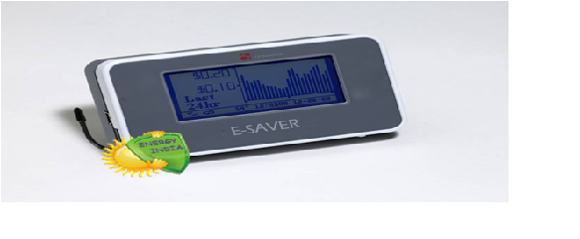

**HARDWARE REQUIREMENTS:**

Processor : Pentium III and above.

RAM : 512 MB and above.

Hard Disk Drive : 10GB and above.

**SOFTWARE REQUIREMENTS**

Database : MS SQL SERVER 2005

Technologies : ASP.NET

VB.NET

VISUAL C++

Stimulation Tool : PROTUS STIMULATION TOOL

Browser : Mozilla Firefox

**DESCRIPTION OF SOFTWARE USED:**

**Overview of the .NET Framework**

The .net framework, that runs usually on Microsoft windows. It supports several programming languages like vb, c#, Jscript, vbscript etc., that provide language interoperability to the framework. It also includes a large library that is available to all the programming languages that .net supports.

**ASP.NET:**

* ASP.NET is a web application framework developed by Microsoft to allow programmers to build dynamic Web sites, Web applications and web services.
* It was first released in January 2002 with version 1.0 of the .NET Framework, and is the successor to Microsoft’s Active Server Pages (Asp) technology.
* ASP.NET is built on the Common Language Runtime (CLR), allowing programmers to write ASP.NET code using any supported .NET language.
* ASP.NET makes building real world Web applications dramatically easier.
* The ASP.NET page and controls framework is a programming framework that runs on a web server to dynamically produce and render ASP.NET web pages.
* The ASP.NET page framework also enables you to define the pattern for URLs that will be used in your site. This helps with search engine optimization (SEO) and makes URLs more user-friendly.
* All ASP.NET code is compiled, which enables strong typing, performance optimizations, and early binding, among other benefits.
* Once the code has been compiled, the common language runtime further compiles ASP.NET code to native code, providing improved performance.
* Executable portions of a web application compiled so they execute more quickly than interpreted scripts.
* Full support for Extensible Markup Language (XML), cascading style sheets (CSS), and other new and established web standards.

**SQL SERVER 2005:**

* Microsoft SQL Server 2005 extends the performance, reliability, availability, programmability, and ease of use of SQL Server2000.
* SQL Server 2005 includes several new features that make it an excellent database platform.
* It also includes many enhancements and new features compared with previous releases.
* SQL Server 2005 is more than a database management system.
* It includes multiple components and services that make it a comprehensive platform for enterprise applications.

**VB.NET**

**FUNCTIONALITY OF DIFFERENT MODULES**

**Modules:**

* **Administrator.**
* **Add / Remove Category**
* **Add / Remove Surcharge**
* **Add / Remove Worker**
* **View the Usage Summary**
* **Email management**
* **SMS management**
* **Energy Indian (User)**
* **Add personal details**
* **Track current usage**
* **View the usage history**
* **Worker in E-saver**
* **Receive SMS**
* **Receive Mail**

**BLOCK DIAGRAM**

**CONTROL FLOW DIAGRAM**

Login

Add personal details

ADMIN

View details (usage)

Add category

ADMIN

USER

Add message

ADMIN

USER

Track different day

Add mail

USER

Calculate energy usage

View Usage

ADMIN

Add Worker

ADMIN

USER

Mail alert

ADMIN

USER

Message alert

Average tariff

ADMIN

USER

ADMIN

**USE CASE DIAGRAM**

**Worker**

**Admin**

**ER DIAGRAM**

**Esaver_reading**

**EI_rate_look_up**

**User_complaint**

**Esaver_status**

1:M

1:1

**EI_details**

**EI_reading**

1:1

1:1

**Worker_info**

1:1

1:1

**Special_charge**

**EI_identity**

1:1

1:1

**EI_category**

**Personal**

login

1:1

**Login**

1:1

**Contact**

**DATAFLOW DIAGRAM**

**Verify**

**Database**

1

**LOGIN**

**Username**

**Admin**

**Password**

**Details**

**Login fails or success**

**DATABASE DESIGN**

**contact**

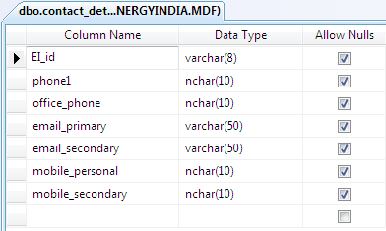

**Division_Category**

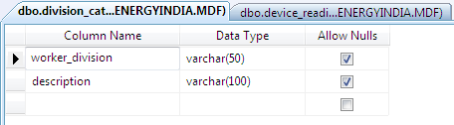

**EI_category**

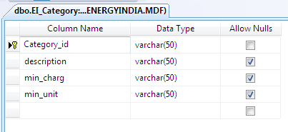

**EI_details**

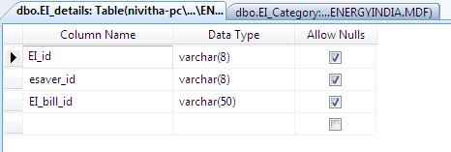

**EI_identity**

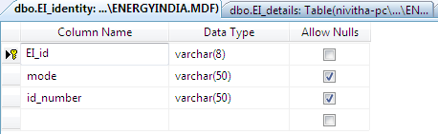

**EI_rate_look_up**

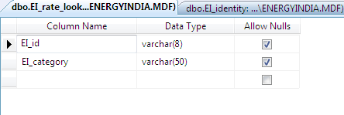

**EI_reading**

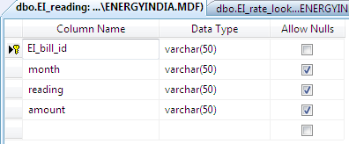

**Device_reading**

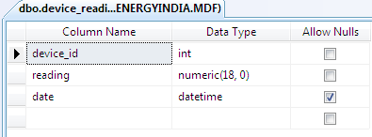

**Email_management**

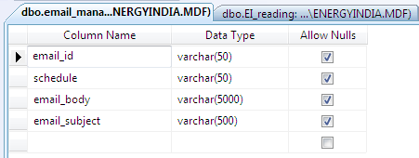

**Esaver_reading**

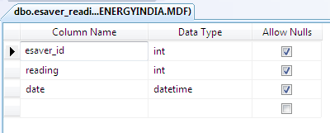

**Esaver_status**

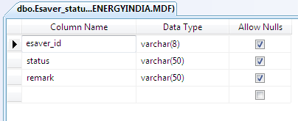

**login**

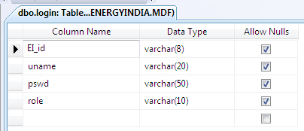

**Message management**

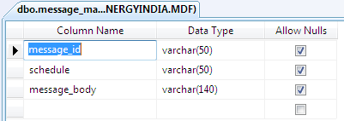

**personal**

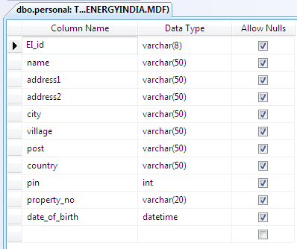

**Special_charge**

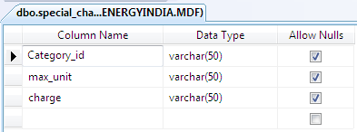

**User complaint**

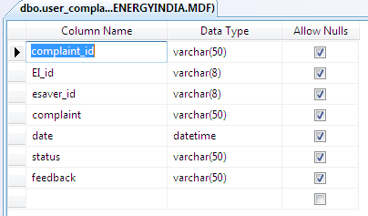

**Worker_in_esaver**

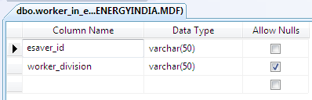

**Worker_information**

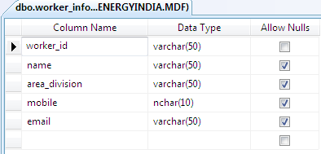

**UI SCREENS**

**Home Page**

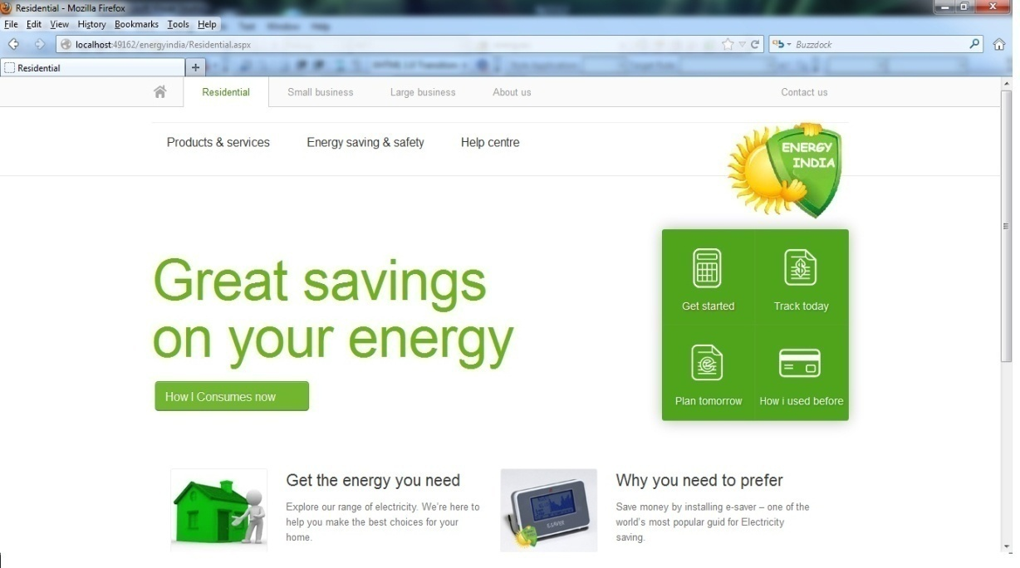

**Residential**

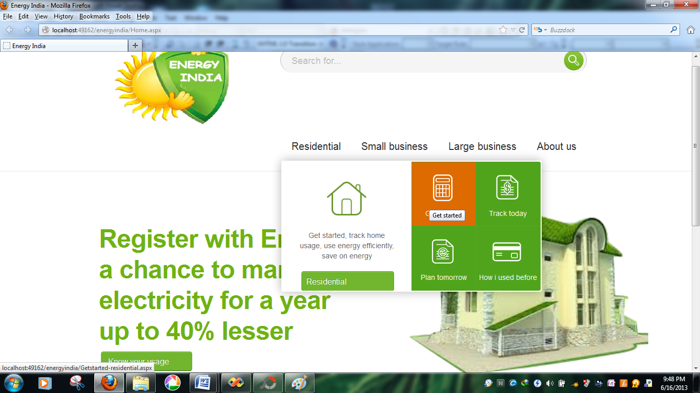

**Residential-registration form**

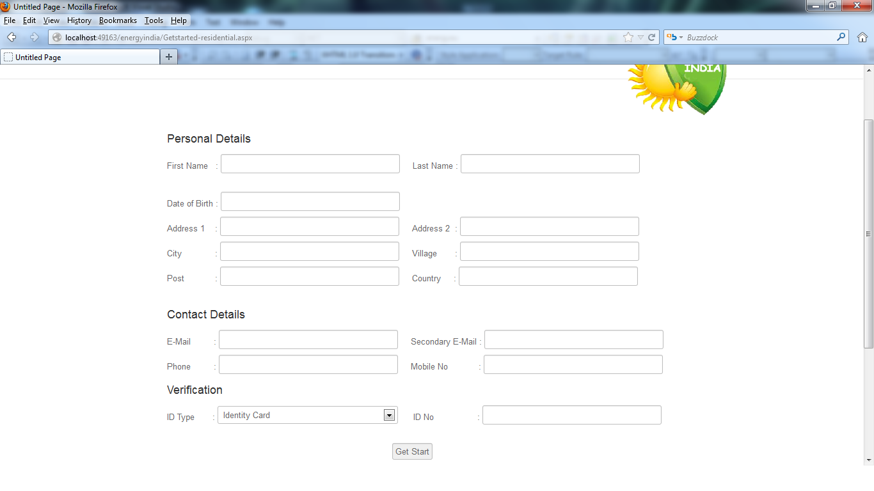

**Small Business**

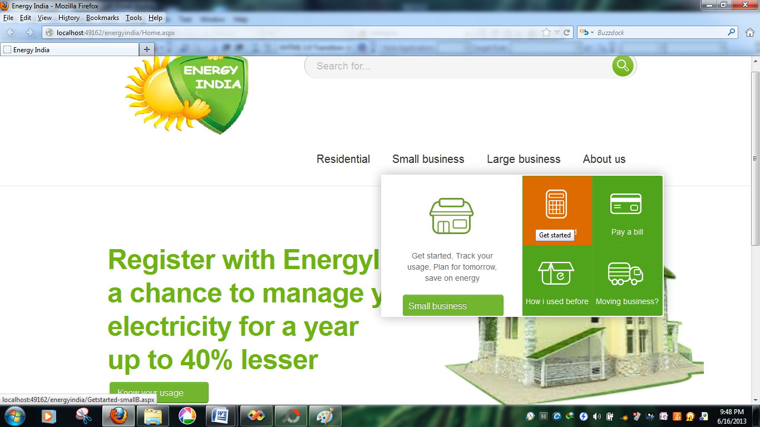

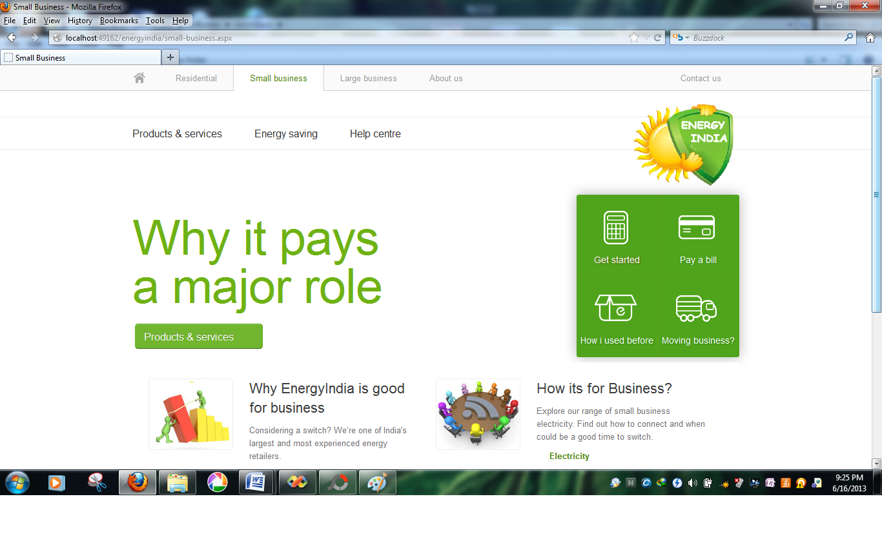

**Small business-Registration form**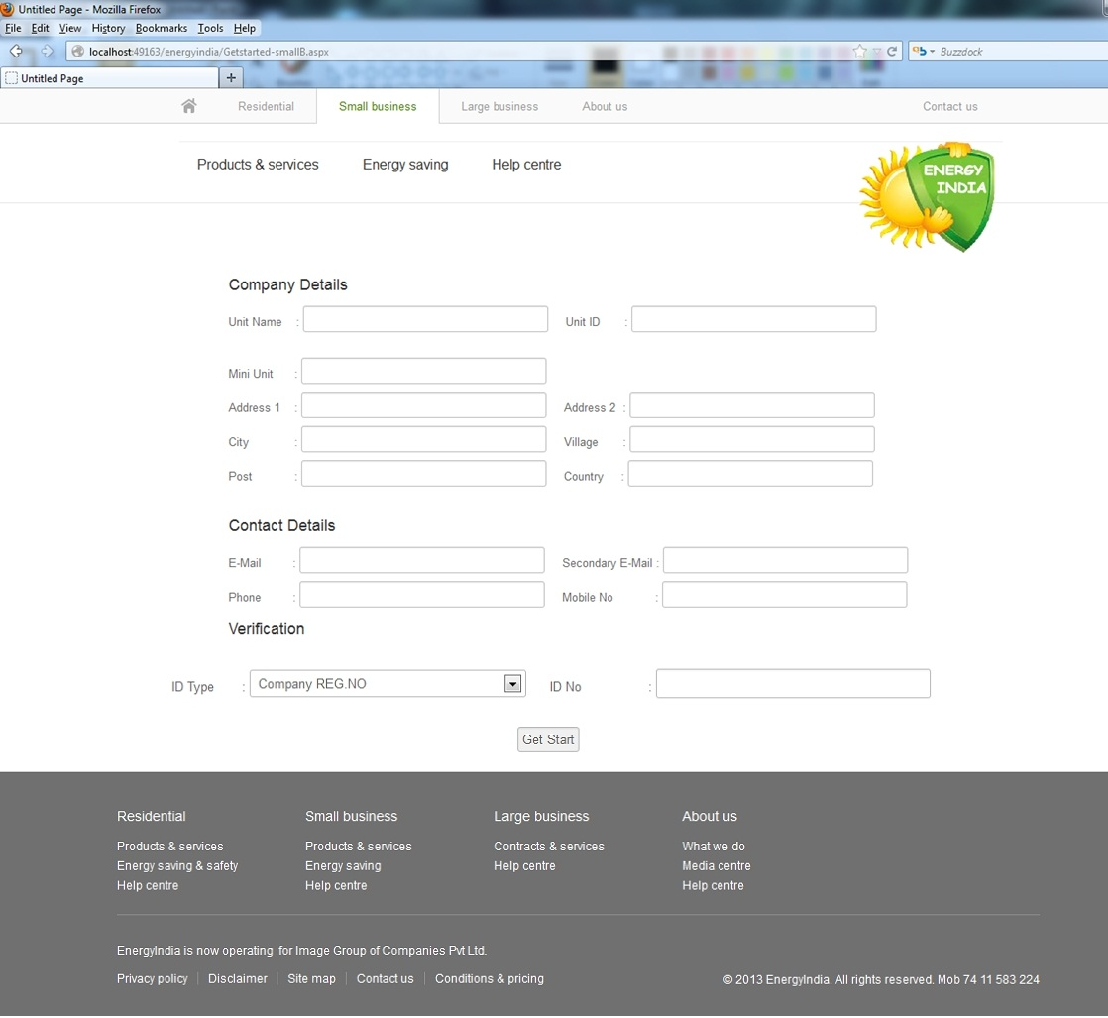

**Large Business**

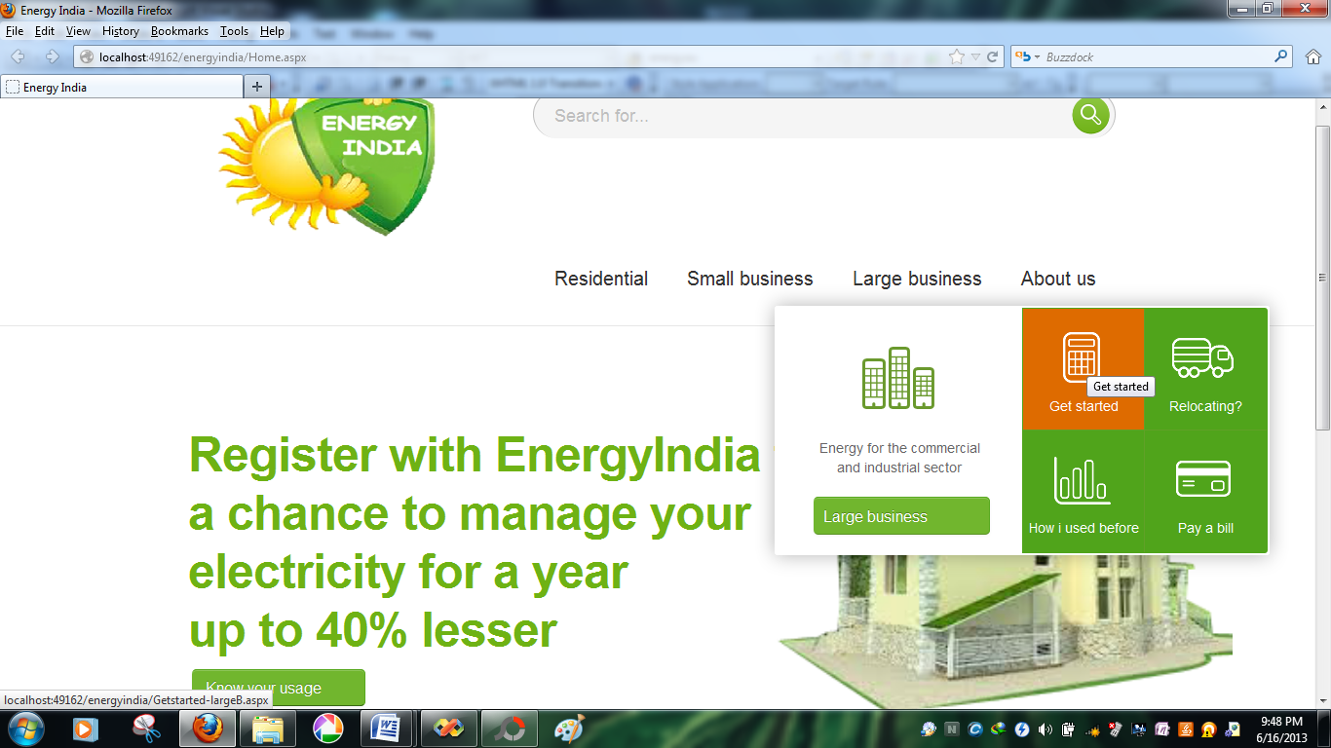

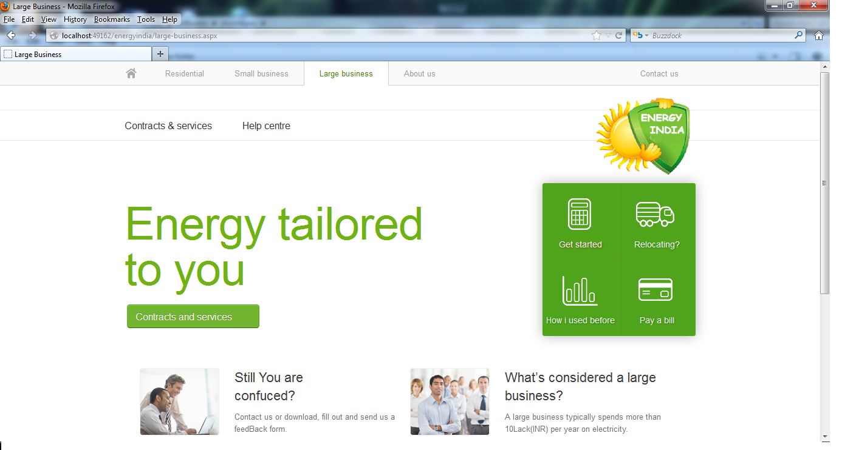

**About Us**



**HOW I CONSUME NOW**

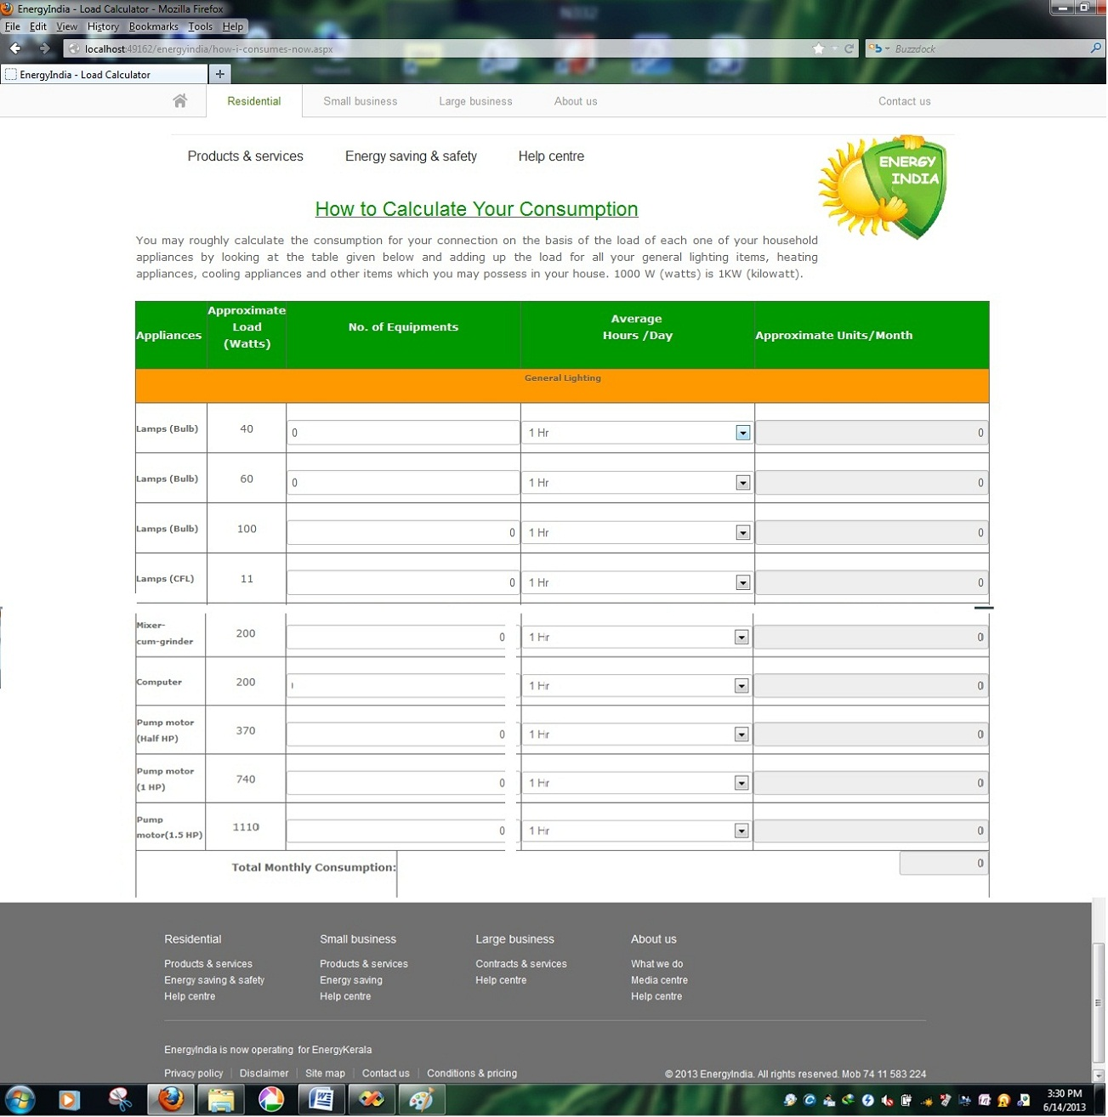

**Form Snapshots**

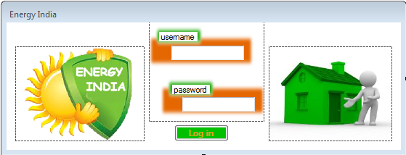

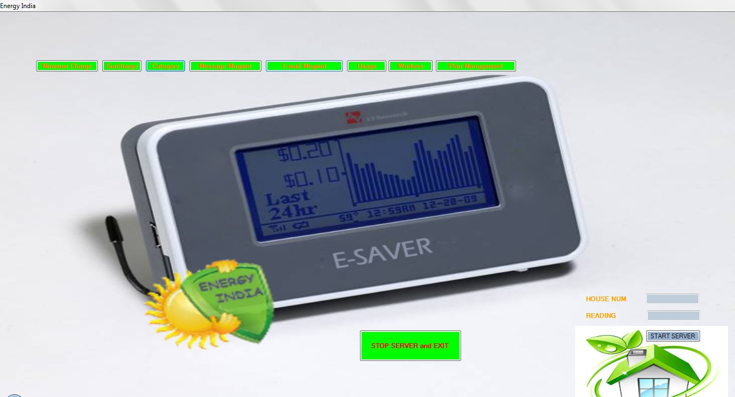

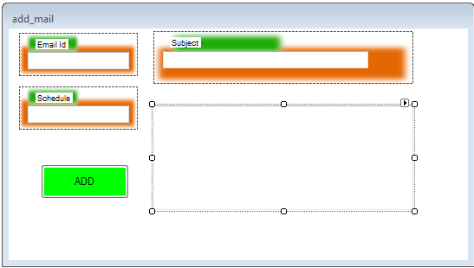

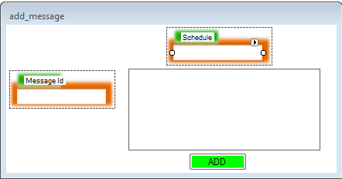

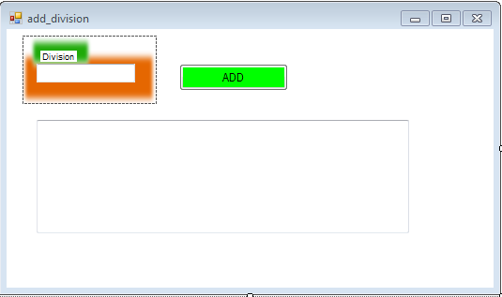

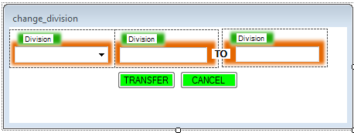

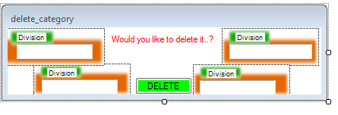

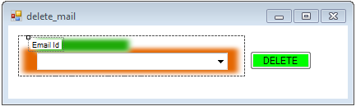

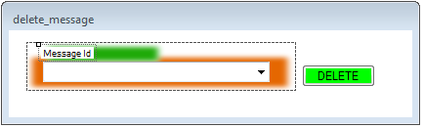

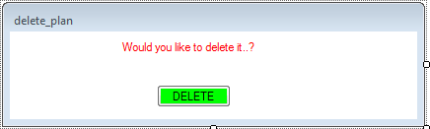

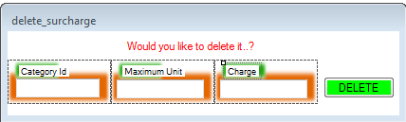

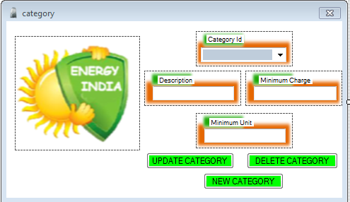

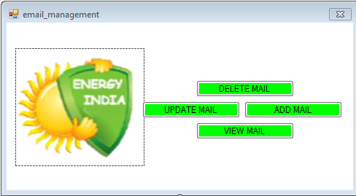

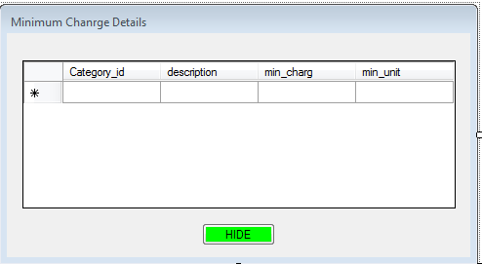

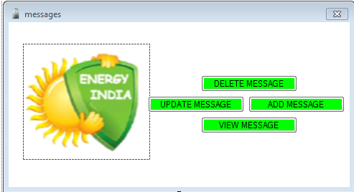

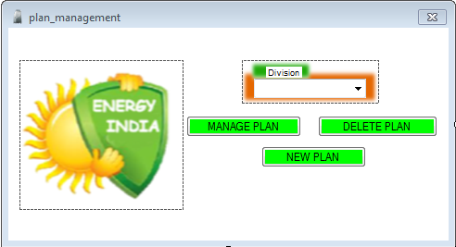

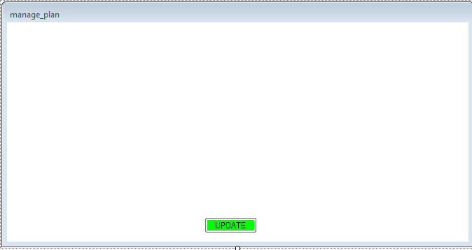

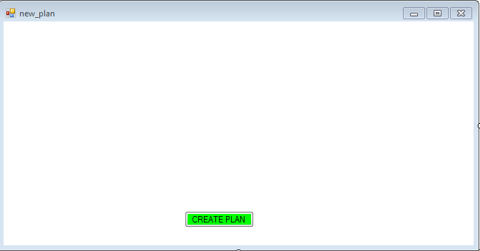

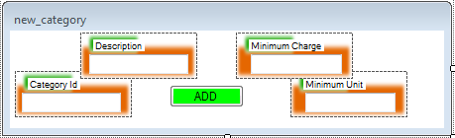

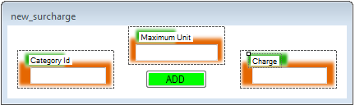

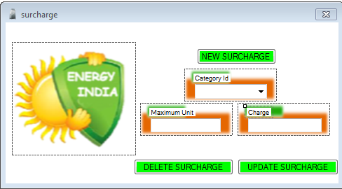

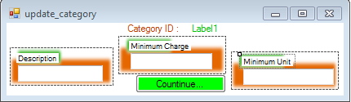

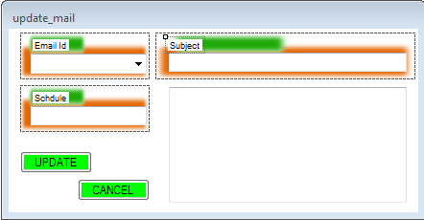

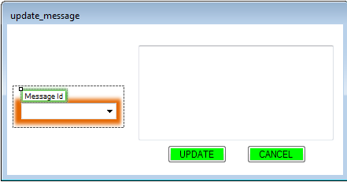

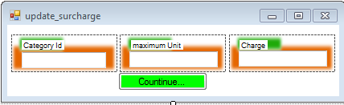

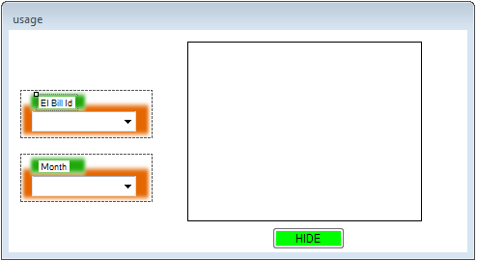

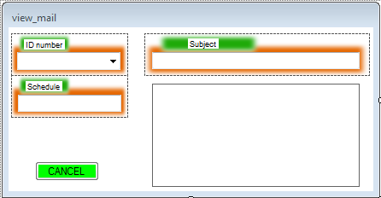

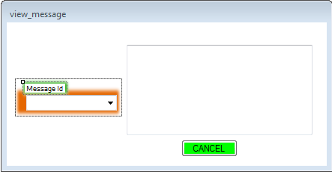

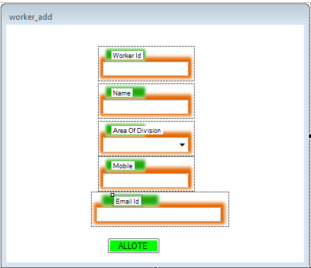

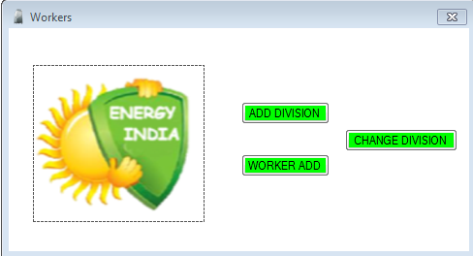

**CODE SNIPPETS**

**HOME.aspx**

<%@ Page Language="C#" AutoEventWireup="true" CodeFile="Home.aspx.cs" Inherits="_Default" %>

<!DOCTYPE html PUBLIC "-//W3C//DTD XHTML 1.0 Transitional//EN" "http://www.w3.org/TR/xhtml1/DTD/xhtml1-transitional.dtd">

<html xmlns="http://www.w3.org/1999/xhtml">

<head runat="server">

<title>Energy India</title>

<!-- CSS -->

<link rel="stylesheet" href="resources/css/global.css" type="text/css">

<!-- JS -->

<script src="resources/js/libs/modernizr-2.5.3.min.js" type="text/javascript">

</script>

<script type="text/javascript" src='resources/js/libs/mbox.js'></script>

</head>

<body>

<div style ="position:absolute; top: 743px; left: 204px;">

<img src="images/img1.png"alt=" " title=" "/>

</div>

<div style ="position:absolute; top: 742px; left: 356px; margin-top: 0px;">

<div class="featured-content">

<h2>Residential</h2>

<p>We focused on <br />managing home electricity,<br />We here for you.

<p>

<a href='help-centre-R.aspx' target='_self' class='arrow-link' >

Know more

</a> <p/>

</p>

</div>

</div>

<div style ="position:absolute; top: 744px; left: 579px;">

<img src="images/img2.png"alt=" " title=" "/>

</div>

<div style ="position:absolute; top: 744px; left: 734px; margin-top: 0px;">

<div class="featured-content">

<h2>Small Business</h2>

<p>Energy is saved<br /> by managing it efficiently,<br />we guid u for that.</p>

<p>

<a href='help-centre-R.aspx' target='_self' class='arrow-link' >

Know more

</a>

</p>

</div>

</div>

<div style ="position:absolute; top: 744px; left: 961px;">

<img src="images/img3.png"alt=" " title=" "/>

</div>

<div style ="position:absolute; top: 744px; left: 1114px; margin-top: 0px; width: 177px;">

<div class="featured-content">

<h2>Large Business</h2>

<p>Give little attention,<br />Give constant monitoring on it,<br />We helps you for that.</p>

<p>

<a href='help-centre-R.aspx' target='_self' class='arrow-link' >

Know more

</a>

</p>

</div>

</div>

<div style ="position:absolute; top: 155px; left: 780px; height: 371px; width: 465px;" >

<asp:Image ID ="mainback"

style="position:absolute; top: 140px; left: 17px; width: 468px;"

runat ="server" ImageUrl ="~/images/img.png" />

</div>

<div id="header" class="header-large">

<!-- START .nav-top -->

<div class="masthead">

<%--Logo for energy india--%>

<div class ="logo" >

<a href="Home.aspx">

<span>Home</span>

<asp:Image ID ="logo" runat ="server" ImageUrl ="~/servlet/energyindia.png"

AlternateText ="Energy India" Height="162px" Width="268px" />

</a>

</div>

<div class="search">

<form class="form-search" action="#">

<input type="text" name="query" class="input-medium search-query placeholder" title="Search" placeholder="Search for..." autocomplete="off">

<button type="submit" class="btn"><img src="resources/css/images/btn-sprite.png" alt="Search" /></button>

<!-- START .predictive-search -->

<div class="predictive-search" >

<div class="arrow"></div>

<h3>Suggestions</h3>

<ul class="search-results"></ul>

<ul class="search-view-all"></ul>

</div>

<!-- END .predictive-search -->

</form>

</div>

</div>

<div id="nav-first-level" class="navbar nav-first-level nav-megadrop">

<div class="navbar-inner">

<div class="container">

<ul class="nav">

<li>

<a href="Residential.aspx">Residential</a>

<!-- START .hero -->

<div class="hero hero-megadrop">

<div class="hero-top-border"></div>

<!-- START .hero-content -->

<div class="hero-content">

<!-- START .hero-unit -->

<div class="hero-unit">

<div class="content">

<img src="servlet/Satellite_2.gif" alt=" " title=" "/>

<h2>Get started, track home usage, use energy efficiently, save on energy</h2>

<a href='Residential.aspx' target='_self' class='btn btn-large btn-primary btn-action' >Residential

<span class="arrow"></span></a>

</div>

</div>

<!-- END .hero-unit -->

<!-- START .quick-tasks -->

<div class='quick-tasks quick-tasks-large'>

<ul class="nav">

<li>

<%--blank--%>

<a href='Getstarted-residential.aspx' target='_self' class='first-task' >

<img src="servlet/Satellite_3.gif" alt="Get started" title="Get started"/>

<span>

Get started

</span>

</a>

</li>

<li>

<a href='Tracktoday.aspx' target='_self' class='null' >

<img src="servlet/Satellite_4.gif" alt="Track today" title="Track today"/>

<span>

Track today

</span>

</a>

</li>

<li>

<a href='Plantomorrow.aspx' target='_self' class='null' >

<img src="servlet/Satellite_5.gif" alt="Plan tomorrow" title="Plan tomorrow"/>

<span>

Plan tomorrow

</span>

</a>

</li>

<li>

<a href='Usageinfo-residential.aspx' target='_self' class='null' >

<img src="servlet/Satellite_6.gif" alt="How i used" title="How i used"/>

<span>

How i used before

</span>

</a>

</li>

</ul>

</div>

<!-- END .quick-tasks -->

</div>

<!-- END .hero-content -->

</div>

<!-- END .hero -->

</li>

<li>

<a href="small-business.aspx">Small business</a>

<!-- START .hero -->

<div class="hero hero-megadrop">

<div class="hero-top-border"></div>

<!-- START .hero-content -->

<div class="hero-content">

<!-- START .hero-unit -->

<div class="hero-unit">

<div class="content">

<img src="servlet/Satellite_7.gif" alt=" " title=" "/>

<h2>Get started, Track your usage, Plan for tomorrow, save on energy</h2>

<a href='small-business.aspx' target='_self' class='btn btn-large btn-primary btn-action' >Small business

<span class="arrow"></span></a>

</div>

</div>

<!-- END .hero-unit -->

<!-- START .quick-tasks -->

<div class='quick-tasks quick-tasks-large'>

<ul class="nav">

<li>

<a href='Getstarted-smallB.aspx' target='_self' class='first-task' >

<img src="servlet/Satellite_8.gif" alt="Get started" title="Get started"/>

<span>

Get started

</span>

</a>

</li>

<li>

<a href='#' target='_self' class='null' >

<img src="servlet/Satellite_9.gif" alt="Pay a bill" title="Pay a bill"/>

<span>

Pay a bill

</span>

</a>

</li>

<li>

<a href='Usageinfo-smallB.aspx

' target='_self' class='null' >

<img src="servlet/Satellite_10.gif" alt="How i used before" title="How i used before"/>

<span>

How i used before

</span>

</a>

</li>

<li>

<a href='Movingbusiness.aspx' target='_self' class='null' >

<img src="servlet/Satellite_11.gif" alt="Moving business?" title="Moving business?"/>

<span>

Moving business?

</span>

</a>

</li>

</ul>

</div>

<!-- END .quick-tasks -->

</div>

<!-- END .hero-content -->

</div>

<!-- END .hero -->

</li>

<li>

<a href="large-business.aspx">Large business</a>

<!-- START .hero -->

<div class="hero hero-megadrop">

<div class="hero-top-border"></div>

<!-- START .hero-content -->

<div class="hero-content">

<!-- START .hero-unit -->

<div class="hero-unit">

<div class="content">

<img src="servlet/Satellite_12.gif" alt=" " title=" "/>

<h2>Energy for the commercial and industrial sector</h2>

<a href='large-business.aspx' target='_self' class='btn btn-large btn-primary btn-action' >Large business

<span class="arrow"></span></a>

</div>

</div>

<!-- END .hero-unit -->

<!-- START .quick-tasks -->

<div class='quick-tasks quick-tasks-large'>

<ul class="nav">

<li>

<a href='Getstarted-largeB.aspx' target='_self' class='first-task' >

<img src="servlet/Satellite_13.gif" alt="Get started" title="Get started"/>

<span>

Get started

</span>

</a>

</li>

<li>

<a href='Relocating-largeB.aspx' target='_self' class='null' >

<img src="servlet/Satellite_20.gif" alt="Relocating?" title="Relocating?"/>

<span>

Relocating?

</span>

</a>

</li>

<li>

<a href='Usageinfo-largeB.aspx' target='_self' class='null' >

<img src="servlet/Satellite_21.gif" alt="How i used before" title="How i used before"/>

<span>

How i used before

</span>

</a>

</li>

<li>

<a href='#' target='_self' class='null' >

<img src="servlet/Satellite_14.gif" alt="Pay a bill" title="Pay a bill"/>

<span>

Pay a bill

</span>

</a>

</li>

</ul>

</div>

<!-- END .quick-tasks -->

</div>

<!-- END .hero-content -->

</div>

<!-- END .hero -->

</li>

<li>

<a href="about-us.aspx">About us</a>

<!-- START .hero -->

<div class="hero hero-megadrop">

<div class="hero-top-border"></div>

<!-- START .hero-content -->

<div class="hero-content">

<!-- START .hero-unit -->

<div class="hero-unit">

<div class="content">

<img src="servlet/Satellite_15.gif" alt=" " title=" "/>

<h2>Find out who we are and where we invest our energy</h2>

<a href='about-us.aspx' target='_self' class='btn btn-large btn-primary btn-action' >About us

<span class="arrow"></span></a>

</div>

</div>

<!-- END .hero-unit -->

<!-- START .quick-tasks -->

<div class='quick-tasks quick-tasks-large'>

<ul class="nav">

<li>

<a href='What-we-do.aspx' target='_self' class='first-task' >

<img src="servlet/Satellite_16.gif" alt="What we do" title="What we do"/>

<span>

What we do

</span>

</a>

</li>

<li>

<a href='Media-centre.aspx' target='_self' class='null' >

<img src="servlet/Satellite_17.gif" alt="Media centre" title="Media centre"/>

<span>

Media centre

</span>

</a>

</li>

<li>

<a href='Careers.aspx' target='_self' class='null' >

<img src="servlet/Satellite_18.gif" alt="Careers" title="Careers"/>

<span>

Careers

</span>

</a>

</li>

<li>

<a href='Electricity-Board.aspx' target='_self' class='null' >

<img src="servlet/Satellite_19.gif" alt="Education tools" title="Education tools"/>

<span>

Electricity Board

</span>

</a>

</li>

</ul>

</div>

<!-- END .quick-tasks -->

</div>

<!-- END .hero-content -->

</div>

<!-- END .hero -->

</li>

</ul>

</div>

</div>

</div>

</div>

<div class="hero hero-has-banner hero-large" >

<div class="hero-top-border">

</div>

<!-- START .hero-content -->

<div class="hero-content">

<!-- START .hero-unit -->

<div class="hero-unit">

<div class="content">

<h1><h1 style="font-size:50px; font-weight:bold; line-height:120%;">Register with EnergyIndia for <br />a chance to manage your <br />electricity for a year <br />up to 40% lesser</h1></h1>

<p></p>

<a href='how-i-consumes-now.aspx' target='_self' class='btn btn-large btn-primary btn-action' >Know your usage

<span class="arrow"></span></a>

</div>

</div>

</div>

</div>

<div id="footer" class="">

<div id="nav-footer-top" class="nav-footer-top">

<p class='tagline '>EnergyIndia is now operating&nbsp; for Image Group of Companies Pvt Ltd.</p>

<ul class="nav">

<li>

<a href='#' target='_self' class='null' >

Privacy policy

</a>

</li>

<li>

<a href='#' target='_self' class='null' >

Disclaimer

</a>

</li>

<li>

<a href='#' target='_self' class='null' >

Site map

</a>

</li>

<li>

<a href='#' target='_self' class='null' >

Contact us

</a>

</li>

<li>

<a href='#' target='_self' class='null' >

Conditions & pricing

</a>

</li>

<li>

<a href='#' target='_self' class='null' >

Energy India reports

</a>

</li>

</ul>

<div class="copyright">

© 2013 EnergyIndia. All rights reserved. Mob 74 11 583 224

</div>

</div>

</div>

<!-- SiteCatalyst code version: H.24.4. -->

<script language="JavaScript" type="text/javascript"><!--

// SET PAGE LEVEL VARIABLES IN THIS SECTION

/************* DO NOT ALTER ANYTHING BELOW THIS LINE ! **************/

var s_code=s.t();if(s_code)document.write(s_code)//--></script>

<!-- End SiteCatalyst code version: H.24.4. -->

<script>window.jQuery || document.write('<script src="resources/js/libs/jquery-1.7.1.min.js"><\/script>')</script>

</script><script src="resources/js/libs/jquery-plugins.js" type="text/javascript">

</script>

<!-- JS: Bootstrap -->

<!-- <script type="text/javascript" src="http://platform.twitter.com/widgets.js"></script> -->

<script src="resources/js/libs/bootstrap/bootstrap-transition.js" type="text/javascript">

</script><script src="resources/js/libs/bootstrap/bootstrap-collapse.js" type="text/javascript">

</script><script src="resources/js/libs/bootstrap/bootstrap-carousel.js" type="text/javascript">

</script><!-- JS: Global -->

<script src="resources/js/power.js" type="text/javascript">

</script><script src="resources/js/power-utils.js" type="text/javascript">

</script><script src="resources/js/power-modules.js" type="text/javascript">

</script><script src="resources/js/power-forms.js" type="text/javascript">

</script><script src="resources/js/power-navigation.js" type="text/javascript">

</script><script src="resources/js/global.js" type="text/javascript">

</script>

</body>

</html>

**RESIDENTIAL.ASPX**

<%@ Page Language="C#" AutoEventWireup="true" CodeFile="Residential.aspx.cs" Inherits="Residential" %>

<!DOCTYPE html PUBLIC "-//W3C//DTD XHTML 1.0 Transitional//EN" "http://www.w3.org/TR/xhtml1/DTD/xhtml1-transitional.dtd">

<html xmlns="http://www.w3.org/1999/xhtml">

<head runat="server">

<title>Residential</title>

<!-- CSS -->

<link rel="stylesheet" href="global.css" type="text/css">

<!-- JS -->

<script src="modernizr-2.5.3.min.js" type="text/javascript">

</script>

<script type="text/javascript" src='mbox.js'></script>

</head>

<body>

<div style ="position:absolute; top: 58px; left: 968px; height: 133px; width: 188px;">

<asp:Image ID ="logo" runat ="server" ImageUrl ="~/servlet/energyindia.png"

AlternateText ="Energy India" Height="131px" Width="186px" />

</div>

<div id="header" >

<!-- START .nav-top -->

<div id="nav-sections" class="navbar nav-top">

<div class="navbar-inner">

<div class="container">

<ul class="nav">

<li><a href='Home.aspx'><img src='btn-sprite.png' alt='Home'></a></li>

<li class='active'><a href='Residential.aspx'>Residential</a></li>

<li><a href='small-business.aspx'>Small business</a></li>

<li><a href='large-business.aspx'>Large business</a></li>

<li><a href='about-us.aspx'>About us</a></li>

<li class="contact-us"><a href="contact-us.aspx">Contact us</a></li>

</ul>

</div>

</div>

</div><!-- END .nav-top -->

<div class="masthead">

<!-- START .nav-second-level -->

<div id="nav-primary" class="navbar nav-second-level">

<div class="navbar-inner">

<div class="container">

<ul class="nav">

<li class=''><a href='products-services_R.aspx'>Products & services</a></li>

<li class=''><a href='energy-saving-R.aspx'>Energy saving & safety</a></li>

<li class=''><a href='help-centre-R.aspx'>Help centre</a></li>

</ul>

</div>

</div>

</div><!-- END .nav-second-level -->

</div>

</div>

<div class="hero hero-has-banner hero-medium" style="background-image: url('/servlet/Satellite?blobcol=urldata&blobkey=id&blobtable=MungoBlobs&blobwhere=1343702604498&ssbinary=true')">

<div class="hero-top-border">

</div>

<!-- START .hero-content -->

<div class="hero-content">

<!-- START .hero-unit -->

<div class="hero-unit">

<div class="content">

<h1>Great savings <br /> on your energy</h1>

<p></p>

<!--

<p>

<a class="btn btn-primary btn-large">

Learn more

</a>

</p>

-->

<a href='how-i-consumes-now.aspx' target='_self' class='btn btn-large btn-primary btn-action' >How I Consumes now

<span class="arrow"></span></a>

</div>

</div>

<!-- START .quick-tasks -->

<div class='quick-tasks quick-tasks-large'>

<ul class="nav">

<li>

<a href='Getstarted-residential.aspx' target='_self' class='first-task' >

<img src="servlet/Satellite_3.gif" alt="Get started" title="Get started"/>

<span>

Get started

</span>

</a>

</li>

<li>

<a href='#' target='_self' class='null' >

<img src="servlet/Satellite_4.gif" alt="Track today" title="Track today"/>

<span>

Track today

</span>

</a>

</li>

<li>

<a href='#' target='_self' class='null' >

<img src="servlet/Satellite_5.gif" alt="Plan tomorrow" title="Plan tomorrow"/>

<span>

Plan tomorrow

</span>

</a>

</li>

<li>

<a href='#' target='_self' class='null' >

<img src="servlet/Satellite_6.gif" alt="How i used before" title="How i used before"/>

<span>

How i used before

</span>

</a>

</li>

</ul>

</div>

<!-- END .quick-tasks -->

<!-- SiteCatalyst code version: H.24.4. -->

<script language="JavaScript" type="text/javascript" src="s_code.js"></script>

<script language="JavaScript" type="text/javascript"><!--

/* You may give each page an identifying name, server, and channel on

the next lines. */

s.pageName="ea:Residential";

s.prop20="Content";

//--></script>

<!-- End SiteCatalyst code version: H.24.4. -->

<div class="featured-items">

<div class="featured-item last ">

<img src="images/img4.png"alt=" " title=" "/>

<div class="featured-content">

<h2>Get the energy you need</h2>

<p>Explore our range of electricity. We’re here to help you make the best choices for your home.</p>

<p>

<a href='Getstarted-residential.aspx' target='_self' class='arrow-link' >

Become an Energy Indian

</a>

</p>

</div>

</div>

<div class="featured-item ">

<img src="images/img5.png"alt=" " title=" "/>

<div class="featured-content">

<h2>Why you need to prefer</h2>

<p>Save money by installing e-saver – one of the world’s most popular guid for Electricity saving.</p>

<p>

<a href='solar-power.htm' target='_self' class='arrow-link' >

e-saver?

</a>

</p>

</div>

</div>

</div>

</div>

<!-- END .hero-unit -->

</div>

<!-- START .container.one-column -->

<div class="container one-column">

<!-- START .row -->

<!-- END .row -->

</div>

<!-- END .container.one-column -->

<div id="footer">

<div id="nav-footer-second-level" class="nav-footer-second-level">

<div class='section'><h3><a href='residential.aspx'>Residential</a></h3>

<ul class='nav'>

<li><a href='#'>Products & services</a></li>

<li><a href='#'>Energy saving & safety</a></li>

<li><a href='#'>Help centre</a></li>

</ul></div>

<div class='section'><h3><a href='small-business.aspx'>Small business</a></h3>

<ul class='nav'>

<li><a href='#'>Products & services</a></li>

<li><a href='#'>Energy saving</a></li>

<li><a href='#'>Help centre</a></li>

</ul></div>

<div class='section'><h3><a href='large-business.aspx'>Large business</a></h3>

<ul class='nav'>

<li><a href='#'>Contracts & services</a></li>

<li><a href='#'>Help centre</a></li>

</ul></div>

<div class='section'><h3><a href='about-us.aspx'>About us</a></h3>

<ul class='nav'>

<li><a href='#'>What we do</a></li>

<li><a href='#'>Media centre</a></li>

<li><a href='#'>Help centre</a></li>

</ul></div>

</div>

<div id="nav-footer-top" class="nav-footer-top">

<p class='tagline '>EnergyIndia is now operating&nbsp; for EnergyKerala</p>

<ul class="nav">

<li>

<a href='Privacy-policy.aspx' target='_self' class='null' >

Privacy policy

</a>

</li>

<li>

<a href='Disclaimer.aspx' target='_self' class='null' >

Disclaimer

</a>

</li>

<li>

<a href='sitemap.aspx' target='_self' class='null' >

Site map

</a>

</li>

<li>

<a href='#' target='_self' class='null' >

Contact us

</a>

</li>

<li>

<a href='conditions-pricing.aspx' target='_self' class='null' >

Conditions & pricing

</a>

</li>

</ul>

<div class="copyright">

© 2013 EnergyIndia. All rights reserved. Mob 74 11 583 224

</div>

</div>

<!-- SiteCatalyst code version: H.24.4. -->

<script language="JavaScript" type="text/javascript"><!--

// SET PAGE LEVEL VARIABLES IN THIS SECTION

/************* DO NOT ALTER ANYTHING BELOW THIS LINE ! **************/

var s_code=s.t();if(s_code)document.write(s_code)//--></script>

<!-- End SiteCatalyst code version: H.24.4. -->

<script>window.jQuery || document.write('<script src="jquery-1.7.1.min.js"><\/script>')</script>

</script><script src="jquery-plugins.js" type="text/javascript">

</script>

<!-- JS: Bootstrap -->

<!-- <script type="text/javascript" src="http://platform.twitter.com/widgets.js"></script> -->

<script src="residentsjs/bootstrap-transition.js" type="text/javascript">

</script><script src="residentsjs/bootstrap-collapse.js" type="text/javascript">

</script><script src="residentsjs/bootstrap-carousel.js" type="text/javascript">

</script><!-- JS: Global -->

<script src="residentsjs/power.js" type="text/javascript">

</script><script src="residentsjs/power-utils.js" type="text/javascript">

</script><script src="residentsjs/power-modules.js" type="text/javascript">

</script><script src="residentsjs/power-forms.js" type="text/javascript">

</script><script src="residentsjs/power-navigation.js" type="text/javascript">

</script><script src="residentsjs/global.js" type="text/javascript">

</script>

</div>

</body>

</html>

**SMALL BUSINESS.ASPX**

<%@ Page Language="C#" AutoEventWireup="true" CodeFile="small-business.aspx.cs" Inherits="small_business" %>

<!DOCTYPE html PUBLIC "-//W3C//DTD XHTML 1.0 Transitional//EN" "http://www.w3.org/TR/xhtml1/DTD/xhtml1-transitional.dtd">

<html xmlns="http://www.w3.org/1999/xhtml">

<head runat="server">

<title >Small Business</title>

<!-- CSS -->

<link rel="stylesheet" href="global.css" type="text/css">

<!-- JS -->

<script src="modernizr-2.5.3.min.js" type="text/javascript">

</script>

<script type="text/javascript" src='resources/js/libs/mbox.js'></script>

</head>

<body>

<div style ="position:absolute; top: 58px; left: 968px; height: 133px; width: 188px;">

<asp:Image ID ="logo" runat ="server" ImageUrl ="~/servlet/energyindia.png"

AlternateText ="Energy India" Height="131px" Width="186px" />

</div>

<div id="header" >

<!-- START .nav-top -->

<div id="nav-sections" class="navbar nav-top">

<div class="navbar-inner">

<div class="container">

<ul class="nav">

<li><a href='Home.aspx'><img src='btn-sprite.png' alt='Home'></a></li>

<li><a href='Residential.aspx'>Residential</a></li>

<li class='active'><a href='small-business.aspx'>Small business</a></li>

<li><a href='large-business.aspx'>Large business</a></li>

<li><a href='about-us.aspx'>About us</a></li>

<li class="contact-us"><a href="contact-us.aspx">Contact us</a></li>

</ul>

</div>

</div>

</div><!-- END .nav-top -->

<div class="masthead">

</div><!-- START .nav-second-level -->

<div id="nav-primary" class="navbar nav-second-level">

<div class="navbar-inner">

<div class="container">

<ul class="nav">

<li class=''><a href='products-services-SB.aspx'>Products & services</a></li>

<li class=''><a href='energy-saving-SB.aspx'>Energy saving</a></li>

<li class=''><a href='help-centre-SB.aspx'>Help centre</a></li>

</ul>

</div>

</div>

</div><!-- END .nav-second-level -->

</div>

<div class="hero hero-has-banner hero-medium" style="background-image: url('/servlet/Satellite?blobcol=urldata&blobkey=id&blobtable=MungoBlobs&blobwhere=1343702604929&ssbinary=true')">

<div class="hero-top-border">

</div>

<!-- START .hero-content -->

<div class="hero-content">

<!-- START .hero-unit -->

<div class="hero-unit">

<div class="content">

<h1>Why it pays<br />a major role</h1>

<p></p>

<!--

<p>

<a class="btn btn-primary btn-large">

Learn more

</a>

</p>

-->

<a href='products-services_2.htm' target='_self' class='btn btn-large btn-primary btn-action' >Products & services

<span class="arrow"></span></a>

</div>

</div>

<!-- START .quick-tasks -->

<div class='quick-tasks quick-tasks-large'>

<ul class="nav">

<li>

<a href='Getstarted-smallB.aspx' target='_self' class='first-task' >

<img src="servlet/Satellite_8.gif" alt="Get started" title="Get started"/>

<span>

Get started

</span>

</a>

</li>

<li>

<a href='#' target='_self' class='null' >

<img src="servlet/Satellite_9.gif" alt="Pay a bill" title="Pay a bill"/>

<span>

Pay a bill

</span>

</a>

</li>

<li>

<a href='Usageinfo-smallB.aspx

' target='_self' class='null' >

<img src="servlet/Satellite_10.gif" alt="How i used before" title="How i used before"/>

<span>

How i used before

</span>

</a>

</li>

<li>

<a href='Movingbusiness.aspx' target='_self' class='null' >

<img src="servlet/Satellite_11.gif" alt="Moving business?" title="Moving business?"/>

<span>

Moving business?

</span>

</a>

</li>

</ul>

</div>

<!-- END .quick-tasks -->

<!-- SiteCatalyst code version: H.24.4. -->

<script language="JavaScript" type="text/javascript" src="s_code.js"></script>

<script language="JavaScript" type="text/javascript"><!--

/* You may give each page an identifying name, server, and channel on

the next lines. */

s.pageName="ea:Small business";

s.prop20="Content";

//--></script>

<!-- End SiteCatalyst code version: H.24.4. -->

<div class="featured-items">

<div class="featured-item last ">

<img src="images/img7.png"alt=" " title=" "/>

<div class="featured-content">

<h2>Why EnergyIndia is good for business</h2>

<p>Considering a switch? We’re one of India's largest and most experienced energy retailers.</p>

<p>

<a href='products-services-SB.aspx' target='_self' class='arrow-link' >

Why EnergyIndia?

</a>

</p>

</div>

</div>

<div class="featured-item ">

<img src="images/img6.png"alt=" " title=" "/>

<div class="featured-content">

<h2>How its for Business?</h2>

<p>Explore our range of small business electricity. Find out how to connect and when could be a good time to switch.</p>

<p>

<a href='e-saver-for-SB.aspx' target='_self' class='arrow-link' >

Electricity

</a>

</p>

</div>

</div>

</div>

</div>

<!-- END .hero-unit -->

</div>

<div id="footer">

<div id="nav-footer-second-level" class="nav-footer-second-level">

<div class='section'><h3><a href='residential.aspx'>Residential</a></h3>

<ul class='nav'>

<li><a href='#'>Products & services</a></li>

<li><a href='#'>Energy saving & safety</a></li>

<li><a href='#'>Help centre</a></li>

</ul></div>

<div class='section'><h3><a href='small-business.aspx'>Small business</a></h3>

<ul class='nav'>

<li><a href='#'>Products & services</a></li>

<li><a href='#'>Energy saving</a></li>

<li><a href='#'>Help centre</a></li>

</ul></div>

<div class='section'><h3><a href='large-business.aspx'>Large business</a></h3>

<ul class='nav'>

<li><a href='#'>Contracts & services</a></li>

<li><a href='#'>Help centre</a></li>

</ul></div>

<div class='section'><h3><a href='about-us.aspx'>About us</a></h3>

<ul class='nav'>

<li><a href='#'>What we do</a></li>

<li><a href='#'>Media centre</a></li>

<li><a href='#'>Help centre</a></li>

</ul></div>

</div>

<div id="nav-footer-top" class="nav-footer-top">

<p class='tagline '>EnergyIndia is now operating&nbsp; for EnergyKerala</p>

<ul class="nav">

<li>

<a href='Privacy-policy.aspx' target='_self' class='null' >

Privacy policy

</a>

</li>

<li>

<a href='Disclaimer.aspx' target='_self' class='null' >

Disclaimer

</a>

</li>

<li>

<a href='sitemap.aspx' target='_self' class='null' >

Site map

</a>

</li>

<li>

<a href='#' target='_self' class='null' >

Contact us

</a>

</li>

<li>

<a href='conditions-pricing.aspx' target='_self' class='null' >

Conditions & pricing

</a>

</li>

</ul>

<div class="copyright">

© 2013 EnergyIndia. All rights reserved. Mob 74 11 583 224

</div>

</div>

<!-- SiteCatalyst code version: H.24.4. -->

<script language="JavaScript" type="text/javascript"><!--

// SET PAGE LEVEL VARIABLES IN THIS SECTION

/************* DO NOT ALTER ANYTHING BELOW THIS LINE ! **************/

var s_code=s.t();if(s_code)document.write(s_code)//--></script>

<!-- End SiteCatalyst code version: H.24.4. -->

<script>window.jQuery || document.write('<script src="jquery-1.7.1.min.js"><\/script>')</script>

</script><script src="jquery-plugins.js" type="text/javascript">

</script>

<!-- JS: Bootstrap -->

<!-- <script type="text/javascript" src="http://platform.twitter.com/widgets.js"></script> -->

<script src="residentsjs/bootstrap-transition.js" type="text/javascript">

</script><script src="residentsjs/bootstrap-collapse.js" type="text/javascript">

</script><script src="residentsjs/bootstrap-carousel.js" type="text/javascript">

</script><!-- JS: Global -->

<script src="residentsjs/power.js" type="text/javascript">

</script><script src="residentsjs/power-utils.js" type="text/javascript">

</script><script src="residentsjs/power-modules.js" type="text/javascript">

</script><script src="residentsjs/power-forms.js" type="text/javascript">

</script><script src="residentsjs/power-navigation.js" type="text/javascript">

</script><script src="residentsjs/global.js" type="text/javascript">

</script>

</div>

</body>

</html>

**LARGE BUSINESS**

<%@ Page Language="C#" AutoEventWireup="true" CodeFile="large-business.aspx.cs" Inherits="large_business" %>

<!DOCTYPE html PUBLIC "-//W3C//DTD XHTML 1.0 Transitional//EN" "http://www.w3.org/TR/xhtml1/DTD/xhtml1-transitional.dtd">

<html xmlns="http://www.w3.org/1999/xhtml">

<head runat="server">

<title>Large Business</title>

<!-- CSS -->

<link rel="stylesheet" href="global.css" type="text/css">

<!-- JS -->

<script src="modernizr-2.5.3.min.js" type="text/javascript">

</script>

<script type="text/javascript" src='resources/js/libs/mbox.js'></script>

</head>

<body>

<div style ="position:absolute; top: 58px; left: 968px; height: 133px; width: 188px;">

<asp:Image ID ="logo" runat ="server" ImageUrl ="~/servlet/energyindia.png"

AlternateText ="Energy India" Height="131px" Width="186px" />

</div>

<div id="header" >

<!-- START .nav-top -->

<div id="nav-sections" class="navbar nav-top">

<div class="navbar-inner">

<div class="container">

<ul class="nav">

<li><a href='Home.aspx'><img src='btn-sprite.png' alt='Home'></a></li>

<li><a href='residential.aspx'>Residential</a></li>

<li><a href='small-business.aspx'>Small business</a></li>

<li class='active'><a href='large-business.aspx'>Large business</a></li>

<li><a href='about-us.aspx'>About us</a></li>

<li class="contact-us"><a href="contact-us.aspx">Contact us</a></li>

</ul>

</div>

</div>

</div><!-- END .nav-top -->

<div class="masthead">

</div><!-- START .nav-second-level -->

<div id="nav-primary" class="navbar nav-second-level">

<div class="navbar-inner">

<div class="container">

<ul class="nav">

<li class=''><a href='contracts-services.aspx'>Contracts & services</a></li>

<li class=''><a href='help-centre-LB.aspx'>Help centre</a></li>

</ul>

</div>

</div>

</div><!-- END .nav-second-level -->

</div>

<div class="hero hero-has-banner hero-medium" style="background-image: url('/servlet/Satellite?blobcol=urldata&blobkey=id&blobtable=MungoBlobs&blobwhere=1343702604860&ssbinary=true')">

<div class="hero-top-border">

</div>

<!-- START .hero-content -->

<div class="hero-content">

<!-- START .hero-unit -->

<div class="hero-unit">

<div class="content">

<h1>Energy tailored<br>to you</h1>

<p></p>

<!--

<p>

<a class="btn btn-primary btn-large">

Learn more

</a>

</p>

-->

<a href='#' target='_self' class='btn btn-large btn-primary btn-action' >Contracts and services

<span class="arrow"></span></a>

</div>

</div>

<!-- START .quick-tasks -->

<div class='quick-tasks quick-tasks-large'>

<ul class="nav">

<li>

<a href='Getstarted-largeB.aspx' target='_self' class='first-task' >

<img src="servlet/Satellite_13.gif" alt="Get started" title="Get started"/>

<span>

Get started

</span>

</a>

</li>

<li>

<a href='Relocating-largeB.aspx' target='_self' class='null' >

<img src="servlet/Satellite_20.gif" alt="Relocating?" title="Relocating?"/>

<span>

Relocating?

</span>

</a>

</li>

<li>

<a href='Usageinfo-largeB.aspx' target='_self' class='null' >

<img src="servlet/Satellite_21.gif" alt="How i used before" title="How i used before"/>

<span>

How i used before

</span>

</a>

</li>

<li>

<a href='#' target='_self' class='null' >

<img src="servlet/Satellite_14.gif" alt="Pay a bill" title="Pay a bill"/>

<span>

Pay a bill

</span>

</a>

</li>

</ul>

</div>

<!-- END .quick-tasks -->

<!-- SiteCatalyst code version: H.24.4. -->

<script language="JavaScript" type="text/javascript" src="s_code.js"></script>

<script language="JavaScript" type="text/javascript"><!--

/* You may give each page an identifying name, server, and channel on

the next lines. */

s.pageName="ea:Large business";

s.prop20="Content";

//--></script>

<!-- End SiteCatalyst code version: H.24.4. -->

<div class="featured-items">

<div class="featured-item last ">

<img src="images/Satellitea.jpg"alt=" " title=" "/>

<div class="featured-content">

<h2>Still You are <br />confuced?</h2>

<p>Contact us or download, fill out and send us a feedBack form.</p>

<p>

<a href='keep-in-touch.aspx' target='_self' class='arrow-link' >

feedBack to us

</a>

</p>

</div>

</div>

<div class="featured-item ">

<img src="images/Satellitel.jpg"alt=" " title=" "/>

<div class="featured-content">

<h2>What’s considered a large business?</h2>

<p>A large business typically spends more than 10Lack(INR) per year on electricity.</p>

<p>

<a href='what-is-largeB.aspx' target='_self' class='arrow-link' >

Contracts and services

</a>

</p>

</div>

</div>

</div>

</div>

<!-- END .hero-unit -->

</div>

<div id="footer">

<div id="nav-footer-second-level" class="nav-footer-second-level">

<div class='section'><h3><a href='residential.aspx'>Residential</a></h3>

<ul class='nav'>

<li><a href='#'>Products & services</a></li>

<li><a href='#'>Energy saving & safety</a></li>

<li><a href='#'>Help centre</a></li>

</ul></div>

<div class='section'><h3><a href='small-business.aspx'>Small business</a></h3>

<ul class='nav'>

<li><a href='#'>Products & services</a></li>

<li><a href='#'>Energy saving</a></li>

<li><a href='#'>Help centre</a></li>

</ul></div>

<div class='section'><h3><a href='large-business.aspx'>Large business</a></h3>

<ul class='nav'>

<li><a href='#'>Contracts & services</a></li>

<li><a href='#'>Help centre</a></li>

</ul></div>

<div class='section'><h3><a href='about-us.aspx'>About us</a></h3>

<ul class='nav'>

<li><a href='#'>What we do</a></li>

<li><a href='#'>Media centre</a></li>

<li><a href='#'>Help centre</a></li>

</ul></div>

</div>

<div id="nav-footer-top" class="nav-footer-top">

<p class='tagline '>EnergyIndia is now operating&nbsp; for EnergyKerala</p>

<ul class="nav">

<li>

<a href='Privacy-policy.aspx' target='_self' class='null' >

Privacy policy

</a>

</li>

<li>

<a href='Disclaimer.aspx' target='_self' class='null' >

Disclaimer

</a>

</li>

<li>

<a href='sitemap.aspx' target='_self' class='null' >

Site map

</a>

</li>

<li>

<a href='#' target='_self' class='null' >

Contact us

</a>

</li>

<li>

<a href='conditions-pricing.aspx' target='_self' class='null' >

Conditions & pricing

</a>

</li>

</ul>

<div class="copyright">

© 2013 EnergyIndia. All rights reserved. Mob 74 11 583 224

</div>

</div>

<!-- SiteCatalyst code version: H.24.4. -->

<script language="JavaScript" type="text/javascript"><!--

// SET PAGE LEVEL VARIABLES IN THIS SECTION

/************* DO NOT ALTER ANYTHING BELOW THIS LINE ! **************/

var s_code=s.t();if(s_code)document.write(s_code)//--></script>

<!-- End SiteCatalyst code version: H.24.4. -->

<script>window.jQuery || document.write('<script src="jquery-1.7.1.min.js"><\/script>')</script>

</script><script src="jquery-plugins.js" type="text/javascript">

</script>

<!-- JS: Bootstrap -->

<!-- <script type="text/javascript" src="http://platform.twitter.com/widgets.js"></script> -->

<script src="residentsjs/bootstrap-transition.js" type="text/javascript">

</script><script src="residentsjs/bootstrap-collapse.js" type="text/javascript">

</script><script src="residentsjs/bootstrap-carousel.js" type="text/javascript">

</script><!-- JS: Global -->

<script src="residentsjs/power.js" type="text/javascript">

</script><script src="residentsjs/power-utils.js" type="text/javascript">

</script><script src="residentsjs/power-modules.js" type="text/javascript">

</script><script src="residentsjs/power-forms.js" type="text/javascript">

</script><script src="residentsjs/power-navigation.js" type="text/javascript">

</script><script src="residentsjs/global.js" type="text/javascript">

</script>

</div>

</body>

</html>

**GET STARTED-RESIDENTIAL**

<%@ Page Language="C#" AutoEventWireup="true" CodeFile="Getstarted-residential.aspx.cs" Inherits="Getstarted_residential" %>

<!DOCTYPE html PUBLIC "-//W3C//DTD XHTML 1.0 Transitional//EN" "http://www.w3.org/TR/xhtml1/DTD/xhtml1-transitional.dtd">

<html xmlns="http://www.w3.org/1999/xhtml">

<head runat="server">

<title>Untitled Page</title>

<!-- CSS -->

<link rel="stylesheet" href="global.css" type="text/css">

<!-- JS -->

<script src="modernizr-2.5.3.min.js" type="text/javascript">

</script>

<script type="text/javascript" src='resources/js/libs/mbox.js'></script>

</head>

<body>

<div style ="position:absolute; top: 58px; left: 968px; height: 133px; width: 188px;">

<asp:Image ID ="logo" runat ="server" ImageUrl ="~/servlet/energyindia.png"

AlternateText ="Energy India" Height="131px" Width="186px" />

</div>

<div id="header" >

<!-- START .nav-top -->

<div id="nav-sections" class="navbar nav-top">

<div class="navbar-inner">

<div class="container">

<ul class="nav">

<li><a href='Home.aspx'><img src='btn-sprite.png' alt='Home'></a></li>

<li class='active'><a href='Residential.aspx'>Residential</a></li>

<li><a href='small-business.aspx'>Small business</a></li>

<li><a href='large-business.aspx'>Large business</a></li>

<li><a href='about-us.aspx'>About us</a></li>

<li class="contact-us"><a href="contact-us.aspx">Contact us</a></li>

</ul>

</div>

</div>

</div><!-- END .nav-top -->

<div class="masthead">

<!-- START .nav-second-level -->

<div id="nav-primary" class="navbar nav-second-level">

<div class="navbar-inner">

<div class="container">

<ul class="nav">

<li class=''><a href='products-services_R.aspx'>Products & services</a></li>

<li class=''><a href='energy-saving-R.aspx'>Energy saving & safety</a></li>

<li class=''><a href='help-centre-R.aspx'>Help centre</a></li>

</ul>

</div>

</div>

</div><!-- END .nav-second-level -->

</div>

</div>

<div class="hero hero-has-banner hero-medium" >

<div class="hero-top-border">

</div>

<!-- START .hero-content -->

<div class="hero-content">

<!-- START .hero-unit -->

<div class="hero-unit">

<form id="form1" runat="server" method = "get" action="va.html" >

<div style ="position:absolute; top: 77px; left: 56px; width: 935px;">

<div>

<h3>Personal Details</h3>

<asp:Label ID="lblFirstName" runat="server" Text="First Name"></asp:Label>&nbsp;&nbsp;&nbsp;:

<asp:TextBox ID="txtName" runat="server"></asp:TextBox>&nbsp;&nbsp;&nbsp;&nbsp;

<asp:Label ID="lblLastName" runat="server" Text="Last Name :"></asp:Label>

<asp:TextBox ID="txtLastName" runat="server"></asp:TextBox><br /><br />

<asp:Label ID="lblDob" runat="server" Text="Date of Birth :"></asp:Label>

<asp:TextBox ID="txtDob" type="date" runat="server"></asp:TextBox><br />

<asp:Label ID="lbAddr" runat="server" Text="Address 1"></asp:Label>&nbsp;&nbsp;&nbsp;&nbsp;:

<asp:TextBox ID="txtAddr" runat="server"></asp:TextBox>&nbsp;&nbsp;&nbsp;&nbsp;

<asp:Label ID="lblAddr2" runat="server" Text="Address 2 "></asp:Label>&nbsp;:

<asp:TextBox ID="txtAddr2" runat="server"></asp:TextBox><br />

<asp:Label ID="lblCity" runat="server" Text="City"></asp:Label>&nbsp;&nbsp;&nbsp;&nbsp;&nbsp;&nbsp;&nbsp;&nbsp;&nbsp;&nbsp;&nbsp;&nbsp;&nbsp;:

<asp:TextBox ID="txtCity" runat="server"></asp:TextBox>&nbsp;&nbsp;&nbsp;&nbsp;

<asp:Label ID="lblVillage" runat="server" Text="Village "></asp:Label>&nbsp;&nbsp;&nbsp;&nbsp;&nbsp;&nbsp;:

<asp:TextBox ID="txtVillage" runat="server"></asp:TextBox><br />

<asp:Label ID="lblPost" runat="server" Text="Post "></asp:Label>&nbsp;&nbsp;&nbsp;&nbsp;&nbsp;&nbsp;&nbsp;&nbsp;&nbsp;&nbsp;&nbsp;:

<asp:TextBox ID="txtPost" runat="server"></asp:TextBox>&nbsp;&nbsp;&nbsp;&nbsp;

<asp:Label ID="lblCountry" runat="server" Text="Country "></asp:Label>&nbsp;&nbsp;&nbsp;&nbsp;:

<asp:TextBox ID="txtCountry" runat="server"></asp:TextBox><br /><br />

<h3>Contact Details</h3>

<asp:Label ID="lblEmail" runat="server" Text="E-Mail "></asp:Label>&nbsp;&nbsp;&nbsp;&nbsp;&nbsp;&nbsp;&nbsp;&nbsp;:

<input type ="email" required />&nbsp;&nbsp;&nbsp;&nbsp;

<asp:Label ID="lblEmail2" runat="server" Text="Secondary E-Mail :"></asp:Label>

<input type ="email" required /><br />

<asp:Label ID="lblPh" runat="server" Text="Phone "></asp:Label>&nbsp;&nbsp;&nbsp;&nbsp;&nbsp;&nbsp;&nbsp;&nbsp;:

<input type ="tel" pattern="[0-9]{11}" required />&nbsp;&nbsp;&nbsp;&nbsp;

<asp:Label ID="lblMob" runat="server" Text="Mobile No "></asp:Label>&nbsp;&nbsp;&nbsp;&nbsp;&nbsp;&nbsp;&nbsp;&nbsp;&nbsp;&nbsp;&nbsp;:

<input type ="tel" pattern="[0-9]{10}" required /><br />

<h3>Verification</h3>

<asp:Label ID="lblMod" runat="server" Text="ID Type "></asp:Label>&nbsp;&nbsp;&nbsp;&nbsp;&nbsp;&nbsp;:

<asp:DropDownList ID="DropDownList1" runat="server" Width="282px">

<asp:ListItem>Identity Card</asp:ListItem>

<asp:ListItem>PAN Card</asp:ListItem>

<asp:ListItem>Driving Licence</asp:ListItem>

<asp:ListItem>Ration Card</asp:ListItem>

<asp:ListItem></asp:ListItem>

</asp:DropDownList>&nbsp;&nbsp;&nbsp;&nbsp;&nbsp;

<asp:Label ID="lblIdno" runat="server" Text="ID No"></asp:Label>&nbsp;&nbsp;&nbsp;&nbsp;&nbsp;&nbsp;&nbsp;&nbsp;&nbsp;&nbsp;&nbsp;&nbsp;&nbsp;&nbsp;&nbsp;&nbsp;&nbsp;:

<asp:TextBox ID="txtIdNo" runat="server"></asp:TextBox><br /><br />&nbsp;&nbsp;&nbsp;&nbsp;&nbsp;&nbsp;&nbsp;&nbsp;&nbsp;&nbsp;&nbsp;&nbsp;&nbsp;&nbsp;&nbsp;&nbsp;&nbsp;&nbsp;

&nbsp;&nbsp;&nbsp;&nbsp;&nbsp;&nbsp;&nbsp;&nbsp;&nbsp;&nbsp;&nbsp;&nbsp;&nbsp;&nbsp;&nbsp;&nbsp;&nbsp;&nbsp;&nbsp;&nbsp;&nbsp;&nbsp;&nbsp;&nbsp;&nbsp;&nbsp;&nbsp;&nbsp;&nbsp;&nbsp;

&nbsp;&nbsp;&nbsp;&nbsp;&nbsp;&nbsp;&nbsp;&nbsp;&nbsp;&nbsp;&nbsp;&nbsp;&nbsp;&nbsp;&nbsp;&nbsp;&nbsp;&nbsp;&nbsp;&nbsp;&nbsp;&nbsp;&nbsp;&nbsp;&nbsp;&nbsp;&nbsp;&nbsp;&nbsp;&nbsp;

&nbsp;&nbsp;&nbsp;&nbsp;&nbsp;&nbsp;

<input id="Submit" type ="submit" value ="Get Start" />

</div>

</div>

</form>

</div>

</div>

<!-- END .hero-unit -->

</div>

<div class="container one-column">

<!-- START .row -->

<!-- END .row -->

</div>

<div id="footer">

<div id="nav-footer-second-level" class="nav-footer-second-level">

<div class='section'><h3><a href='residential.aspx'>Residential</a></h3>

<ul class='nav'>

<li><a href='#'>Products & services</a></li>

<li><a href='#'>Energy saving & safety</a></li>

<li><a href='#'>Help centre</a></li>

</ul></div>

<div class='section'><h3><a href='small-business.aspx'>Small business</a></h3>

<ul class='nav'>

<li><a href='#'>Products & services</a></li>

<li><a href='#'>Energy saving</a></li>

<li><a href='#'>Help centre</a></li>

</ul></div>

<div class='section'><h3><a href='large-business.aspx'>Large business</a></h3>

<ul class='nav'>

<li><a href='#'>Contracts & services</a></li>

<li><a href='#'>Help centre</a></li>

</ul></div>

<div class='section'><h3><a href='about-us.aspx'>About us</a></h3>

<ul class='nav'>

<li><a href='#'>What we do</a></li>

<li><a href='#'>Media centre</a></li>

<li><a href='#'>Help centre</a></li>

</ul></div>

</div>

<div id="nav-footer-top" class="nav-footer-top">

<p class='tagline '>EnergyIndia is now operating&nbsp; for Image Group of Companies Pvt Ltd.</p>

<ul class="nav">

<li>

<a href='Privacy-policy.aspx' target='_self' class='null' >

Privacy policy

</a>

</li>

<li>

<a href='Disclaimer.aspx' target='_self' class='null' >

Disclaimer

</a>

</li>

<li>

<a href='sitemap.aspx' target='_self' class='null' >

Site map

</a>

</li>

<li>

<a href='#' target='_self' class='null' >

Contact us

</a>

</li>

<li>

<a href='conditions-pricing.aspx' target='_self' class='null' >

Conditions & pricing

</a>

</li>

</ul>

<div class="copyright">

© 2013 EnergyIndia. All rights reserved. Mob 74 11 583 224

</div>

</div>

<!-- SiteCatalyst code version: H.24.4. -->

<script language="JavaScript" type="text/javascript"><!--

// SET PAGE LEVEL VARIABLES IN THIS SECTION

/************* DO NOT ALTER ANYTHING BELOW THIS LINE ! **************/

var s_code=s.t();if(s_code)document.write(s_code)//--></script>

<!-- End SiteCatalyst code version: H.24.4. -->

<script>window.jQuery || document.write('<script src="jquery-1.7.1.min.js"><\/script>')</script>

</script><script src="jquery-plugins.js" type="text/javascript">

</script>

<!-- JS: Bootstrap -->

<!-- <script type="text/javascript" src="http://platform.twitter.com/widgets.js"></script> -->

<script src="residentsjs/bootstrap-transition.js" type="text/javascript">

</script><script src="residentsjs/bootstrap-collapse.js" type="text/javascript">

</script><script src="residentsjs/bootstrap-carousel.js" type="text/javascript">

</script><!-- JS: Global -->

<script src="residentsjs/power.js" type="text/javascript">

</script><script src="residentsjs/power-utils.js" type="text/javascript">

</script><script src="residentsjs/power-modules.js" type="text/javascript">

</script><script src="residentsjs/power-forms.js" type="text/javascript">

</script><script src="residentsjs/power-navigation.js" type="text/javascript">

</script><script src="residentsjs/global.js" type="text/javascript">

</script>

</div>

</body>

</html>

**GETSTARTED-SMALL BUSINESS**

<%@ Page Language="C#" AutoEventWireup="true" CodeFile="Getstarted-smallB.aspx.cs" Inherits="Getstarted_smallB" %>

<!DOCTYPE html PUBLIC "-//W3C//DTD XHTML 1.0 Transitional//EN" "http://www.w3.org/TR/xhtml1/DTD/xhtml1-transitional.dtd">

<html xmlns="http://www.w3.org/1999/xhtml">

<head id="Head1" runat="server">

<title>Untitled Page</title>

<!-- CSS -->

<link rel="stylesheet" href="global.css" type="text/css">

<!-- JS -->

<script src="modernizr-2.5.3.min.js" type="text/javascript">

</script>

<script type="text/javascript" src='resources/js/libs/mbox.js'></script>

</head>

<body>

<div style ="position:absolute; top: 58px; left: 968px; height: 133px; width: 188px;">

<asp:Image ID ="logo" runat ="server" ImageUrl ="~/servlet/energyindia.png"

AlternateText ="Energy India" Height="131px" Width="186px" />

</div>

<div id="header" >

<!-- START .nav-top -->

<div id="nav-sections" class="navbar nav-top">

<div class="navbar-inner">

<div class="container">

<ul class="nav">

<li><a href='Home.aspx'><img src='btn-sprite.png' alt='Home'></a></li>

<li ><a href='Residential.aspx'>Residential</a></li>

<li class='active'><a href='small-business.aspx'>Small business</a></li>

<li><a href='large-business.aspx'>Large business</a></li>

<li><a href='about-us.aspx'>About us</a></li>

<li class="contact-us"><a href="contact-us.aspx">Contact us</a></li>

</ul>

</div>

</div>

</div><!-- END .nav-top -->

<div class="masthead">

<!-- START .nav-second-level -->

<div id="nav-primary" class="navbar nav-second-level">

<div class="navbar-inner">

<div class="container">

<ul class="nav">

<li class=''><a href='products-services_SB.aspx'>Products & services</a></li>

<li class=''><a href='energy-saving-SB.aspx'>Energy saving</a></li>

<li class=''><a href='help-centre-SB.aspx'>Help centre</a></li>

</ul>

</div>

</div>

</div><!-- END .nav-second-level -->

</div>

</div>

<div class="hero hero-has-banner hero-medium" >

<div class="hero-top-border">

</div>

<!-- START .hero-content -->

<div class="hero-content">

<!-- START .hero-unit -->

<div class="hero-unit">

<form id="form1" runat="server" method = "get" action="va.html" >

<div style ="position:absolute; top: 77px; left: 56px; width: 935px;">

<div>

<h3>Company Details</h3>

<asp:Label ID="unitname" runat="server" Text="Unit Name"></asp:Label>&nbsp;&nbsp;&nbsp;&nbsp;:

<asp:TextBox ID="txtName" runat="server"></asp:TextBox>&nbsp;&nbsp;&nbsp;&nbsp;

<asp:Label ID="unitid" runat="server" Text="Unit ID "></asp:Label>&nbsp;&nbsp;&nbsp;&nbsp;&nbsp;&nbsp;:

<asp:TextBox ID="txtLastName" runat="server"></asp:TextBox><br /><br />

<asp:Label ID="minunit" runat="server" Text="Mini Unit "></asp:Label>&nbsp;&nbsp;&nbsp;&nbsp;&nbsp;:

<asp:TextBox ID="txtDob" type="date" runat="server"></asp:TextBox><br />

<asp:Label ID="lbAddr" runat="server" Text="Address 1"></asp:Label>&nbsp;&nbsp;&nbsp;&nbsp;:

<asp:TextBox ID="txtAddr" runat="server"></asp:TextBox>&nbsp;&nbsp;&nbsp;&nbsp;

<asp:Label ID="lblAddr2" runat="server" Text="Address 2 "></asp:Label>&nbsp;:

<asp:TextBox ID="txtAddr2" runat="server"></asp:TextBox><br />

<asp:Label ID="lblCity" runat="server" Text="City"></asp:Label>&nbsp;&nbsp;&nbsp;&nbsp;&nbsp;&nbsp;&nbsp;&nbsp;&nbsp;&nbsp;&nbsp;&nbsp;&nbsp;:

<asp:TextBox ID="txtCity" runat="server"></asp:TextBox>&nbsp;&nbsp;&nbsp;&nbsp;

<asp:Label ID="lblVillage" runat="server" Text="Village "></asp:Label>&nbsp;&nbsp;&nbsp;&nbsp;&nbsp;&nbsp;:

<asp:TextBox ID="txtVillage" runat="server"></asp:TextBox><br />

<asp:Label ID="lblPost" runat="server" Text="Post "></asp:Label>&nbsp;&nbsp;&nbsp;&nbsp;&nbsp;&nbsp;&nbsp;&nbsp;&nbsp;&nbsp;&nbsp;:

<asp:TextBox ID="txtPost" runat="server"></asp:TextBox>&nbsp;&nbsp;&nbsp;&nbsp;

<asp:Label ID="lblCountry" runat="server" Text="Country "></asp:Label>&nbsp;&nbsp;&nbsp;&nbsp;:

<asp:TextBox ID="txtCountry" runat="server"></asp:TextBox><br /><br />

<h3>Contact Details</h3>

<asp:Label ID="lblEmail" runat="server" Text="E-Mail "></asp:Label>&nbsp;&nbsp;&nbsp;&nbsp;&nbsp;&nbsp;&nbsp;&nbsp;:

<input type ="email" required />&nbsp;&nbsp;&nbsp;&nbsp;

<asp:Label ID="lblEmail2" runat="server" Text="Secondary E-Mail :"></asp:Label>

<input type ="email" required /><br />

<asp:Label ID="lblPh" runat="server" Text="Phone "></asp:Label>&nbsp;&nbsp;&nbsp;&nbsp;&nbsp;&nbsp;&nbsp;&nbsp;:

<input type ="tel" pattern="[0-9]{11}" required />&nbsp;&nbsp;&nbsp;&nbsp;

<asp:Label ID="lblMob" runat="server" Text="Mobile No "></asp:Label>&nbsp;&nbsp;&nbsp;&nbsp;&nbsp;&nbsp;&nbsp;&nbsp;&nbsp;&nbsp;&nbsp;:

<input type ="tel" pattern="[0-9]{10}" required /><br />

<h3>Verification</h3>

<asp:Label ID="lblMod" runat="server" Text="ID Type "></asp:Label>&nbsp;&nbsp;&nbsp;&nbsp;&nbsp;&nbsp;:

<asp:DropDownList ID="DropDownList1" runat="server" Width="282px">

<asp:ListItem>Company REG.NO</asp:ListItem>

<%-- <asp:ListItem>PAN Card</asp:ListItem>

<asp:ListItem>Driving Licence</asp:ListItem>

<asp:ListItem>Ration Card</asp:ListItem>--%>

<asp:ListItem></asp:ListItem>

</asp:DropDownList>&nbsp;&nbsp;&nbsp;&nbsp;&nbsp;

<asp:Label ID="lblIdno" runat="server" Text="ID No"></asp:Label>&nbsp;&nbsp;&nbsp;&nbsp;&nbsp;&nbsp;&nbsp;&nbsp;&nbsp;&nbsp;&nbsp;&nbsp;&nbsp;&nbsp;&nbsp;&nbsp;&nbsp;:

<asp:TextBox ID="txtIdNo" runat="server"></asp:TextBox><br /><br />&nbsp;&nbsp;&nbsp;&nbsp;&nbsp;&nbsp;&nbsp;&nbsp;&nbsp;&nbsp;&nbsp;&nbsp;&nbsp;&nbsp;&nbsp;&nbsp;&nbsp;&nbsp;

&nbsp;&nbsp;&nbsp;&nbsp;&nbsp;&nbsp;&nbsp;&nbsp;&nbsp;&nbsp;&nbsp;&nbsp;&nbsp;&nbsp;&nbsp;&nbsp;&nbsp;&nbsp;&nbsp;&nbsp;&nbsp;&nbsp;&nbsp;&nbsp;&nbsp;&nbsp;&nbsp;&nbsp;&nbsp;&nbsp;

&nbsp;&nbsp;&nbsp;&nbsp;&nbsp;&nbsp;&nbsp;&nbsp;&nbsp;&nbsp;&nbsp;&nbsp;&nbsp;&nbsp;&nbsp;&nbsp;&nbsp;&nbsp;&nbsp;&nbsp;&nbsp;&nbsp;&nbsp;&nbsp;&nbsp;&nbsp;&nbsp;&nbsp;&nbsp;&nbsp;

&nbsp;&nbsp;&nbsp;&nbsp;&nbsp;&nbsp;

<input id="Submit" type ="submit" value ="Get Start" />

</div>

</div>

</form>

</div>

</div>

<!-- END .hero-unit -->

</div>

<div class="container one-column">

<!-- START .row -->

<!-- END .row -->

</div>

<div id="footer">

<div id="nav-footer-second-level" class="nav-footer-second-level">

<div class='section'><h3><a href='residential.aspx'>Residential</a></h3>

<ul class='nav'>

<li><a href='#'>Products & services</a></li>

<li><a href='#'>Energy saving & safety</a></li>

<li><a href='#'>Help centre</a></li>

</ul></div>

<div class='section'><h3><a href='small-business.aspx'>Small business</a></h3>

<ul class='nav'>

<li><a href='#'>Products & services</a></li>

<li><a href='#'>Energy saving</a></li>

<li><a href='#'>Help centre</a></li>

</ul></div>

<div class='section'><h3><a href='large-business.aspx'>Large business</a></h3>

<ul class='nav'>

<li><a href='#'>Contracts & services</a></li>

<li><a href='#'>Help centre</a></li>

</ul></div>

<div class='section'><h3><a href='about-us.aspx'>About us</a></h3>

<ul class='nav'>

<li><a href='#'>What we do</a></li>

<li><a href='#'>Media centre</a></li>

<li><a href='#'>Help centre</a></li>

</ul></div>

</div>

<div id="nav-footer-top" class="nav-footer-top">

<p class='tagline '>EnergyIndia is now operating&nbsp; for Image Group of Companies Pvt Ltd.</p>

<ul class="nav">

<li>

<a href='Privacy-policy.aspx' target='_self' class='null' >

Privacy policy

</a>

</li>

<li>

<a href='Disclaimer.aspx' target='_self' class='null' >

Disclaimer

</a>

</li>

<li>

<a href='sitemap.aspx' target='_self' class='null' >

Site map

</a>

</li>

<li>

<a href='#' target='_self' class='null' >

Contact us

</a>

</li>

<li>

<a href='conditions-pricing.aspx' target='_self' class='null' >

Conditions & pricing

</a>

</li>

</ul>

<div class="copyright">

© 2013 EnergyIndia. All rights reserved. Mob 74 11 583 224

</div>

</div>

<!-- SiteCatalyst code version: H.24.4. -->

<script language="JavaScript" type="text/javascript"><!--

// SET PAGE LEVEL VARIABLES IN THIS SECTION

/************* DO NOT ALTER ANYTHING BELOW THIS LINE ! **************/

var s_code=s.t();if(s_code)document.write(s_code)//--></script>

<!-- End SiteCatalyst code version: H.24.4. -->

<script>window.jQuery || document.write('<script src="jquery-1.7.1.min.js"><\/script>')</script>

</script><script src="jquery-plugins.js" type="text/javascript">

</script>

<!-- JS: Bootstrap -->

<!-- <script type="text/javascript" src="http://platform.twitter.com/widgets.js"></script> -->

<script src="residentsjs/bootstrap-transition.js" type="text/javascript">

</script><script src="residentsjs/bootstrap-collapse.js" type="text/javascript">

</script><script src="residentsjs/bootstrap-carousel.js" type="text/javascript">

</script><!-- JS: Global -->

<script src="residentsjs/power.js" type="text/javascript">

</script><script src="residentsjs/power-utils.js" type="text/javascript">

</script><script src="residentsjs/power-modules.js" type="text/javascript">

</script><script src="residentsjs/power-forms.js" type="text/javascript">

</script><script src="residentsjs/power-navigation.js" type="text/javascript">

</script><script src="residentsjs/global.js" type="text/javascript">

</script>

</div>

</body>

</html>

**HOW I CONSUME NOW**

<%@ Page Language="C#" AutoEventWireup="true" CodeFile="how-i-consumes-now.aspx.cs" Inherits="how_i_consumes_now" %>

<!DOCTYPE html PUBLIC "-//W3C//DTD XHTML 1.0 Transitional//EN" "http://www.w3.org/TR/xhtml1/DTD/xhtml1-transitional.dtd">

<html xmlns="http://www.w3.org/1999/xhtml">

<head runat="server">

<title>EnergyIndia - Load Calculator</title>

<meta http-equiv="Content-Type" content="text/html; charset=UTF-8">

<script language="javascript">

function AddTotal(){

document.forms[0].elements["TTlBill"].value = Math.round(

parseFloat(document.forms[0].elements

["L4TU"].value)

+ parseFloat(document.forms[0].elements

["L6TU"].value)

+ parseFloat(document.forms[0].elements

["LTU"].value)

+ parseFloat(document.forms[0].elements

["CFL1TU"].value)

+ parseFloat(document.forms[0].elements

["CFL2TU"].value)

+ parseFloat(document.forms[0].elements

["TLTU"].value)

+ parseFloat(document.forms[0].elements

["ELITU"].value)

+ parseFloat(document.forms[0].elements

["IHTU"].value)

+ parseFloat(document.forms[0].elements

["WHTU"].value)

+ parseFloat(document.forms[0].elements

["TTU"].value)

+ parseFloat(document.forms[0].elements

["RFTU"].value)

+ parseFloat(document.forms[0].elements

["WACTU"].value)

+ parseFloat(document.forms[0].elements

["DCTU"].value)

+ parseFloat(document.forms[0].elements

["RCTU"].value)

+ parseFloat(document.forms[0].elements

["TFTU"].value)

+ parseFloat(document.forms[0].elements

["EFTU"].value)

+ parseFloat(document.forms[0].elements

["WMTU"].value)

+ parseFloat(document.forms[0].elements

["RTU"].value)

+ parseFloat(document.forms[0].elements

["TVTU"].value)

+ parseFloat(document.forms[0].elements

["MCGTU"].value)

+ parseFloat(document.forms[0].elements

["PCTU"].value)

+ parseFloat(document.forms[0].elements

["PM1TU"].value)

+ parseFloat(document.forms[0].elements

["PM2TU"].value)

+ parseFloat(document.forms[0].elements

["PM3TU"].value));

}

function CalcUnit(objSel , objVal, objNo, objDisp ){

if ( isNaN(parseFloat(objNo.value)) ){

objDisp.value = 0;

return;

}

else

objDisp.value =

(parseFloat(objNo.value) *

parseFloat( objSel.options[objSel.selectedIndex].value) *

parseFloat( objVal.value));

objDisp.value = Math.round(objDisp.value)

//alert(objDisp.value);

AddTotal();

}

</script>

<script type="text/javascript">

function Go(){return}

</script>

<!-- CSS -->

<link rel="stylesheet" href="global.css" type="text/css">

<!-- JS -->

<script src="modernizr-2.5.3.min.js" type="text/javascript">

</script>

<script type="text/javascript" src='mbox.js'></script>

</head>

<body>

<div style ="position:absolute; top: 58px; left: 968px; height: 133px; width: 188px;">

<asp:Image ID ="logo" runat ="server" ImageUrl ="~/servlet/energyindia.png"

AlternateText ="Energy India" Height="131px" Width="186px" />

</div>

<div id="header" >

<!-- START .nav-top -->

<div id="nav-sections" class="navbar nav-top">

<div class="navbar-inner">

<div class="container">

<ul class="nav">

<li><a href='Home.aspx'><img src='btn-sprite.png' alt='Home'></a></li>

<li class='active'><a href='Residential.aspx'>Residential</a></li>

<li><a href='small-business.aspx'>Small business</a></li>

<li><a href='large-business.aspx'>Large business</a></li>

<li><a href='about-us.aspx'>About us</a></li>

<li class="contact-us"><a href="contact-us.aspx">Contact us</a></li>

</ul>

</div>

</div>

</div><!-- END .nav-top -->

<div class="masthead">

<!-- START .nav-second-level -->

<div id="nav-primary" class="navbar nav-second-level">

<div class="navbar-inner">

<div class="container">

<ul class="nav">

<li class=''><a href='products-services_R.aspx'>Products & services</a></li>

<li class=''><a href='energy-saving-R.aspx'>Energy saving & safety</a></li>

<li class=''><a href='help-centre-R.aspx'>Help centre</a></li>

</ul>

</div>

</div>

</div><!-- END .nav-second-level -->

</div>

</div>

<table bordercolorlight="#000000" bordercolordark="#ffffff" border="0" cellpadding="4"

cellspacing="4" width="760" align="center">

<tbody><tr>

<td width="760">

<form name="LoadCal">

<div>

<table border="0" width="80%">

<tbody><tr><td colspan="2" width="100%" align="center"><b><u><font face="Verdana"

size="2"><h3 ><font color="#009900" size="5">How

to Calculate Your Consumption</font> </h3></font></u></b></td></tr>

<tr><td align="justify"><font face="Verdana" size="2">You may roughly calculate

the consumption for your connection on the basis of the load of each

one of your household appliances by looking at the table given below and

adding up the load for all your general lighting items, heating

appliances, cooling appliances and other items which you may possess in

your house. 1000 W (watts) is 1KW (kilowatt).</font></td>

</tr><tr><td colspan="2">&nbsp;</td></tr>

</tbody></table>

</div>

<table bordercolorlight="#000000" bordercolordark="#ffffff" border="1" cellpadding="0"

cellspacing="0" width="80%">

<tbody><tr>

<td bgcolor="#009900" width="27%"><b><font color="#ffffff" face="Verdana"

size="2">Appliances</font></b></td>

<td bgcolor="#009900" width="27%">

<p align="center"><b><font color="#ffffff" face="Verdana" size="2">Approximate Load

(Watts)</font></b></p></td>

<td colspan="2" bgcolor="#009900" width="18%">

<p align="center"><b><font color="#ffffff" face="Verdana" size="2">No. of

Equipments</font></b></p></td>

<td bgcolor="#009900" width="20%">

<p align="center"><b><font color="#ffffff" face="Verdana"

size="2">Average&nbsp;<br>Hours

/Day</font></b></p></td>

<td bgcolor="#009900" width="33%"><b><font color="#ffffff" face="Verdana"

size="2">Approximate

Units/Month</font></b></td></tr>

<tr>

<td colspan="6" bgcolor="#ff9900" width="100%">

<p align="center"><b><font face="Verdana" size="1">General

Lighting</font></b></p></td></tr>

<tr>

<td width="27%"><b><font face="Verdana" size="1">Lamps (Bulb)</font></b></td>

<td width="27%" align="center"><font face="Verdana" size="2">40

<input readonly="readonly" size="8" value="1.2" name="L4U" type="hidden"></font></td>

<td colspan="2" width="18%"><font align="right" face="Verdana" size="2">&nbsp;<input

onchange="CalcUnit( L4H, L4U, L4No, L4TU)" size="10" value="0" name="L4No" style="text-

align: right;">

</font></td>

<td width="20%"><font face="Verdana" size="2">&nbsp; <select style="left: 0px; top:

2px;" onchange="CalcUnit( this, L4U, L4No, L4TU)" size="1" name="L4H"> <option value="0">0

Hr</option> <option value="1" selected="selected">1

Hr</option> <option value="2">2 Hr</option> <option value="3">3 Hr</option>

<option value="4">4 Hr</option> <option value="5">5 Hr</option> <option value="6">6

Hr</option> <option value="7">7 Hr</option> <option value="8">8

Hr</option> <option value="9">9 Hr</option> <option value="10">10

Hr</option> <option value="11">11 Hr</option> <option value="12">12

Hr</option> <option value="13">13 Hr</option> <option value="14">14

Hr</option> <option value="15">15 Hr</option> <option value="16">16

Hr</option> <option value="17">17 Hr</option> <option value="18">18

Hr</option> <option value="19">19 Hr</option> <option value="20">20

Hr</option> <option value="21">21 Hr</option> <option value="22">22

Hr</option> <option value="23">23 Hr</option> <option value="24">24

Hr</option></select></font></td>

<td width="33%"><font face="Verdana" size="2">&nbsp;<input readonly="readonly" value="0"

name="L4TU" size="20" style="text-align: right;"></font></td></tr>

<tr>

</tr><tr>

<td width="27%"><b><font face="Verdana" size="1">Lamps (Bulb)</font></b></td>

<td width="27%" align="center"><font face="Verdana" size="2">60

<input readonly="readonly" size="8" value="1.8" name="L6U" type="hidden"></font></td>

<td colspan="2" width="18%"><font align="right" face="Verdana" size="2">&nbsp;<input

onchange="CalcUnit( L6H, L6U, L6No, L6TU)" size="10" value="0" name="L6No" style="text-

align: right;">

</font></td>

<td width="20%"><font face="Verdana" size="2">&nbsp; <select style="left: 0px; top:

2px;" onchange="CalcUnit( this, L6U, L6No, L6TU)" size="1" name="L6H"> <option value="0">0

Hr</option> <option value="1" selected="selected">1

Hr</option> <option value="2">2 Hr</option> <option value="3">3 Hr</option>

<option value="4">4 Hr</option> <option value="5">5 Hr</option> <option value="6">6

Hr</option> <option value="7">7 Hr</option> <option value="8">8

Hr</option> <option value="9">9 Hr</option> <option value="10">10

Hr</option> <option value="11">11 Hr</option> <option value="12">12

Hr</option> <option value="13">13 Hr</option> <option value="14">14

Hr</option> <option value="15">15 Hr</option> <option value="16">16

Hr</option> <option value="17">17 Hr</option> <option value="18">18

Hr</option> <option value="19">19 Hr</option> <option value="20">20

Hr</option> <option value="21">21 Hr</option> <option value="22">22

Hr</option> <option value="23">23 Hr</option> <option value="24">24

Hr</option></select></font></td>

<td width="33%"><font face="Verdana" size="2">&nbsp;<input readonly="readonly" value="0"

name="L6TU" size="20" style="text-align: right;"></font></td></tr>

<tr>

</tr><tr>

<td width="27%"><b><font face="Verdana" size="1">Lamps (Bulb)</font></b></td>

<td width="27%" align="center"><font face="Verdana" size="2">100

<input readonly="readonly" size="8" value="3" name="LU" type="hidden"></font></td>

<td colspan="2" width="18%"><font align="right" face="Verdana" size="2">&nbsp;<input

onchange="CalcUnit( LH, LU, LNo, LTU)" size="10" value="0" name="LNo" style="text-align:

right;">

</font></td>

<td width="20%"><font face="Verdana" size="2">&nbsp; <select style="left: 0px; top:

2px;" onchange="CalcUnit( this, LU, LNo, LTU)" size="1" name="LH"> <option value="0">0

Hr</option> <option value="1" selected="selected">1

Hr</option> <option value="2">2 Hr</option> <option value="3">3 Hr</option>

<option value="4">4 Hr</option> <option value="5">5 Hr</option> <option value="6">6

Hr</option> <option value="7">7 Hr</option> <option value="8">8

Hr</option> <option value="9">9 Hr</option> <option value="10">10

Hr</option> <option value="11">11 Hr</option> <option value="12">12

Hr</option> <option value="13">13 Hr</option> <option value="14">14

Hr</option> <option value="15">15 Hr</option> <option value="16">16

Hr</option> <option value="17">17 Hr</option> <option value="18">18

Hr</option> <option value="19">19 Hr</option> <option value="20">20

Hr</option> <option value="21">21 Hr</option> <option value="22">22

Hr</option> <option value="23">23 Hr</option> <option value="24">24

Hr</option></select></font></td>

<td width="33%"><font face="Verdana" size="2">&nbsp;<input readonly="readonly" value="0"

name="LTU" size="20" style="text-align: right;"></font></td></tr>

<tr>

<td width="27%"><b><font face="Verdana" size="1">Lamps (CFL)</font></b></td>

<td width="27%" align="center"><font face="Verdana" size="2">11

<input readonly="readonly" size="8" value="0.33" name="CFL1U"

type="hidden"></font></td>

<td colspan="2" width="18%"><font align="right" face="Verdana" size="2">&nbsp;<input

onchange="CalcUnit( CFL1H, CFL1U, CFL1No, CFL1TU)" size="10" value="0" name="CFL1No"

style="text-align: right;">

</font></td>

<td width="20%"><font face="Verdana" size="2">&nbsp; <select style="left: 0px; top:

2px;" onchange="CalcUnit( this, CFL1U, CFL1No, CFL1TU)" size="1" name="CFL1H"> <option

value="0">0 Hr</option> <option value="1" selected="selected">1

Hr</option> <option value="2">2 Hr</option> <option value="3">3 Hr</option>

<option value="4">4 Hr</option> <option value="5">5 Hr</option> <option value="6">6

Hr</option> <option value="7">7 Hr</option> <option value="8">8

Hr</option> <option value="9">9 Hr</option> <option value="10">10

Hr</option> <option value="11">11 Hr</option> <option value="12">12

Hr</option> <option value="13">13 Hr</option> <option value="14">14

Hr</option> <option value="15">15 Hr</option> <option value="16">16

Hr</option> <option value="17">17 Hr</option> <option value="18">18

Hr</option> <option value="19">19 Hr</option> <option value="20">20

Hr</option> <option value="21">21 Hr</option> <option value="22">22

Hr</option> <option value="23">23 Hr</option> <option value="24">24

Hr</option></select></font></td>

<td width="33%"><font face="Verdana" size="2">&nbsp;<input readonly="readonly" value="0"

name="CFL1TU" size="20" style="text-align: right;"></font></td></tr>

<tr>

<td width="27%"><b><font face="Verdana" size="1">Lamps (CFL)</font></b></td>

<td width="27%" align="center"><font face="Verdana" size="2">22

<input readonly="readonly" size="8" value="0.66" name="CFL2U"

type="hidden"></font></td>

<td colspan="2" width="18%"><font align="right" face="Verdana" size="2">&nbsp;<input

onchange="CalcUnit( CFL2H, CFL2U, CFL2No, CFL2TU)" size="10" value="0" name="CFL2No"

style="text-align: right;">

</font></td>

<td width="20%"><font face="Verdana" size="2">&nbsp; <select style="left: 0px; top:

2px;" onchange="CalcUnit( this, CFL2U, CFL2No, CFL2TU)" size="1" name="CFL2H"> <option

value="0">0 Hr</option> <option value="1" selected="selected">1

Hr</option> <option value="2">2 Hr</option> <option value="3">3 Hr</option>

<option value="4">4 Hr</option> <option value="5">5 Hr</option> <option value="6">6

Hr</option> <option value="7">7 Hr</option> <option value="8">8

Hr</option> <option value="9">9 Hr</option> <option value="10">10

Hr</option> <option value="11">11 Hr</option> <option value="12">12

Hr</option> <option value="13">13 Hr</option> <option value="14">14

Hr</option> <option value="15">15 Hr</option> <option value="16">16

Hr</option> <option value="17">17 Hr</option> <option value="18">18

Hr</option> <option value="19">19 Hr</option> <option value="20">20

Hr</option> <option value="21">21 Hr</option> <option value="22">22

Hr</option> <option value="23">23 Hr</option> <option value="24">24

Hr</option></select></font></td>

<td width="33%"><font face="Verdana" size="2">&nbsp;<input readonly="readonly" value="0"

name="CFL2TU" size="20" style="text-align: right;"></font></td></tr>

<tr>

<td width="27%"><b><font face="Verdana" size="1">Tube

Lights</font></b></td>

<td width="27%" align="center"><font face="Verdana" size="2">40&nbsp;<input size="8"

value="1.2" name="TLU" type="hidden"> </font></td>

<td colspan="2" width="18%"><font face="Verdana" size="2">&nbsp;<input

onchange="CalcUnit( TLH, TLU, TLNo, TLTU)" size="10" value="0" name="TLNo" style="text-

align: right;"></font></td>

<td width="20%"><font face="Verdana" size="2">&nbsp; <select onchange="CalcUnit( this,

TLU,TLNo, TLTU)" size="1" name="TLH"> <option value="0">0 Hr</option> <option value="1"

selected="selected">1 Hr</option> <option value="2">2 Hr</option> <option value="3">3

Hr</option> <option value="4">4

Hr</option> <option value="5">5 Hr</option> <option value="6">6 Hr</option>

<option value="7">7 Hr</option> <option value="8">8 Hr</option> <option value="9">9

Hr</option> <option value="10">10 Hr</option> <option value="11">11 Hr</option> <option

value="12">12 Hr</option> <option value="13">13 Hr</option> <option value="14">14

Hr</option> <option value="15">15 Hr</option> <option value="16">16 Hr</option> <option

value="17">17 Hr</option> <option value="18">18 Hr</option> <option value="19">19

Hr</option> <option value="20">20 Hr</option> <option value="21">21 Hr</option> <option

value="22">22 Hr</option> <option value="23">23 Hr</option> <option value="24">24

Hr</option></select></font></td>

<td width="33%"><font face="Verdana" size="2">&nbsp;<input readonly="readonly" value="0"

name="TLTU" size="20" style="text-align: right;"></font></td></tr>

<tr>

<td colspan="6" bgcolor="#ff9900" width="100%">

<p align="center"><b><font face="Verdana" size="1">Heating

Appliances</font></b></p></td></tr>

<tr>

<td width="27%"><b><font face="Verdana" size="1">Electric

iron</font></b></td>

<td width="27%" align="center"><font face="Verdana" size="2">600-

1000 <input size="8" value="30" name="ELIU" type="hidden"> </font></td>

<td colspan="2" width="18%"><font face="Verdana" size="2">&nbsp;<input

onchange="CalcUnit( ELIH, ELIU, ELINo, ELITU)" size="10" value="0" name="ELINo"

style="text-align: right;"></font></td>

<td width="20%"><font face="Verdana" size="2">&nbsp; <select onchange="CalcUnit( this,

ELIU,ELINo, ELITU)" size="1" name="ELIH"> <option value="0">0 Hr</option> <option value="1"

selected="selected">1 Hr</option> <option value="2">2 Hr</option> <option value="3">3

Hr</option> <option value="4">4

Hr</option> <option value="5">5 Hr</option> <option value="6">6 Hr</option>

<option value="7">7 Hr</option> <option value="8">8 Hr</option> <option value="9">9

Hr</option> <option value="10">10 Hr</option> <option value="11">11 Hr</option> <option

value="12">12 Hr</option> <option value="13">13 Hr</option> <option value="14">14

Hr</option> <option value="15">15 Hr</option> <option value="16">16 Hr</option> <option

value="17">17 Hr</option> <option value="18">18 Hr</option> <option value="19">19

Hr</option> <option value="20">20 Hr</option> <option value="21">21 Hr</option> <option

value="22">22 Hr</option> <option value="23">23 Hr</option> <option value="24">24

Hr</option></select></font></td>

<td width="33%"><font face="Verdana" size="2">&nbsp;<input readonly="readonly" value="0"

name="ELITU" style="text-align: right;"></font></td></tr>

<tr>

<td width="27%"><b><font face="Verdana" size="1">Immersion

heater</font></b></td>

<td width="27%" align="center"><font face="Verdana" size="2">1500<input

readonly="readonly" size="8" value="45" name="IHU" type="hidden"></font></td>

<td colspan="2" width="18%"><font face="Verdana" size="2">&nbsp;<input

onchange="CalcUnit( IHH, IHU, IHNo, IHTU)" size="10" value="0" name="IHNo" style="text-

align: right;"></font></td>

<td width="20%"><font face="Verdana" size="2">&nbsp; <select onchange="CalcUnit( this,

IHU,IHNo, IHTU)" size="1" name="IHH"> <option value="0">0 Hr</option> <option value="1"

selected="selected">1 Hr</option> <option value="2">2 Hr</option> <option value="3">3

Hr</option> <option value="4">4

Hr</option> <option value="5">5 Hr</option> <option value="6">6 Hr</option>

<option value="7">7 Hr</option> <option value="8">8 Hr</option> <option value="9">9

Hr</option> <option value="10">10 Hr</option> <option value="11">11 Hr</option> <option

value="12">12 Hr</option> <option value="13">13 Hr</option> <option value="14">14

Hr</option> <option value="15">15 Hr</option> <option value="16">16 Hr</option> <option

value="17">17 Hr</option> <option value="18">18 Hr</option> <option value="19">19

Hr</option> <option value="20">20 Hr</option> <option value="21">21 Hr</option> <option

value="22">22 Hr</option> <option value="23">23 Hr</option> <option value="24">24

Hr</option></select></font></td>

<td width="33%"><font face="Verdana" size="2">&nbsp;<input readonly="readonly" value="0"

name="IHTU" style="text-align: right;"></font></td></tr>

<tr>

<td width="27%"><b><font face="Verdana" size="1">Water

heater/Geyser</font></b></td>

<td width="27%" align="center"><font face="Verdana" size="2">1000-

2000<input readonly="readonly" size="8" value="60" name="WHU" type="hidden">

</font></td>

<td colspan="2" width="18%"><font face="Verdana" size="2">&nbsp;<input

onchange="CalcUnit( WHH, WHU, WHNo, WHTU)" size="10" value="0" name="WHNo" style="text-

align: right;"></font></td>

<td width="20%"><font face="Verdana" size="2">&nbsp; <select onchange="CalcUnit( this,

WHU,WHNo, WHTU)" size="1" name="WHH"> <option value="0">0 Hr</option> <option value="1"

selected="selected">1 Hr</option> <option value="2">2 Hr</option> <option value="3">3

Hr</option> <option value="4">4

Hr</option> <option value="5">5 Hr</option> <option value="6">6 Hr</option>

<option value="7">7 Hr</option> <option value="8">8 Hr</option> <option value="9">9

Hr</option> <option value="10">10 Hr</option> <option value="11">11 Hr</option> <option

value="12">12 Hr</option> <option value="13">13 Hr</option> <option value="14">14

Hr</option> <option value="15">15 Hr</option> <option value="16">16 Hr</option> <option

value="17">17 Hr</option> <option value="18">18 Hr</option> <option value="19">19

Hr</option> <option value="20">20 Hr</option> <option value="21">21 Hr</option> <option

value="22">22 Hr</option> <option value="23">23 Hr</option> <option value="24">24

Hr</option></select></font></td>

<td width="33%"><font face="Verdana" size="2">&nbsp;<input readonly="readonly" value="0"

name="WHTU" style="text-align: right;"></font></td></tr>

<tr>

<td width="27%"><b><font face="Verdana" size="1">Toaster</font></b></td>

<td width="27%" align="center"><font face="Verdana" size="2">750<input

readonly="readonly" size="8" value="22.5" name="TU" type="hidden"></font></td>

<td colspan="2" width="18%"><font face="Verdana" size="2">&nbsp;<input

onchange="CalcUnit( TH, TU, TNo, TTU)" size="10" value="0" name="TNo" style="text-align:

right;"></font></td>

<td width="20%"><font face="Verdana" size="2">&nbsp; <select onchange="CalcUnit( this,

TU,TNo, TTU)" size="1" name="TH"> <option value="0">0 Hr</option> <option value="1"

selected="selected">1 Hr</option> <option value="2">2 Hr</option> <option value="3">3

Hr</option> <option value="4">4

Hr</option> <option value="5">5 Hr</option> <option value="6">6 Hr</option>

<option value="7">7 Hr</option> <option value="8">8 Hr</option> <option value="9">9

Hr</option> <option value="10">10 Hr</option> <option value="11">11 Hr</option> <option

value="12">12 Hr</option> <option value="13">13 Hr</option> <option value="14">14

Hr</option> <option value="15">15 Hr</option> <option value="16">16 Hr</option> <option

value="17">17 Hr</option> <option value="18">18 Hr</option> <option value="19">19

Hr</option> <option value="20">20 Hr</option> <option value="21">21 Hr</option> <option

value="22">22 Hr</option> <option value="23">23 Hr</option> <option value="24">24

Hr</option></select></font></td>

<td width="33%"><font face="Verdana" size="2">&nbsp;<input readonly="readonly" value="0"

name="TTU" style="text-align: right;"></font></td></tr>

<tr>

<td colspan="6" bgcolor="#ff9900" width="100%">

<p align="center"><b><font face="Verdana" size="1">Cooling

Appliances</font></b></p></td></tr>

<tr>

<td width="27%"><b><font face="Verdana" size="1">Refrigerator

(165 liters )</font></b></td>

<td width="27%" align="center"><font face="Verdana" size="2">200<input

readonly="readonly" size="8" value="6" name="RFU" type="hidden"></font></td>

<td colspan="2" width="18%"><font face="Verdana" size="2">&nbsp;<input

onchange="CalcUnit( RFH, RFU, RFNo, RFTU)" size="10" value="0" name="RFNo" style="text-

align: right;"></font></td>

<td width="20%"><font face="Verdana" size="2">&nbsp; <select onchange="CalcUnit( this,

RFU,RFNo, RFTU)" size="1" name="RFH"> <option value="0">0 Hr</option> <option value="1"

selected="selected">1 Hr</option> <option value="2">2 Hr</option> <option value="3">3

Hr</option> <option value="4">4

Hr</option> <option value="5">5 Hr</option> <option value="6">6 Hr</option>

<option value="7">7 Hr</option> <option value="8">8 Hr</option> <option value="9">9

Hr</option> <option value="10">10 Hr</option> <option value="11">11 Hr</option> <option

value="12">12 Hr</option> <option value="13">13 Hr</option> <option value="14">14

Hr</option> <option value="15">15 Hr</option> <option value="16">16 Hr</option> <option

value="17">17 Hr</option> <option value="18">18 Hr</option> <option value="19">19

Hr</option> <option value="20">20 Hr</option> <option value="21">21 Hr</option> <option

value="22">22 Hr</option> <option value="23">23 Hr</option> <option value="24">24

Hr</option></select></font></td>

<td width="33%"><font face="Verdana" size="2">&nbsp;<input readonly="readonly" value="0"

name="RFTU" size="20" style="text-align: right;"></font></td></tr>

<tr>

<td width="27%"><b><font face="Verdana" size="1">Window air

-conditioner&nbsp;<br>( 1.5 ton)</font></b></td>

<td width="27%" align="center"><font face="Verdana" size="2">1500

-2000<input readonly="readonly" size="8" value="60" name="WACU" type="hidden">

</font></td>

<td colspan="2" width="18%"><font face="Verdana" size="2">&nbsp;<input

onchange="CalcUnit( WACH, WACU, WACNo, WACTU)" size="10" value="0" name="WACNo"

style="text-align: right;"></font></td>

<td width="20%"><font face="Verdana" size="2">&nbsp; <select onchange="CalcUnit( this,

WACU,WACNo, WACTU)" size="1" name="WACH"> <option value="0">0 Hr</option> <option value="1"

selected="selected">1 Hr</option> <option value="2">2 Hr</option> <option value="3">3

Hr</option> <option value="4">4

Hr</option> <option value="5">5 Hr</option> <option value="6">6 Hr</option>

<option value="7">7 Hr</option> <option value="8">8 Hr</option> <option value="9">9

Hr</option> <option value="10">10 Hr</option> <option value="11">11 Hr</option> <option

value="12">12 Hr</option> <option value="13">13 Hr</option> <option value="14">14

Hr</option> <option value="15">15 Hr</option> <option value="16">16 Hr</option> <option

value="17">17 Hr</option> <option value="18">18 Hr</option> <option value="19">19

Hr</option> <option value="20">20 Hr</option> <option value="21">21 Hr</option> <option

value="22">22 Hr</option> <option value="23">23 Hr</option> <option value="24">24

Hr</option></select></font></td>

<td width="33%"><font face="Verdana" size="2">&nbsp;<input readonly="readonly" value="0"

name="WACTU" style="text-align: right;"></font></td></tr>

<tr>

<td width="27%"><b><font face="Verdana" size="1">Desert cooler (

medium)</font></b></td>

<td width="27%" align="center"><font face="Verdana" size="2">200<input

readonly="readonly" size="8" value="6" name="DCU" type="hidden"></font></td>

<td colspan="2" width="18%"><font face="Verdana" size="2">&nbsp;<input

onchange="CalcUnit( DCH, DCU, DCNo, DCTU)" size="10" value="0" name="DCNo" style="text-

align: right;"></font></td>

<td width="20%"><font face="Verdana" size="2">&nbsp; <select onchange="CalcUnit( this,

DCU,DCNo, DCTU)" size="1" name="DCH"> <option value="0">0 Hr</option> <option value="1"

selected="selected">1 Hr</option> <option value="2">2 Hr</option> <option value="3">3

Hr</option> <option value="4">4

Hr</option> <option value="5">5 Hr</option> <option value="6">6 Hr</option>

<option value="7">7 Hr</option> <option value="8">8 Hr</option> <option value="9">9

Hr</option> <option value="10">10 Hr</option> <option value="11">11 Hr</option> <option

value="12">12 Hr</option> <option value="13">13 Hr</option> <option value="14">14

Hr</option> <option value="15">15 Hr</option> <option value="16">16 Hr</option> <option

value="17">17 Hr</option> <option value="18">18 Hr</option> <option value="19">19

Hr</option> <option value="20">20 Hr</option> <option value="21">21 Hr</option> <option

value="22">22 Hr</option> <option value="23">23 Hr</option> <option value="24">24

Hr</option></select></font></td>

<td width="33%"><font face="Verdana" size="2">&nbsp;<input readonly="readonly" value="0"

name="DCTU" style="text-align: right;"></font></td></tr>

<tr>

<td width="27%"><b><font face="Verdana" size="1">Room

cooler</font></b></td>

<td width="27%" align="center"><font face="Verdana" size="2">60

-200<input readonly="readonly" size="8" value="3" name="RCU" type="hidden">

</font></td>

<td colspan="2" width="18%"><font face="Verdana" size="2">&nbsp;<input

onchange="CalcUnit( RCH, RCU, RCNo, RCTU)" size="10" value="0" name="RCNo" style="text-

align: right;"></font></td>

<td width="20%"><font face="Verdana" size="2">&nbsp; <select onchange="CalcUnit( this,

RCU, RCNo,RCTU)" size="1" name="RCH"> <option value="0">0 Hr</option> <option value="1"

selected="selected">1 Hr</option> <option value="2">2 Hr</option> <option value="3">3

Hr</option> <option value="4">4

Hr</option> <option value="5">5 Hr</option> <option value="6">6 Hr</option>

<option value="7">7 Hr</option> <option value="8">8 Hr</option> <option value="9">9

Hr</option> <option value="10">10 Hr</option> <option value="11">11 Hr</option> <option

value="12">12 Hr</option> <option value="13">13 Hr</option> <option value="14">14

Hr</option> <option value="15">15 Hr</option> <option value="16">16 Hr</option> <option

value="17">17 Hr</option> <option value="18">18 Hr</option> <option value="19">19

Hr</option> <option value="20">20 Hr</option> <option value="21">21 Hr</option> <option

value="22">22 Hr</option> <option value="23">23 Hr</option> <option value="24">24

Hr</option></select></font></td>

<td width="33%"><font face="Verdana" size="2">&nbsp;<input readonly="readonly" value="0"

name="RCTU" size="20" style="text-align: right;"></font></td></tr>

<tr>

<td width="27%"><b><font face="Verdana" size="1">Table

fan/ceiling fan</font></b></td>

<td width="27%" align="center"><font face="Verdana" size="2">60-100<input

readonly="readonly" size="8" value="2.4" name="TFU" type="hidden"></font></td>

<td colspan="2" width="18%"><font face="Verdana" size="2">&nbsp;<input

onchange="CalcUnit( TFH, TFU, TFNo, TFTU)" size="10" value="0" name="TFNo" style="text-

align: right;"></font></td>

<td width="20%"><font face="Verdana" size="2">&nbsp; <select onchange="CalcUnit( this,

TFU,TFNo, TFTU)" size="1" name="TFH"> <option value="0">0 Hr</option> <option value="1"

selected="selected">1 Hr</option> <option value="2">2 Hr</option> <option value="3">3

Hr</option> <option value="4">4

Hr</option> <option value="5">5 Hr</option> <option value="6">6 Hr</option>

<option value="7">7 Hr</option> <option value="8">8 Hr</option> <option value="9">9

Hr</option> <option value="10">10 Hr</option> <option value="11">11 Hr</option> <option

value="12">12 Hr</option> <option value="13">13 Hr</option> <option value="14">14

Hr</option> <option value="15">15 Hr</option> <option value="16">16 Hr</option> <option

value="17">17 Hr</option> <option value="18">18 Hr</option> <option value="19">19

Hr</option> <option value="20">20 Hr</option> <option value="21">21 Hr</option> <option

value="22">22 Hr</option> <option value="23">23 Hr</option> <option value="24">24

Hr</option></select></font></td>

<td width="33%"><font face="Verdana" size="2">&nbsp;<input readonly="readonly" value="0"

name="TFTU" size="20" style="text-align: right;"></font></td></tr>

<tr>

<td width="27%"><b><font face="Verdana" size="1">Exhaust

fan</font></b></td>

<td width="27%" align="center"><font face="Verdana" size="2">150<input

readonly="readonly" size="8" value="4.5" name="EFU" type="hidden"></font></td>

<td colspan="2" width="18%"><font face="Verdana" size="2">&nbsp;<input

onchange="CalcUnit( EFH, EFU, EFNo, EFTU)" size="10" value="0" name="EFNo" style="text-

align: right;"></font></td>

<td width="20%"><font face="Verdana" size="2">&nbsp; <select onchange="CalcUnit( this,

EFU,EFNo, EFTU)" size="1" name="EFH"> <option value="0">0 Hr</option> <option value="1"

selected="selected">1 Hr</option> <option value="2">2 Hr</option> <option value="3">3

Hr</option> <option value="4">4

Hr</option> <option value="5">5 Hr</option> <option value="6">6 Hr</option>

<option value="7">7 Hr</option> <option value="8">8 Hr</option> <option value="9">9

Hr</option> <option value="10">10 Hr</option> <option value="11">11 Hr</option> <option

value="12">12 Hr</option> <option value="13">13 Hr</option> <option value="14">14

Hr</option> <option value="15">15 Hr</option> <option value="16">16 Hr</option> <option

value="17">17 Hr</option> <option value="18">18 Hr</option> <option value="19">19

Hr</option> <option value="20">20 Hr</option> <option value="21">21 Hr</option> <option

value="22">22 Hr</option> <option value="23">23 Hr</option> <option value="24">24

Hr</option></select></font></td>

<td width="33%"><font face="Verdana" size="2">&nbsp;<input readonly="readonly" value="0"

name="EFTU" size="20" style="text-align: right;"></font></td></tr>

<tr>

<td colspan="6" bgcolor="#ff9900" width="100%">

<p align="center"><b><font face="Verdana" size="1">Other

Items</font></b></p></td></tr>

<tr>

<td width="27%"><b><font face="Verdana" size="1">Washing

machine</font></b></td>

<td width="27%" align="center"><font face="Verdana" size="2">700<input

readonly="readonly" size="8" value="21" name="WMU" type="hidden"></font></td>

<td colspan="2" width="18%"><font face="Verdana" size="2">&nbsp;<input

onchange="CalcUnit( WMH, WMU, WMNo, WMTU)" size="10" value="0" name="WMNo" style="text-

align: right;"></font></td>

<td width="20%"><font face="Verdana" size="2">&nbsp; <select onchange="CalcUnit( this,

WMU,WMNo, WMTU)" size="1" name="WMH"> <option value="0">0 Hr</option> <option value="1"

selected="selected">1 Hr</option> <option value="2">2 Hr</option> <option value="3">3

Hr</option> <option value="4">4

Hr</option> <option value="5">5 Hr</option> <option value="6">6 Hr</option>

<option value="7">7 Hr</option> <option value="8">8 Hr</option> <option value="9">9

Hr</option> <option value="10">10 Hr</option> <option value="11">11 Hr</option> <option

value="12">12 Hr</option> <option value="13">13 Hr</option> <option value="14">14

Hr</option> <option value="15">15 Hr</option> <option value="16">16 Hr</option> <option

value="17">17 Hr</option> <option value="18">18 Hr</option> <option value="19">19

Hr</option> <option value="20">20 Hr</option> <option value="21">21 Hr</option> <option

value="22">22 Hr</option> <option value="23">23 Hr</option> <option value="24">24

Hr</option></select></font></td>

<td width="33%"><font face="Verdana" size="2">&nbsp;<input readonly="readonly" value="0"

name="WMTU" size="20" style="text-align: right;"></font></td></tr>

<tr>

<td width="27%"><b><font face="Verdana" size="1">Radio</font></b></td>

<td width="27%" align="center"><font face="Verdana" size="2">40<input

readonly="readonly" size="8" value="1.2" name="RU" type="hidden"></font></td>

<td colspan="2" width="18%"><font face="Verdana" size="2">&nbsp;<input

onchange="CalcUnit( RH, RU, RNo, RTU)" size="10" value="0" name="RNo" style="text-align:

right;"></font></td>

<td width="20%"><font face="Verdana" size="2">&nbsp; <select onchange="CalcUnit( this,

RU,RNo, RTU)" size="1" name="RH"> <option value="0">0 Hr</option> <option value="1"

selected="selected">1 Hr</option> <option value="2">2 Hr</option> <option value="3">3

Hr</option> <option value="4">4

Hr</option> <option value="5">5 Hr</option> <option value="6">6 Hr</option>

<option value="7">7 Hr</option> <option value="8">8 Hr</option> <option value="9">9

Hr</option> <option value="10">10 Hr</option> <option value="11">11 Hr</option> <option

value="12">12 Hr</option> <option value="13">13 Hr</option> <option value="14">14

Hr</option> <option value="15">15 Hr</option> <option value="16">16 Hr</option> <option

value="17">17 Hr</option> <option value="18">18 Hr</option> <option value="19">19

Hr</option> <option value="20">20 Hr</option> <option value="21">21 Hr</option> <option

value="22">22 Hr</option> <option value="23">23 Hr</option> <option value="24">24

Hr</option></select></font></td>

<td width="33%"><font face="Verdana" size="2">&nbsp;<input readonly="readonly" value="0"

name="RTU" size="20" style="text-align: right;"></font></td></tr>

<tr>

<td width="27%"><b><font face="Verdana" size="1">Television</font></b></td>

<td width="27%" align="center"><font face="Verdana" size="2">200<input

readonly="readonly" size="8" value="6" name="TVU" type="hidden"></font></td>

<td colspan="2" width="18%"><font face="Verdana" size="2">&nbsp;<input

onchange="CalcUnit( TVH, TVU, TVNo, TVTU)" size="10" value="0" name="TVNo" style="text-

align: right;"></font></td>

<td width="20%"><font face="Verdana" size="2">&nbsp; <select onchange="CalcUnit( this,

TVU,TVNo, TVTU)" size="1" name="TVH"> <option value="0">0 Hr</option> <option value="1"

selected="selected">1 Hr</option> <option value="2">2 Hr</option> <option value="3">3

Hr</option> <option value="4">4

Hr</option> <option value="5">5 Hr</option> <option value="6">6 Hr</option>

<option value="7">7 Hr</option> <option value="8">8 Hr</option> <option value="9">9

Hr</option> <option value="10">10 Hr</option> <option value="11">11 Hr</option> <option

value="12">12 Hr</option> <option value="13">13 Hr</option> <option value="14">14

Hr</option> <option value="15">15 Hr</option> <option value="16">16 Hr</option> <option

value="17">17 Hr</option> <option value="18">18 Hr</option> <option value="19">19

Hr</option> <option value="20">20 Hr</option> <option value="21">21 Hr</option> <option

value="22">22 Hr</option> <option value="23">23 Hr</option> <option value="24">24

Hr</option></select></font></td>

<td width="33%"><font face="Verdana" size="2">&nbsp;<input readonly="readonly" value="0"

name="TVTU" size="20" style="text-align: right;"></font></td></tr>

<tr>

<td width="27%"><b><font face="Verdana" size="1">Mixer-cum-grinder</font></b></td>

<td width="27%" align="center"><font face="Verdana" size="2">200<input

readonly="readonly" size="8" value="6" name="MCGU" type="hidden"></font></td>

<td colspan="2" width="18%"><font face="Verdana" size="2">&nbsp;<input

onchange="CalcUnit( MCGH, MCGU, MCGNo, MCGTU)" size="10" value="0" name="MCGNo"

style="text-align: right;"></font></td>

<td width="20%"><font face="Verdana" size="2">&nbsp; <select onchange="CalcUnit( this,

MCGU,MCGNo, MCGTU)" size="1" name="MCGH"> <option value="0">0 Hr</option> <option value="1"

selected="selected">1 Hr</option> <option value="2">2 Hr</option> <option value="3">3

Hr</option> <option value="4">4

Hr</option> <option value="5">5 Hr</option> <option value="6">6 Hr</option>

<option value="7">7 Hr</option> <option value="8">8 Hr</option> <option value="9">9

Hr</option> <option value="10">10 Hr</option> <option value="11">11 Hr</option> <option

value="12">12 Hr</option> <option value="13">13 Hr</option> <option value="14">14

Hr</option> <option value="15">15 Hr</option> <option value="16">16 Hr</option> <option

value="17">17 Hr</option> <option value="18">18 Hr</option> <option value="19">19

Hr</option> <option value="20">20 Hr</option> <option value="21">21 Hr</option> <option

value="22">22 Hr</option> <option value="23">23 Hr</option> <option value="24">24

Hr</option></select></font></td>

<td width="33%"><font face="Verdana" size="2">&nbsp;<input readonly="readonly" value="0"

name="MCGTU" size="20" style="text-align: right;"></font></td></tr>

<tr>

<td width="27%"><b><font face="Verdana" size="1">Computer</font></b></td>

<td width="27%" align="center"><font face="Verdana" size="2">200<input

readonly="readonly" size="8" value="6" name="PCU" type="hidden"></font></td>

<td colspan="2" width="18%"><font face="Verdana" size="2">&nbsp;<input

onchange="CalcUnit( PCH, PCU, PCNo, PCTU)" size="10" value="0" name="PCNo" style="text-

align: right;"></font></td>

<td width="20%"><font face="Verdana" size="2">&nbsp; <select onchange="CalcUnit( this,

PCU,PCNo, PCTU)" size="1" name="PCH"> <option value="0">0 Hr</option> <option value="1"

selected="selected">1 Hr</option> <option value="2">2 Hr</option> <option value="3">3

Hr</option> <option value="4">4

Hr</option> <option value="5">5 Hr</option> <option value="6">6 Hr</option>

<option value="7">7 Hr</option> <option value="8">8 Hr</option> <option value="9">9

Hr</option> <option value="10">10 Hr</option> <option value="11">11 Hr</option> <option

value="12">12 Hr</option> <option value="13">13 Hr</option> <option value="14">14

Hr</option> <option value="15">15 Hr</option> <option value="16">16 Hr</option> <option

value="17">17 Hr</option> <option value="18">18 Hr</option> <option value="19">19

Hr</option> <option value="20">20 Hr</option> <option value="21">21 Hr</option> <option

value="22">22 Hr</option> <option value="23">23 Hr</option> <option value="24">24

Hr</option></select></font></td>

<td width="33%"><font face="Verdana" size="2">&nbsp;<input readonly="readonly" value="0"

name="PCTU" style="text-align: right;"></font></td></tr>

<tr>

<td width="27%"><b><font face="Verdana" size="1">Pump

motor (Half HP)</font></b></td>

<td width="27%" align="center"><font face="Verdana" size="2">370<input

readonly="readonly" size="8" value="11" name="PM1U" type="hidden"></font></td>

<td colspan="2" width="18%"><font face="Verdana" size="2">&nbsp;<input

onchange="CalcUnit( PM1H, PM1U, PM1No, PM1TU)" size="10" value="0" name="PM1No"

style="text-align: right;"></font></td>

<td width="20%"><font face="Verdana" size="2">&nbsp; <select onchange="CalcUnit( this,

PM1U,PM1No, PM1TU)" size="1" name="PM1H"> <option value="0">0 Hr</option> <option value="1"

selected="selected">1 Hr</option> <option value="2">2 Hr</option> <option value="3">3

Hr</option> <option value="4">4

Hr</option> <option value="5">5 Hr</option> <option value="6">6 Hr</option>

<option value="7">7 Hr</option> <option value="8">8 Hr</option> <option value="9">9

Hr</option> <option value="10">10 Hr</option> <option value="11">11 Hr</option> <option

value="12">12 Hr</option> <option value="13">13 Hr</option> <option value="14">14

Hr</option> <option value="15">15 Hr</option> <option value="16">16 Hr</option> <option

value="17">17 Hr</option> <option value="18">18 Hr</option> <option value="19">19

Hr</option> <option value="20">20 Hr</option> <option value="21">21 Hr</option> <option

value="22">22 Hr</option> <option value="23">23 Hr</option> <option value="24">24

Hr</option></select></font></td>

<td width="33%"><font face="Verdana" size="2">&nbsp;<input readonly="readonly" value="0"

name="PM1TU" style="text-align: right;"></font></td></tr>

<tr>

<td width="27%"><b><font face="Verdana" size="1">Pump

motor (1 HP)</font></b></td>

<td width="27%" align="center"><font face="Verdana" size="2">740<input

readonly="readonly" size="8" value="22" name="PM2U" type="hidden"></font></td>

<td colspan="2" width="18%"><font face="Verdana" size="2">&nbsp;<input

onchange="CalcUnit( PM2H, PM2U, PM2No, PM2TU)" size="10" value="0" name="PM2No"

style="text-align: right;"></font></td>

<td width="20%"><font face="Verdana" size="2">&nbsp; <select onchange="CalcUnit( this,

PM2U,PM2No, PM2TU)" size="1" name="PM2H"> <option value="0">0 Hr</option> <option value="1"

selected="selected">1 Hr</option> <option value="2">2 Hr</option> <option value="3">3

Hr</option> <option value="4">4

Hr</option> <option value="5">5 Hr</option> <option value="6">6 Hr</option>

<option value="7">7 Hr</option> <option value="8">8 Hr</option> <option value="9">9

Hr</option> <option value="10">10 Hr</option> <option value="11">11 Hr</option> <option

value="12">12 Hr</option> <option value="13">13 Hr</option> <option value="14">14

Hr</option> <option value="15">15 Hr</option> <option value="16">16 Hr</option> <option

value="17">17 Hr</option> <option value="18">18 Hr</option> <option value="19">19

Hr</option> <option value="20">20 Hr</option> <option value="21">21 Hr</option> <option

value="22">22 Hr</option> <option value="23">23 Hr</option> <option value="24">24

Hr</option></select></font></td>

<td width="33%"><font face="Verdana" size="2">&nbsp;<input readonly="readonly" value="0"

name="PM2TU" style="text-align: right;"></font></td></tr>

<tr>

<td width="27%"><b><font face="Verdana" size="1">Pump

motor(1.5 HP)</font></b></td>

<td width="27%" align="center"><font face="Verdana" size="2">1110<input

readonly="readonly" size="8" value="33" name="PM3U" type="hidden"></font></td>

<td colspan="2" width="18%"><font face="Verdana" size="2">&nbsp;<input

onchange="CalcUnit( PM3H, PM3U, PM3No, PM3TU)" size="10" value="0" name="PM3No"

style="text-align: right;"></font></td>

<td width="20%"><font face="Verdana" size="2">&nbsp; <select onchange="CalcUnit( this,

PM3U,PM3No, PM3TU)" size="1" name="PM3H"> <option value="0">0 Hr</option> <option value="1"

selected="selected">1 Hr</option> <option value="2">2 Hr</option> <option value="3">3

Hr</option> <option value="4">4

Hr</option> <option value="5">5 Hr</option> <option value="6">6 Hr</option>

<option value="7">7 Hr</option> <option value="8">8 Hr</option> <option value="9">9

Hr</option> <option value="10">10 Hr</option> <option value="11">11 Hr</option> <option

value="12">12 Hr</option> <option value="13">13 Hr</option> <option value="14">14

Hr</option> <option value="15">15 Hr</option> <option value="16">16 Hr</option> <option

value="17">17 Hr</option> <option value="18">18 Hr</option> <option value="19">19

Hr</option> <option value="20">20 Hr</option> <option value="21">21 Hr</option> <option

value="22">22 Hr</option> <option value="23">23 Hr</option> <option value="24">24

Hr</option></select></font></td>

<td width="33%"><font face="Verdana" size="2">&nbsp;<input readonly="readonly" value="0"

name="PM3TU" style="text-align: right;"></font></td></tr>

<tr>

<td colspan="3" width="50%">

<p align="right"><b><font face="Verdana" size="2">Total Monthly

Consumption:</font></b></p></td>

<td colspan="3" width="50%">

<p align="right"><font face="Verdana" size="2"><input readonly="readonly" value="0"

name="TTlBill" style="width: 90px;text-align: right;"></font> </p></td></tr></tbody></table>

</form>

</td>

</tr>

</tbody></table>

<div id="footer">

<div id="nav-footer-second-level" class="nav-footer-second-level">

<div class='section'><h3><a href='residential.aspx'>Residential</a></h3>

<ul class='nav'>

<li><a href='#'>Products & services</a></li>

<li><a href='#'>Energy saving & safety</a></li>

<li><a href='#'>Help centre</a></li>

</ul></div>

<div class='section'><h3><a href='small-business.aspx'>Small business</a></h3>

<ul class='nav'>

<li><a href='#'>Products & services</a></li>

<li><a href='#'>Energy saving</a></li>

<li><a href='#'>Help centre</a></li>

</ul></div>

<div class='section'><h3><a href='large-business.aspx'>Large business</a></h3>

<ul class='nav'>

<li><a href='#'>Contracts & services</a></li>

<li><a href='#'>Help centre</a></li>

</ul></div>

<div class='section'><h3><a href='about-us.aspx'>About us</a></h3>

<ul class='nav'>

<li><a href='#'>What we do</a></li>

<li><a href='#'>Media centre</a></li>

<li><a href='#'>Help centre</a></li>

</ul></div>

</div>

<div id="nav-footer-top" class="nav-footer-top">

<p class='tagline '>EnergyIndia is now operating&nbsp; for EnergyKerala</p

<ul class="nav">

<li>

<a href='Privacy-policy.aspx' target='_self' class='null' >

Privacy policy

</a>

</li>

<li>

<a href='Disclaimer.aspx' target='_self' class='null' >

Disclaimer

</a>

</li>

<li>

<a href='sitemap.aspx' target='_self' class='null' >

Site map

</a>

</li>

<li>

<a href='#' target='_self' class='null' >

Contact us

</a>

</li>

<li>

<a href='conditions-pricing.aspx' target='_self' class='null' >

Conditions & pricing

</a>

</li>

</ul>

<div class="copyright">

© 2013 EnergyIndia. All rights reserved. Mob 74 11 583 224

</div>

</div>

<!-- SiteCatalyst code version: H.24.4. -->

<script language="JavaScript" type="text/javascript"><!--

// SET PAGE LEVEL VARIABLES IN THIS SECTION

/************* DO NOT ALTER ANYTHING BELOW THIS LINE ! **************/

var s_code=s.t();if(s_code)document.write(s_code)//--></script>

<!-- End SiteCatalyst code version: H.24.4. -->

<script>window.jQuery || document.write('<script src="jquery-1.7.1.min.js"><\/script>')</script>

</script><script src="jquery-plugins.js" type="text/javascript">

</script>

<!-- JS: Bootstrap -->

<!-- <script type="text/javascript" src="http://platform.twitter.com/widgets.js"></script> -->

<script src="residentsjs/bootstrap-transition.js" type="text/javascript">

</script><script src="residentsjs/bootstrap-collapse.js" type="text/javascript">

</script><script src="residentsjs/bootstrap-carousel.js" type="text/javascript">

</script><!-- JS: Global -->

<script src="residentsjs/power.js" type="text/javascript">

</script><script src="residentsjs/power-utils.js" type="text/javascript">

</script><script src="residentsjs/power-modules.js" type="text/javascript">

</script><script src="residentsjs/power-forms.js" type="text/javascript">

</script><script src="residentsjs/power-navigation.js" type="text/javascript">

</script><script src="residentsjs/global.js" type="text/javascript">

</script>

</div>

</body>

</html>

**MAILING.ASPX**

<%@ Page Language="C#" AutoEventWireup="true" CodeFile="mailing.aspx.cs" Inherits="_Default" %>

<!DOCTYPE html PUBLIC "-//W3C//DTD XHTML 1.0 Transitional//EN" "http://www.w3.org/TR/xhtml1/DTD/xhtml1-transitional.dtd">

<html xmlns="http://www.w3.org/1999/xhtml">

<head runat="server">

<title>Untitled Page</title>

</head>

<body>

<form id="form1" runat="server">

<div>

<asp:Button ID="Button1" runat="server" Text="Button" onclick="Button1_Click" />

<br />

<br />

<asp:Label ID="Label1" runat="server" Text="To"></asp:Label>

&nbsp;&nbsp;&nbsp;&nbsp;&nbsp;&nbsp;&nbsp;&nbsp;&nbsp;&nbsp;&nbsp;&nbsp;&nbsp;&nbsp;&nbsp;&nbsp;&nbsp;&nbsp;&nbsp;&nbsp;&nbsp;&nbsp;&nbsp;&nbsp;&nbsp;&nbsp;&nbsp;&nbsp;&nbsp;

<asp:TextBox ID="TextBox1" runat="server" Width="290px"></asp:TextBox>

<br />

<br />

<asp:Label ID="Label2" runat="server" Text="Message to be Sent"></asp:Label>

&nbsp;&nbsp;&nbsp;

<asp:TextBox ID="TextBox2" runat="server" Width="290px"></asp:TextBox>

<br />

<br />

<br />

&nbsp;&nbsp;&nbsp;&nbsp;&nbsp;&nbsp;&nbsp;&nbsp;&nbsp;&nbsp;&nbsp;&nbsp;&nbsp;&nbsp;&nbsp;&nbsp;&nbsp;&nbsp;&nbsp;&nbsp;&nbsp;&nbsp;&nbsp;&nbsp;&nbsp;&nbsp;&nbsp;&nbsp;&nbsp;&nbsp;&nbsp;&nbsp;&nbsp;&nbsp;&nbsp;&nbsp;&nbsp;&nbsp;&nbsp;&nbsp;

<asp:ImageButton ID="ImageButton1" runat="server"

ImageUrl="~/servlet/energyindia.png" onclick="ImageButton1_Click"

Width="135px" />

<br />

<br />

<br />

&nbsp;&nbsp;&nbsp;&nbsp;&nbsp;&nbsp;&nbsp;&nbsp;&nbsp;&nbsp;&nbsp;&nbsp;&nbsp;&nbsp;&nbsp;&nbsp;&nbsp;&nbsp;&nbsp;&nbsp;&nbsp;&nbsp;&nbsp;&nbsp;&nbsp;&nbsp;&nbsp;&nbsp;&nbsp;&nbsp;&nbsp;&nbsp;&nbsp;&nbsp;&nbsp;

<br />

</div>

</form>

</body>

</html>

**MAILING.ASPX.CS**

using System;

using System.Collections;

using System.Configuration;

using System.Data;

using System.Linq;

using System.Web;

using System.Web.Security;

using System.Web.UI;

using System.Web.UI.HtmlControls;

using System.Web.UI.WebControls;

using System.Web.UI.WebControls.WebParts;

using System.Xml.Linq;

using System.Net.Mail;

using System.Net;

public partial class _Default : System.Web.UI.Page

{

protected void Page_Load(object sender, EventArgs e)

{

}

protected void Button1_Click(object sender, EventArgs e)

{

MailAddress from = new MailAddress("energyindia.kerala@gmail.com");

MailAddress to = new MailAddress(TextBox1 .Text);

MailMessage msg = new MailMessage(from, to);

msg.Subject = "Energy India";

msg.Body = TextBox2 .Text ;

NetworkCredential nc = new NetworkCredential("energyindia.kerala@gmail.com", "energy@india");

SmtpClient client = new SmtpClient("smtp.gmail.com", 587);

client.UseDefaultCredentials = false;

client.Credentials = nc;

client.EnableSsl = true;

client.Send(msg);

}

protected void ImageButton1_Click(object sender, ImageClickEventArgs e)

{

MailAddress from = new MailAddress("energyindia.kerala@gmail.com");

MailAddress to = new MailAddress("sarathbabun@nttf.co.in");

MailMessage msg = new MailMessage(from, to);

msg.Subject = "Energy India";

msg.Body = "confirmation mail";

NetworkCredential nc = new NetworkCredential("energyindia.kerala@gmail.com", "energy@india");

SmtpClient client = new SmtpClient("smtp.gmail.com", 587);

client.UseDefaultCredentials = false;

client.Credentials = nc;

client.EnableSsl = true;

client.Send(msg);

}

}

**VALIDATION.ASPX**

<%@ Page Language="C#" AutoEventWireup="true" CodeFile="validation.aspx.cs" Inherits="validation" %>

<!DOCTYPE html PUBLIC "-//W3C//DTD XHTML 1.0 Transitional//EN" "http://www.w3.org/TR/xhtml1/DTD/xhtml1-transitional.dtd">

<html xmlns="http://www.w3.org/1999/xhtml">

<head runat="server">

<title>Untitled Page</title>

</head>

<body>

<form id="form1" runat="server">

<div>

<%-- mob--%>

<input type ="tel" pattern="[0-9]{10}" required />

<%--email--%>

<input type ="email" required />

<%--number only--%>

<input type ="number" required />

<%--default value--%>

<input type ="text" value ="agi" />

<%--required field--%>

<input type ="text" required placeholder="name" />

<input type ="radio" name ="a" required />

<input type ="radio" name ="a" required />

<%--submit button--%>

<input type ="submit" value ="agi" />

</div>

</form>

</body>

</html>

**WHAT WE DO?**

<%@ Page Language="C#" AutoEventWireup="true" CodeFile="What-we-do.aspx.cs" Inherits="What_we_do" %>

<!DOCTYPE html PUBLIC "-//W3C//DTD XHTML 1.0 Transitional//EN" "http://www.w3.org/TR/xhtml1/DTD/xhtml1-transitional.dtd">

<html xmlns="http://www.w3.org/1999/xhtml">

<head runat="server">

<title>Untitled Page</title>

</head>

<body>

<form id="form1" runat="server">

<div style ="position:absolute; top: 158px; left: 496px;">

<asp:Image runat ="server" ID="loading" ImageUrl ="~/images/loading.png" />

</div>

</form>

</body>

</html>

**CODE IN VB.NET**

**ADD_DIVISION.VB**

Public Class add_division

Private Sub Button2_Click(ByVal sender As System.Object, ByVal e As System.EventArgs) Handles Button2.Click

Me.Visible = False

End Sub

Private Sub add_division_Load(ByVal sender As System.Object, ByVal e As System.EventArgs) Handles MyBase.Load

End Sub

Private Sub TextBox2_TextChanged(ByVal sender As System.Object, ByVal e As System.EventArgs) Handles TextBox2.TextChanged

End Sub

End Class

**ADD_MAIL.VB**

Imports System.Data

Imports System.Data.SqlClient

Public Class add_mail

Dim con As New SqlConnection

Dim dr As SqlDataReader

Private Sub Button1_Click(ByVal sender As System.Object, ByVal e As System.EventArgs) Handles Button1.Click

Dim cmd As New SqlCommand

con.Open()

cmd.Connection = con

If Label1.Text = "" Then

Try

cmd.CommandText = "insert into email_management values('" + TextBox1.Text + "','" + TextBox3.Text + "','" + TextBox2.Text + "','" + TextBox4.Text + "')"

'cmd.ExecuteNonQuery()

cmd.ExecuteNonQuery()

Catch ex As Exception

MessageBox.Show("agi" & ex.Message, "Insert Records")

Finally

con.Close()

End Try

email_management.Close()

email_management.Visible = True

Me.Close()

End If

con.Close()

End Sub

Private Sub TextBox1_TextChanged(ByVal sender As System.Object, ByVal e As System.EventArgs) Handles TextBox1.TextChanged

Dim cmd As New SqlCommand

con.Open()

cmd.Connection = con

Label1.Text = ""

Try

cmd.CommandText = "select email_id from email_management where email_id ='" + TextBox1.Text + "'"

'cmd.ExecuteNonQuery()

dr = cmd.ExecuteReader()

If dr.Read() Then

Label1.Text = "value exist"

End If

Catch ex As Exception

MessageBox.Show("agi" & ex.Message, "Insert Records")

Finally

con.Close()

End Try

End Sub

Private Sub add_mail_Load(ByVal sender As System.Object, ByVal e As System.EventArgs) Handles MyBase.Load

con.ConnectionString = "Data Source=.;Initial Catalog=energyindia;Persist Security Info=True;User ID=sa;Password=111111"

End Sub

End Class

**Add_message.vb**

Imports System.Data

Imports System.Data.SqlClient

Public Class add_message

Dim con As New SqlConnection

Dim dr As SqlDataReader

Private Sub Button1_Click(ByVal sender As System.Object, ByVal e As System.EventArgs) Handles Button1.Click

Dim cmd As New SqlCommand

con.Open()

cmd.Connection = con

If Label1.Text = "" Then

Try

cmd.CommandText = "insert into message_management values('" + TextBox1.Text + "','" + TextBox3.Text + "','" + TextBox2.Text + "')"

'cmd.ExecuteNonQuery()

cmd.ExecuteNonQuery()

Catch ex As Exception

MessageBox.Show("agi" & ex.Message, "Insert Records")

Finally

con.Close()

End Try

message_management.Close()

message_management.Visible = True

Me.Close()

End If

con.Close()

End Sub

Private Sub add_message_Load(ByVal sender As System.Object, ByVal e As System.EventArgs) Handles MyBase.Load

con.ConnectionString = "Data Source=.;Initial Catalog=energyindia;Persist Security Info=True;User ID=sa;Password=111111"

End Sub

Private Sub TextBox1_TextChanged(ByVal sender As System.Object, ByVal e As System.EventArgs) Handles TextBox1.TextChanged

Dim cmd As New SqlCommand

con.Open()

cmd.Connection = con

Label1.Text = ""

Try

cmd.CommandText = "select message_id from message_management where message_id ='" + TextBox1.Text + "'"

'cmd.ExecuteNonQuery()

dr = cmd.ExecuteReader()

If dr.Read() Then

Label1.Text = "value exist"

End If

Catch ex As Exception

MessageBox.Show("agi" & ex.Message, "Insert Records")

Finally

con.Close()

End Try

End Sub

End Class

**Category.Vb**

Imports System.Data

Imports System.Data.SqlClient

Public Class category

Dim con As New SqlConnection

Dim dr As SqlDataReader

Private Sub Button1_Click(ByVal sender As System.Object, ByVal e As System.EventArgs) Handles Button1.Click

new_category.Visible = True

End Sub

Private Sub Button2_Click(ByVal sender As System.Object, ByVal e As System.EventArgs) Handles Button2.Click

delete_category.Visible = True

End Sub

Private Sub category_Load(ByVal sender As System.Object, ByVal e As System.EventArgs) Handles MyBase.Load

'TODO: This line of code loads data into the 'EnergyindiaDataSet.EI_Category' table. You can move, or remove it, as needed.

Me.EI_CategoryTableAdapter.Fill(Me.EnergyindiaDataSet.EI_Category)

con.ConnectionString = "Data Source=.;Initial Catalog=energyindia;Persist Security Info=True;User ID=sa;Password=111111"

ComboBox1_SelectedIndexChanged(sender, e)

End Sub

Private Sub ComboBox1_SelectedIndexChanged(ByVal sender As System.Object, ByVal e As System.EventArgs)

Dim cmd As New SqlCommand

con.Open()

cmd.Connection = con

Try

cmd.CommandText = "select * from EI_category where category_id='" + ComboBox1.SelectedValue + "'"

'cmd.ExecuteNonQuery()

dr = cmd.ExecuteReader()

' ComboBox1 .

If dr.Read() Then

TextBox1.Text = dr.GetString(1).ToString()

TextBox2.Text = dr.GetString(2).ToString()

TextBox3.Text = dr.GetString(3).ToString()

End If

Catch ex As Exception

MessageBox.Show("select any value")

Finally

con.Close()

End Try

End Sub

Private Sub Button3_Click(ByVal sender As System.Object, ByVal e As System.EventArgs) Handles Button3.Click

update_category.Visible = True

End Sub

Private Sub TextBox1_TextChanged(ByVal sender As System.Object, ByVal e As System.EventArgs) Handles TextBox1.TextChanged

End Sub

Private Sub PictureBox2_Click(ByVal sender As System.Object, ByVal e As System.EventArgs) Handles PictureBox2.Click

End Sub

Private Sub PictureBox3_Click(ByVal sender As System.Object, ByVal e As System.EventArgs) Handles PictureBox3.Click

End Sub

Private Sub TextBox3_TextChanged(ByVal sender As System.Object, ByVal e As System.EventArgs) Handles TextBox3.TextChanged

End Sub

End Class

**Change_division.vb**

Public Class change_division

Private Sub Button2_Click(ByVal sender As System.Object, ByVal e As System.EventArgs) Handles Button2.Click

Me.Visible = False

End Sub

Private Sub TextBox2_TextChanged(ByVal sender As System.Object, ByVal e As System.EventArgs) Handles TextBox2.TextChanged

End Sub

Private Sub Label2_Click(ByVal sender As System.Object, ByVal e As System.EventArgs) Handles Label2.Click

End Sub

Private Sub PictureBox3_Click(ByVal sender As System.Object, ByVal e As System.EventArgs) Handles PictureBox3.Click

End Sub

Private Sub Label1_Click(ByVal sender As System.Object, ByVal e As System.EventArgs) Handles Label1.Click

End Sub

End Class

**Delete_category**

Imports System.Data

Imports System.Data.SqlClient

Public Class delete_category

Dim con As New SqlConnection

Private Sub Button1_Click(ByVal sender As System.Object, ByVal e As System.EventArgs) Handles Button1.Click

Dim cmd As New SqlCommand

con.Open()

cmd.Connection = con

Try

cmd.CommandText = "delete from EI_category where category_id='" + category.ComboBox1.SelectedValue + "'"

'cmd.ExecuteNonQuery()

cmd.ExecuteNonQuery()

Catch ex As Exception

MessageBox.Show("agi" & ex.Message, "Insert Records")

Finally

con.Close()

End Try

category.Close()

category.Visible = True

Me.Visible = False

End Sub

Private Sub delete_category_Load(ByVal sender As System.Object, ByVal e As System.EventArgs) Handles MyBase.Load

con.ConnectionString = "Data Source=.;Initial Catalog=energyindia;Persist Security Info=True;User ID=sa;Password=111111"

TextBox1.Text = category.ComboBox1.SelectedValue.ToString()

TextBox2.Text = category.TextBox1.Text

TextBox3.Text = category.TextBox2.Text

TextBox4.Text = category.TextBox3.Text

End Sub

Private Sub TextBox2_TextChanged(ByVal sender As System.Object, ByVal e As System.EventArgs) Handles TextBox2.TextChanged

End Sub

Private Sub Label2_Click(ByVal sender As System.Object, ByVal e As System.EventArgs) Handles Label2.Click

End Sub

Private Sub PictureBox1_Click(ByVal sender As System.Object, ByVal e As System.EventArgs) Handles PictureBox1.Click

End Sub

End Class

**Delete_mail.Vb**

Imports System.Data

Imports System.Data.SqlClient

Public Class delete_category

Dim con As New SqlConnection

Private Sub Button1_Click(ByVal sender As System.Object, ByVal e As System.EventArgs) Handles Button1.Click

Dim cmd As New SqlCommand

con.Open()

cmd.Connection = con

Try

cmd.CommandText = "delete from EI_category where category_id='" + category.ComboBox1.SelectedValue + "'"

'cmd.ExecuteNonQuery()

cmd.ExecuteNonQuery()

Catch ex As Exception

MessageBox.Show("agi" & ex.Message, "Insert Records")

Finally

con.Close()

End Try

category.Close()

category.Visible = True

Me.Visible = False

End Sub

Private Sub delete_category_Load(ByVal sender As System.Object, ByVal e As System.EventArgs) Handles MyBase.Load

con.ConnectionString = "Data Source=.;Initial Catalog=energyindia;Persist Security Info=True;User ID=sa;Password=111111"

TextBox1.Text = category.ComboBox1.SelectedValue.ToString()

TextBox2.Text = category.TextBox1.Text

TextBox3.Text = category.TextBox2.Text

TextBox4.Text = category.TextBox3.Text

End Sub

Private Sub TextBox2_TextChanged(ByVal sender As System.Object, ByVal e As System.EventArgs) Handles TextBox2.TextChanged

End Sub

Private Sub Label2_Click(ByVal sender As System.Object, ByVal e As System.EventArgs) Handles Label2.Click

End Sub

Private Sub PictureBox1_Click(ByVal sender As System.Object, ByVal e As System.EventArgs) Handles PictureBox1.Click

End Sub

End Class

**Delete_message.Vb**

Imports System.Data

Imports System.Data.SqlClient

Public Class delete_message

Dim con As New SqlConnection

Private Sub Button1_Click(ByVal sender As System.Object, ByVal e As System.EventArgs) Handles Button1.Click

Dim cmd As New SqlCommand

con.Open()

cmd.Connection = con

Try

cmd.CommandText = "delete from message_management where message_id='" + ComboBox1.SelectedValue + "'"

'cmd.ExecuteNonQuery()

cmd.ExecuteNonQuery()

Catch ex As Exception

MessageBox.Show("agi" & ex.Message, "Insert Records")

Finally

con.Close()

End Try

message_management.Close()

message_management.Visible = True

Me.Close()

End Sub

Private Sub delete_message_Load(ByVal sender As System.Object, ByVal e As System.EventArgs) Handles MyBase.Load

'TODO: This line of code loads data into the 'EnergyindiaDataSet7.message_management' table. You can move, or remove it, as needed.

Me.Message_managementTableAdapter.Fill(Me.EnergyindiaDataSet7.message_management)

con.ConnectionString = "Data Source=.;Initial Catalog=energyindia;Persist Security Info=True;User ID=sa;Password=111111"

End Sub

End Class

**Delete_plan.Vb**

Public Class delete_plan

Private Sub Button1_Click(ByVal sender As System.Object, ByVal e As System.EventArgs) Handles Button1.Click

Me.Visible = False

End Sub

End Class

**Delete_surcharge.Vb**

Imports System.Data

Imports System.Data.SqlClient

Public Class delete_surcharge

Dim con As New SqlConnection

Private Sub delete_surcharge_Load(ByVal sender As System.Object, ByVal e As System.EventArgs) Handles MyBase.Load

con.ConnectionString = "Data Source=.;Initial Catalog=energyindia;Persist Security Info=True;User ID=sa;Password=111111"

TextBox1.Text = surcharge.ComboBox1.SelectedValue.ToString()

TextBox2.Text = surcharge.TextBox1.Text.ToString()

TextBox3.Text = surcharge.TextBox2.Text.ToString()

End Sub

Private Sub Button1_Click(ByVal sender As System.Object, ByVal e As System.EventArgs) Handles Button1.Click

Dim cmd As New SqlCommand

con.Open()

cmd.Connection = con

Try

cmd.CommandText = "delete from special_charge where category_id='" + TextBox1.Text + "'"

'cmd.ExecuteNonQuery()

cmd.ExecuteNonQuery()

Catch ex As Exception

MessageBox.Show("agi" & ex.Message, "Insert Records")

Finally

con.Close()

End Try

surcharge.Close()

surcharge.Visible = True

Me.Visible = False

End Sub

Private Sub TextBox1_TextChanged(ByVal sender As System.Object, ByVal e As System.EventArgs) Handles TextBox1.TextChanged

End Sub

End Class

**Email_management.Vb**

Public Class email_management

Private Sub Button2_Click(ByVal sender As System.Object, ByVal e As System.EventArgs) Handles Button2.Click

delete_mail.Visible = True

End Sub

Private Sub Button3_Click(ByVal sender As System.Object, ByVal e As System.EventArgs) Handles Button3.Click

update_mail.Visible = True

End Sub

Private Sub Button1_Click(ByVal sender As System.Object, ByVal e As System.EventArgs) Handles Button1.Click

add_mail.Visible = True

End Sub

Private Sub Button4_Click(ByVal sender As System.Object, ByVal e As System.EventArgs) Handles Button4.Click

view_mail.Visible = True

End Sub

End Class

**Form1.Vb**

Imports System.Data

Imports System.Data.SqlClient

Public Class Form1

Dim house_num As Integer

Dim count As Long

Dim temp As String

Dim delay As Integer

Dim a As Integer

Dim addr As Integer

Dim con As New SqlConnection

Private Sub Form1_Load(ByVal sender As System.Object, ByVal e As System.EventArgs) Handles MyBase.Load

con.ConnectionString = "Data Source=.;Initial Catalog=energyindia;Persist Security Info=True;User ID=sa;Password=111111"

con.Open()

house_num = 0

a = 0

delay = 99

End Sub

Private Sub Button1_Click(ByVal sender As System.Object, ByVal e As System.EventArgs) Handles Button1.Click

SerialPort1.Open()

TextBox1.Text = 0

TextBox2.Text = 0

'Timer2.Enabled = True

Timer1.Enabled = True

End Sub

Private Sub Timer1_Tick(ByVal sender As System.Object, ByVal e As System.EventArgs) Handles Timer1.Tick

Dim cmd As New SqlCommand

cmd.Connection = con

l1: count = 0

delay = 0

house_num = house_num + 1

If house_num = 25 Then

house_num = 1

End If

TextBox1.Text = house_num

SerialPort1.Write("@")

SerialPort1.Write(house_num)

SerialPort1.Write("#")

While temp <> "$"

temp = SerialPort1.ReadExisting()

a = a + 1

If a = 100 Then

a = 0

GoTo l1

End If

End While

addr = 0

addr = SerialPort1.ReadChar() - 48

addr = addr * 10 + (SerialPort1.ReadChar() - 48)

count = SerialPort1.ReadChar() - 48

count = count * 10 + (SerialPort1.ReadChar() - 48)

count = count * 10 + (SerialPort1.ReadChar() - 48)

count = count * 10 + (SerialPort1.ReadChar() - 48)

count = count * 10 + (SerialPort1.ReadChar() - 48)

TextBox2.Text = count

While temp <> "#"

temp = SerialPort1.ReadExisting()

End While

Try

cmd.CommandText = "INSERT INTO device_readings(device_id,reading) VALUES(@a,@b )"

cmd.Parameters.AddWithValue("@a", addr)

cmd.Parameters.AddWithValue("@b", count)

cmd.ExecuteNonQuery()

Catch ex As Exception

MessageBox.Show("agi" & ex.Message, "Insert Records")

Finally

End Try

End Sub

Private Sub Timer2_Tick(ByVal sender As System.Object, ByVal e As System.EventArgs) Handles Timer2.Tick

delay = delay + 1

End Sub

Private Function db_update()

Return 0

End Function

Private Sub Label2_Click(ByVal sender As System.Object, ByVal e As System.EventArgs) Handles Label2.Click

End Sub

Private Sub Button2_Click(ByVal sender As System.Object, ByVal e As System.EventArgs) Handles Button2.Click

MsgBox("Do you want to proceed for shutting server off? Check other server is in up condition. ", MsgBoxStyle.OkCancel)

Me.Close()

login.TextBox1.Text = ""

login.TextBox2.Text = ""

login.Visible = True

End Sub

Private Sub PictureBox1_Click(ByVal sender As System.Object, ByVal e As System.EventArgs) Handles PictureBox1.Click

End Sub

Private Sub Button3_Click(ByVal sender As System.Object, ByVal e As System.EventArgs) Handles Button3.Click

Form2.Visible = True

End Sub

Private Sub Button4_Click(ByVal sender As System.Object, ByVal e As System.EventArgs) Handles Button4.Click

surcharge.Visible = True

End Sub

Private Sub Button5_Click(ByVal sender As System.Object, ByVal e As System.EventArgs) Handles Button5.Click

category.Visible = True

End Sub

Private Sub Button6_Click(ByVal sender As System.Object, ByVal e As System.EventArgs) Handles Button6.Click

message_management.Visible = True

End Sub

Private Sub Button7_Click(ByVal sender As System.Object, ByVal e As System.EventArgs) Handles Button7.Click

email_management.Visible = True

End Sub

Private Sub Button8_Click(ByVal sender As System.Object, ByVal e As System.EventArgs) Handles Button8.Click

usage.Visible = True

End Sub

Private Sub Button9_Click(ByVal sender As System.Object, ByVal e As System.EventArgs) Handles Button9.Click

workers.Visible = True

End Sub

Private Sub Button10_Click(ByVal sender As System.Object, ByVal e As System.EventArgs) Handles Button10.Click

plan_management.Visible = True

End Sub

Private Sub TextBox1_TextChanged(ByVal sender As System.Object, ByVal e As System.EventArgs) Handles TextBox1.TextChanged

End Sub

End Class

**Form2.Vb**

Public Class Form2

Private Sub Form2_Load(ByVal sender As System.Object, ByVal e As System.EventArgs) Handles MyBase.Load

'TODO: This line of code loads data into the 'EnergyindiaDataSet.EI_rate_look_up' table. You can move, or remove it, as needed.

Me.EI_rate_look_upTableAdapter.Fill(Me.EnergyindiaDataSet.EI_rate_look_up)

'TODO: This line of code loads data into the 'EnergyindiaDataSet.EI_Category' table. You can move, or remove it, as needed.

Me.EI_CategoryTableAdapter.Fill(Me.EnergyindiaDataSet.EI_Category)

End Sub

Private Sub Button1_Click(ByVal sender As System.Object, ByVal e As System.EventArgs) Handles Button1.Click

Me.Visible = False

End Sub

End Class

**Login.Vb**

Public Class login

Private Sub PictureBox3_Click(ByVal sender As System.Object, ByVal e As System.EventArgs) Handles PictureBox3.Click

End Sub

Private Sub Label1_Click(ByVal sender As System.Object, ByVal e As System.EventArgs) Handles Label1.Click

End Sub

Private Sub Button1_Click(ByVal sender As System.Object, ByVal e As System.EventArgs) Handles Button1.Click

If TextBox1.Text = "admin" And TextBox2.Text = "admin" Then

Form1.Show()

Me.Visible = False

End If

End Sub

End Class

**Manage_plan.Vb**

Public Class manage_plan

Private Sub Button1_Click(ByVal sender As System.Object, ByVal e As System.EventArgs) Handles Button1.Click

Me.Visible = False

End Sub

Private Sub manage_plan_Load(ByVal sender As System.Object, ByVal e As System.EventArgs) Handles MyBase.Load

End Sub

End Class

**Message_management.Vb**

Public Class message_management

Private Sub message_management_Load(ByVal sender As System.Object, ByVal e As System.EventArgs) Handles MyBase.Load

End Sub

Private Sub Button2_Click(ByVal sender As System.Object, ByVal e As System.EventArgs) Handles Button2.Click

delete_message.Visible = True

End Sub

Private Sub Button1_Click(ByVal sender As System.Object, ByVal e As System.EventArgs) Handles Button1.Click

add_message.Visible = True

End Sub

Private Sub Button3_Click(ByVal sender As System.Object, ByVal e As System.EventArgs) Handles Button3.Click

update_message.Visible = True

End Sub

Private Sub Button4_Click(ByVal sender As System.Object, ByVal e As System.EventArgs) Handles Button4.Click

view_message.Visible = True

End Sub

End Class

**New_category.Vb**

Imports System.Data

Imports System.Data.SqlClient

Public Class new_category

Dim con As New SqlConnection

Dim dr As SqlDataReader

Private Sub Button1_Click(ByVal sender As System.Object, ByVal e As System.EventArgs) Handles Button1.Click

Dim cmd As New SqlCommand

con.Open()

cmd.Connection = con

If Label1.Text = "" Then

Try

cmd.CommandText = "insert into EI_category values('" + TextBox1.Text + "','" + TextBox2.Text + "','" + TextBox3.Text + "','" + TextBox4.Text + "')"

'cmd.ExecuteNonQuery()

cmd.ExecuteNonQuery()

Catch ex As Exception

MessageBox.Show("agi" & ex.Message, "Insert Records")

Finally

con.Close()

End Try

category.Close()

category.Visible = True

Me.Close()

End If

con.Close()

End Sub

Private Sub new_category_Load(ByVal sender As System.Object, ByVal e As System.EventArgs) Handles MyBase.Load

con.ConnectionString = "Data Source=.;Initial Catalog=energyindia;Persist Security Info=True;User ID=sa;Password=111111"

End Sub

Private Sub TextBox1_TextChanged(ByVal sender As System.Object, ByVal e As System.EventArgs) Handles TextBox1.TextChanged

Dim cmd As New SqlCommand

con.Open()

cmd.Connection = con

Label1.Text = ""

Try

cmd.CommandText = "select Category_id from EI_category where Category_id ='" + TextBox1.Text + "'"

'cmd.ExecuteNonQuery()

dr = cmd.ExecuteReader()

If dr.Read() Then

Label1.Text = "value exist"

End If

Catch ex As Exception

MessageBox.Show("agi" & ex.Message, "Insert Records")

Finally

con.Close()

End Try

End Sub

End Class

**New_plan.Vb**

Public Class new_plan

Private Sub Button1_Click(ByVal sender As System.Object, ByVal e As System.EventArgs) Handles Button1.Click

Me.Visible = False

End Sub

End Class

**New_surcharge.Vb**

Imports System.Data

Imports System.Data.SqlClient

Public Class new_surcharge

Dim con As New SqlConnection

Dim dr As SqlDataReader

Private Sub new_surcharge_Load(ByVal sender As System.Object, ByVal e As System.EventArgs) Handles MyBase.Load

con.ConnectionString = "Data Source=.;Initial Catalog=energyindia;Persist Security Info=True;User ID=sa;Password=111111"

End Sub

Private Sub Button1_Click(ByVal sender As System.Object, ByVal e As System.EventArgs) Handles Button1.Click

Dim cmd As New SqlCommand

con.Open()

cmd.Connection = con

If Label1.Text = "" Then

Try

cmd.CommandText = "insert into special_charge values('" + TextBox1.Text + "','" + TextBox2.Text + "','" + TextBox3.Text + "')"

'cmd.ExecuteNonQuery()

cmd.ExecuteNonQuery()

Catch ex As Exception

MessageBox.Show("agi" & ex.Message, "Insert Records")

Finally

con.Close()

End Try

surcharge.Close()

surcharge.Visible = True

Me.Close()

End If

con.Close()

End Sub

Private Sub TextBox1_TextChanged(ByVal sender As System.Object, ByVal e As System.EventArgs) Handles TextBox1.TextChanged

Dim cmd As New SqlCommand

con.Open()

cmd.Connection = con

Label1.Text = ""

Try

cmd.CommandText = "select category_id from special_charge where category_id ='" + TextBox1.Text + "'"

'cmd.ExecuteNonQuery()

dr = cmd.ExecuteReader()

If dr.Read() Then

Label1.Text = "value exist"

End If

Catch ex As Exception

MessageBox.Show("agi" & ex.Message, "Insert Records")

Finally

con.Close()

End Try

End Sub

End Class

**Plan_management.Vb**

Public Class plan_management

Private Sub Button3_Click(ByVal sender As System.Object, ByVal e As System.EventArgs) Handles Button3.Click

manage_plan.Visible = True

End Sub

Private Sub Button2_Click(ByVal sender As System.Object, ByVal e As System.EventArgs) Handles Button2.Click

delete_plan.Visible = True

End Sub

Private Sub Button1_Click(ByVal sender As System.Object, ByVal e As System.EventArgs) Handles Button1.Click

new_plan.Visible = True

End Sub

End Class

**Surcharge.vb**

Imports System.Data

Imports System.Data.SqlClient

Public Class surcharge

Dim con As New SqlConnection

Dim dr As SqlDataReader

Private Sub surcharge_Load(ByVal sender As System.Object, ByVal e As System.EventArgs) Handles MyBase.Load

'TODO: This line of code loads data into the 'EnergyindiaDataSet6.special_charge' table. You can move, or remove it, as needed.

Me.Special_chargeTableAdapter.Fill(Me.EnergyindiaDataSet6.special_charge)

con.ConnectionString = "Data Source=.;Initial Catalog=energyindia;Persist Security Info=True;User ID=sa;Password=111111"

ComboBox1_SelectedIndexChanged(sender, e)

End Sub

Private Sub Button1_Click(ByVal sender As System.Object, ByVal e As System.EventArgs) Handles Button1.Click

new_surcharge.Visible = True

End Sub

Private Sub Button2_Click(ByVal sender As System.Object, ByVal e As System.EventArgs) Handles Button2.Click

delete_surcharge.Visible = True

End Sub

Private Sub Button3_Click(ByVal sender As System.Object, ByVal e As System.EventArgs) Handles Button3.Click

update_surcharge.Visible = True

End Sub

Private Sub ComboBox1_SelectedIndexChanged(ByVal sender As System.Object, ByVal e As System.EventArgs) Handles ComboBox1.SelectedIndexChanged

Dim cmd As New SqlCommand

con.Open()

cmd.Connection = con

Try

cmd.CommandText = "select charge,max_unit from special_charge where category_id='" + ComboBox1.SelectedValue + "'"

'cmd.ExecuteNonQuery()

dr = cmd.ExecuteReader()

' ComboBox1 .

If dr.Read() Then

TextBox1.Text = dr.GetString(0).ToString()

TextBox2.Text = dr.GetString(1).ToString()

End If

Catch ex As Exception

MessageBox.Show("select any value")

Finally

con.Close()

End Try

End Sub

Private Sub TextBox2_TextChanged(ByVal sender As System.Object, ByVal e As System.EventArgs) Handles TextBox2.TextChanged

End Sub

End Class

**Update_category.Vb**

Imports System.Data

Imports System.Data.SqlClient

Public Class update_category

Dim con As New SqlConnection

Private Sub Button1_Click(ByVal sender As System.Object, ByVal e As System.EventArgs) Handles Button1.Click

Dim cmd As New SqlCommand

con.Open()

cmd.Connection = con

Try

cmd.CommandText = "update EI_category set description='" + TextBox1.Text + "',min_charg='" + TextBox2.Text + "',min_unit='" + TextBox3.Text + "' where category_id='" + category.ComboBox1.SelectedValue + "'"

'cmd.ExecuteNonQuery()

cmd.ExecuteNonQuery()

Catch ex As Exception

MessageBox.Show("agi" & ex.Message, "Insert Records")

Finally

con.Close()

End Try

category.Close()

category.Visible = True

Me.Close()

End Sub

Private Sub update_category_Load(ByVal sender As System.Object, ByVal e As System.EventArgs) Handles MyBase.Load

con.ConnectionString = "Data Source=.;Initial Catalog=energyindia;Persist Security Info=True;User ID=sa;Password=111111"

'TextBox1.Text = surcharge.ComboBox1.SelectedValue.ToString()

Label1.Text = category.ComboBox1.SelectedValue.ToString()

End Sub

Private Sub TextBox3_TextChanged(ByVal sender As System.Object, ByVal e As System.EventArgs) Handles TextBox3.TextChanged

End Sub

End Class

**Update_mail.Vb**

Imports System.Data

Imports System.Data.SqlClient

Public Class update_mail

Dim con As New SqlConnection

Dim dr As SqlDataReader

Private Sub Button2_Click(ByVal sender As System.Object, ByVal e As System.EventArgs) Handles Button2.Click

Me.Close()

End Sub

Private Sub update_mail_Load(ByVal sender As System.Object, ByVal e As System.EventArgs) Handles MyBase.Load

'TODO: This line of code loads data into the 'EnergyindiaDataSet11.email_management' table. You can move, or remove it, as needed.

Me.Email_managementTableAdapter.Fill(Me.EnergyindiaDataSet11.email_management)

con.ConnectionString = "Data Source=.;Initial Catalog=energyindia;Persist Security Info=True;User ID=sa;Password=111111"

ComboBox1_SelectedIndexChanged(sender, e)

End Sub

Private Sub ComboBox1_SelectedIndexChanged(ByVal sender As System.Object, ByVal e As System.EventArgs) Handles ComboBox1.SelectedIndexChanged

Dim cmd As New SqlCommand

con.Open()

cmd.Connection = con

Try

cmd.CommandText = "select * from email_management where email_id='" + ComboBox1.SelectedValue + "'"

'cmd.ExecuteNonQuery()

dr = cmd.ExecuteReader

If dr.Read() Then

TextBox1.Text = dr.GetString(1)

TextBox2.Text = dr.GetString(2)

TextBox3.Text = dr.GetString(3)

End If

Catch ex As Exception

MessageBox.Show("agi" & ex.Message, "Insert Records")

Finally

con.Close()

End Try

End Sub

Private Sub Button1_Click(ByVal sender As System.Object, ByVal e As System.EventArgs) Handles Button1.Click

Dim cmd As New SqlCommand

con.Open()

cmd.Connection = con

Try

cmd.CommandText = "update email_management set email_body='" + TextBox2.Text + "',email_subject='" + TextBox3.Text + "',schedule='" + TextBox1.Text + "'where email_id='" + ComboBox1.SelectedValue + "'"

'cmd.ExecuteNonQuery()

cmd.ExecuteNonQuery()

Catch ex As Exception

MessageBox.Show("agi" & ex.Message, "Insert Records")

Finally

con.Close()

End Try

email_management.Close()

email_management.Visible = True

Me.Close()

End Sub

Private Sub TextBox2_MouseClick(ByVal sender As Object, ByVal e As System.Windows.Forms.MouseEventArgs) Handles TextBox2.MouseClick

TextBox2.Text = ""

End Sub

Private Sub TextBox2_click(ByVal sender As System.Object, ByVal e As System.EventArgs) Handles TextBox2.TextChanged

TextBox2.Text = ""

End Sub

Private Sub TextBox1_Click(ByVal sender As Object, ByVal e As System.EventArgs) Handles TextBox1.Click

TextBox1.Text = ""

End Sub

Private Sub TextBox1_MouseClick(ByVal sender As Object, ByVal e As System.Windows.Forms.MouseEventArgs) Handles TextBox1.MouseClick

TextBox1.Text = ""

End Sub

Private Sub TextBox3_Click(ByVal sender As Object, ByVal e As System.EventArgs) Handles TextBox3.Click

TextBox3.Text = ""

End Sub

Private Sub TextBox3_MouseClick(ByVal sender As Object, ByVal e As System.Windows.Forms.MouseEventArgs) Handles TextBox3.MouseClick

TextBox3.Text = ""

End Sub

Private Sub TextBox1_TextChanged(ByVal sender As System.Object, ByVal e As System.EventArgs) Handles TextBox1.TextChanged

End Sub

End Class

**Update_message.Vb**

Imports System.Data

Imports System.Data.SqlClient

Public Class update_message

Dim con As New SqlConnection

Dim dr As SqlDataReader

Private Sub Button2_Click(ByVal sender As System.Object, ByVal e As System.EventArgs) Handles Button2.Click

Me.Close()

End Sub

Private Sub Button1_Click(ByVal sender As System.Object, ByVal e As System.EventArgs) Handles Button1.Click

Dim cmd As New SqlCommand

con.Open()

cmd.Connection = con

Try

cmd.CommandText = "update message_management set message_body='" + TextBox2.Text + "'where message_id='" + ComboBox1.SelectedValue + "'"

'cmd.ExecuteNonQuery()

cmd.ExecuteNonQuery()

Catch ex As Exception

MessageBox.Show("agi" & ex.Message, "Insert Records")

Finally

con.Close()

End Try

message_management.Close()

message_management.Visible = True

Me.Close()

End Sub

Private Sub ComboBox1_SelectedIndexChanged(ByVal sender As System.Object, ByVal e As System.EventArgs) Handles ComboBox1.SelectedIndexChanged

Dim cmd As New SqlCommand

con.Open()

cmd.Connection = con

Try

cmd.CommandText = "select message_body from message_management where message_id='" + ComboBox1.SelectedValue + "'"

'cmd.ExecuteNonQuery()

dr = cmd.ExecuteReader

If dr.Read() Then

TextBox2.Text = dr.GetString(0)

End If

Catch ex As Exception

MessageBox.Show("agi" & ex.Message, "Insert Records")

Finally

con.Close()

End Try

End Sub

Private Sub update_message_Load(ByVal sender As System.Object, ByVal e As System.EventArgs) Handles MyBase.Load

'TODO: This line of code loads data into the 'EnergyindiaDataSet8.message_management' table. You can move, or remove it, as needed.

Me.Message_managementTableAdapter.Fill(Me.EnergyindiaDataSet8.message_management)

con.ConnectionString = "Data Source=.;Initial Catalog=energyindia;Persist Security Info=True;User ID=sa;Password=111111"

ComboBox1_SelectedIndexChanged(sender, e)

End Sub

Private Sub TextBox2_Click(ByVal sender As Object, ByVal e As System.EventArgs) Handles TextBox2.Click

TextBox2.Text = ""

End Sub

Private Sub TextBox2_MouseClick(ByVal sender As Object, ByVal e As System.Windows.Forms.MouseEventArgs) Handles TextBox2.MouseClick

TextBox2.Text = ""

End Sub

End Class

**Update_surcharge.Vb**

Imports System.Data

Imports System.Data.SqlClient

Public Class update_surcharge

Dim con As New SqlConnection

Private Sub update_surcharge_Load(ByVal sender As System.Object, ByVal e As System.EventArgs) Handles MyBase.Load

con.ConnectionString = "Data Source=.;Initial Catalog=energyindia;Persist Security Info=True;User ID=sa;Password=111111"

TextBox1.Text = surcharge.ComboBox1.SelectedValue.ToString()

End Sub

Private Sub Button1_Click(ByVal sender As System.Object, ByVal e As System.EventArgs) Handles Button1.Click

Dim cmd As New SqlCommand

con.Open()

cmd.Connection = con

Try

cmd.CommandText = "update special_charge set max_unit='" + TextBox2.Text + "',charge='" + TextBox3.Text + "' where category_id='" + TextBox1.Text + "'"

'cmd.ExecuteNonQuery()

cmd.ExecuteNonQuery()

Catch ex As Exception

MessageBox.Show("agi" & ex.Message, "Insert Records")

Finally

con.Close()

End Try

surcharge.Close()

surcharge.Visible = True

Me.Visible = False

End Sub

Private Sub TextBox1_TextChanged(ByVal sender As System.Object, ByVal e As System.EventArgs) Handles TextBox1.TextChanged

End Sub

End Class

**Usage.Vb**

Imports System.Data

Imports System.Data.SqlClient

Public Class usage

Dim con As New SqlConnection

Dim dr As SqlDataReader

Private Sub usage_Load(ByVal sender As System.Object, ByVal e As System.EventArgs) Handles MyBase.Load

'TODO: This line of code loads data into the 'EnergyindiaDataSet17.EI_Category' table. You can move, or remove it, as needed.

Me.EI_CategoryTableAdapter1.Fill(Me.EnergyindiaDataSet17.EI_Category)

'TODO: This line of code loads data into the 'EnergyindiaDataSet16.EI_details' table. You can move, or remove it, as needed.

Me.EI_detailsTableAdapter.Fill(Me.EnergyindiaDataSet16.EI_details)

'TODO: This line of code loads data into the 'EnergyindiaDataSet15.EI_Category' table. You can move, or remove it, as needed.

Me.EI_CategoryTableAdapter.Fill(Me.EnergyindiaDataSet15.EI_Category)

'TODO: This line of code loads data into the 'EnergyindiaDataSet14.EI_reading' table. You can move, or remove it, as needed.

Me.EI_readingTableAdapter4.Fill(Me.EnergyindiaDataSet14.EI_reading)

'TODO: This line of code loads data into the 'EnergyindiaDataSet13.EI_reading' table. You can move, or remove it, as needed.

Me.EI_readingTableAdapter.Fill(Me.EnergyindiaDataSet13.EI_reading)

'TODO: This line of code loads data into the 'EnergyindiaDataSet5.EI_reading' table. You can move, or remove it, as needed.

Me.EI_readingTableAdapter3.Fill(Me.EnergyindiaDataSet5.EI_reading)

'TODO: This line of code loads data into the 'EnergyindiaDataSet41.EI_reading' table. You can move, or remove it, as needed.

Me.EI_readingTableAdapter1.Fill(Me.EnergyindiaDataSet41.EI_reading)

'TODO: This line of code loads data into the 'EnergyindiaDataSet3.EI_reading' table. You can move, or remove it, as needed.

con.ConnectionString = "Data Source=.;Initial Catalog=energyindia;Persist Security Info=True;User ID=sa;Password=111111"

ComboBox1.SelectedIndex = 0

ComboBox2_SelectedIndexChanged(sender, e)

End Sub

Private Sub Button1_Click(ByVal sender As System.Object, ByVal e As System.EventArgs) Handles Button1.Click

Me.Close()

End Sub

Private Sub ComboBox2_SelectedIndexChanged(ByVal sender As System.Object, ByVal e As System.EventArgs) Handles ComboBox2.SelectedIndexChanged

Dim cmd As New SqlCommand

Dim dt As New DataTable

con.Open()

cmd.Connection = con

Try

cmd.CommandText = "select reading,amount from EI_reading where month='" + ComboBox1.SelectedValue + "' and EI_bill_id in (select EI_bill_id from EI_details where EI_id in (select EI_id from EI_rate_look_up where EI_category ='" + ComboBox2.SelectedValue + "'))"

'cmd.ExecuteNonQuery()

dr = cmd.ExecuteReader

' If dr.Read() Then

' DataGridView1.DataSource = dr

'DataGridView1.Refresh()

dt.Load(dr)

DataGridView1.DataSource = dt

dr.Close()

' End If

Catch ex As Exception

MessageBox.Show("agi" & ex.Message, "Insert Records")

Finally

con.Close()

End Try

End Sub

Private Sub ComboBox1_SelectedIndexChanged(ByVal sender As System.Object, ByVal e As System.EventArgs) Handles ComboBox1.SelectedIndexChanged

ComboBox2_SelectedIndexChanged(sender, e)

End Sub

End Class

**View_mail.Vb**

Imports System.Data

Imports System.Data.SqlClient

Public Class view_mail

Dim con As New SqlConnection

Dim dr As SqlDataReader

Private Sub view_mail_Load(ByVal sender As System.Object, ByVal e As System.EventArgs) Handles MyBase.Load

'TODO: This line of code loads data into the 'EnergyindiaDataSet12.email_management' table. You can move, or remove it, as needed.

Me.Email_managementTableAdapter.Fill(Me.EnergyindiaDataSet12.email_management)

con.ConnectionString = "Data Source=.;Initial Catalog=energyindia;Persist Security Info=True;User ID=sa;Password=111111"

ComboBox1_SelectedIndexChanged(sender, e)

End Sub

Private Sub ComboBox1_SelectedIndexChanged(ByVal sender As System.Object, ByVal e As System.EventArgs) Handles ComboBox1.SelectedIndexChanged

Dim cmd As New SqlCommand

con.Open()

cmd.Connection = con

Try

cmd.CommandText = "select * from email_management where email_id='" + ComboBox1.SelectedValue + "'"

'cmd.ExecuteNonQuery()

dr = cmd.ExecuteReader

If dr.Read() Then

TextBox1.Text = dr.GetString(1)

TextBox2.Text = dr.GetString(2)

TextBox3.Text = dr.GetString(3)

End If

Catch ex As Exception

MessageBox.Show("agi" & ex.Message, "Insert Records")

Finally

con.Close()

End Try

End Sub

Private Sub Button2_Click(ByVal sender As System.Object, ByVal e As System.EventArgs) Handles Button2.Click

Me.Close()

End Sub

Private Sub Label3_Click(ByVal sender As System.Object, ByVal e As System.EventArgs) Handles Label3.Click

End Sub

Private Sub PictureBox3_Click(ByVal sender As System.Object, ByVal e As System.EventArgs) Handles PictureBox3.Click

End Sub

Private Sub Label2_Click(ByVal sender As System.Object, ByVal e As System.EventArgs) Handles Label2.Click

End Sub

Private Sub TextBox2_TextChanged(ByVal sender As System.Object, ByVal e As System.EventArgs) Handles TextBox2.TextChanged

End Sub

End Class

**View_message.Vb**

Imports System.Data

Imports System.Data.SqlClient

Public Class view_message

Dim con As New SqlConnection

Dim dr As SqlDataReader

Private Sub Button2_Click(ByVal sender As System.Object, ByVal e As System.EventArgs) Handles Button2.Click

Me.Close()

End Sub

Private Sub view_message_Load(ByVal sender As System.Object, ByVal e As System.EventArgs) Handles MyBase.Load

'TODO: This line of code loads data into the 'EnergyindiaDataSet9.message_management' table. You can move, or remove it, as needed.

Me.Message_managementTableAdapter.Fill(Me.EnergyindiaDataSet9.message_management)

con.ConnectionString = "Data Source=.;Initial Catalog=energyindia;Persist Security Info=True;User ID=sa;Password=111111"

ComboBox1_SelectedIndexChanged(sender, e)

End Sub

Private Sub ComboBox1_SelectedIndexChanged(ByVal sender As System.Object, ByVal e As System.EventArgs) Handles ComboBox1.SelectedIndexChanged

Dim cmd As New SqlCommand

con.Open()

cmd.Connection = con

Try

cmd.CommandText = "select message_body from message_management where message_id='" + ComboBox1.SelectedValue + "'"

'cmd.ExecuteNonQuery()

dr = cmd.ExecuteReader

If dr.Read() Then

TextBox2.Text = dr.GetString(0)

End If

Catch ex As Exception

MessageBox.Show("agi" & ex.Message, "Insert Records")

Finally

con.Close()

End Try

End Sub

End Class

**Worker_add.Vb**

Public Class worker_add

Private Sub Button1_Click(ByVal sender As System.Object, ByVal e As System.EventArgs) Handles Button1.Click

Me.Visible = False

End Sub

Private Sub worker_add_Load(ByVal sender As System.Object, ByVal e As System.EventArgs) Handles MyBase.Load

End Sub

Private Sub ComboBox1_SelectedIndexChanged(ByVal sender As System.Object, ByVal e As System.EventArgs) Handles ComboBox1.SelectedIndexChanged

End Sub

End Class

**Workers.Vb**

Public Class workers

Private Sub Button1_Click(ByVal sender As System.Object, ByVal e As System.EventArgs) Handles Button1.Click

add_division.Visible = True

End Sub

Private Sub Button3_Click(ByVal sender As System.Object, ByVal e As System.EventArgs) Handles Button3.Click

worker_add.Visible = True

End Sub

Private Sub Button2_Click(ByVal sender As System.Object, ByVal e As System.EventArgs) Handles Button2.Click

change_division.Visible = True

End Sub

End Class

**TESTING**

Testing is a process of executing a program with the intention of finding an error. Testing is a crucial element of software quality assurance and presents ultimate review of specification, design and coding.

System Testing is an important phase. Testing represents an interesting anomaly for the software. Thus a series of testing are performed for the proposed system before the system is ready for user acceptance testing.

A good test case is one that has a high probability of finding an as undiscovered error. A successful test is one that uncovers an as undiscovered error.

**Testing Objectives:**

1. Testing is a process of executing a program with the intent of finding an error
2. A good test case is one that has a probability of finding an as yet undiscovered error
3. A successful test is one that uncovers an undiscovered error

**Testing Principles:**

* + All tests should be traceable to end user requirements
  + Tests should be planned long before testing begins
  + Testing should begin on a small scale and progress towards testing in large
  + Exhaustive testing is not possible
  + To be most effective testing should be conducted by a independent third party

The primary objective for test case design is to derive a set of tests that has the highest livelihood for uncovering defects in software. To accomplish this objective two different categories of test case design techniques are used. They are

* White box testing.
* Black box testing.

# White-box testing:

White box testing focus on the program control structure. Test cases are derived to ensure that all statements in the program have been executed at least once during testing and that all logical conditions have been executed.

# Block-box testing:

Black box testing is designed to validate functional requirements without regard to the internal workings of a program. Black box testing mainly focuses on the information domain of the software, deriving test cases by partitioning input and output in a manner that provides through test coverage. Incorrect and missing functions, interface errors, errors in data structures, error in functional logic are the errors falling in this category.

**Testing strategies:**

A strategy for software testing must accommodate low-level tests that are necessary to verify that all small source code segments has been correctly implemented as well as high-level tests that validate major system functions against customer requirements.

**Testing fundamentals:**

Testing is a process of executing program with the intention of finding error. A good test case is one that has high probability of finding an undiscovered error. If testing is conducted successfully it uncovers the errors in the software. Testing cannot show the absence of defects, it can only show that software defects present.

**Testing Information flow:**

Information flow for testing flows the pattern. Two class of input provided to test the process. The software configuration includes a software requirements specification, a design specification and source code.

Test configuration includes test plan and test cases and test tools. Tests are conducted and all the results are evaluated. That is test results are compared with expected results. When erroneous data are uncovered, an error is implied and debugging commences.

**Unit testing:**

Unit testing is essential for the verification of the code produced during the coding phase and hence the goal is to test the internal logic of the modules. Using the detailed design description as a guide, important paths are tested to uncover errors within the boundary of the modules. These tests were carried out during the programming stage itself. All units of Vienna SQL were successfully tested.

**Integration testing:**

Integration testing focuses on unit tested modules and build the program structure that is dictated by the design phase.

**System testing:**

System testing tests the integration of each module in the system. It also tests to find discrepancies between the system and its original objective, current specification and system documentation. The primary concern is the compatibility of individual modules. Entire system is working properly or not will be tested here, and specified path database connection will correct or not, and giving output or not are tested here these verifications and validations are done by giving input values to the system and by comparing with expected output. Top-down testing implementing here.

## Acceptance Testing:

This testing is done to verify the readiness of the system for the implementation. Acceptance testing begins when the system is complete. Its purpose is to provide the end user with the confidence that the system is ready for use. It involves planning and execution of functional tests, performance tests and stress tests in order to demonstrate that the implemented system satisfies its requirements.

.**Test Items**

The GUI and functionality of Energy India mentioned in the requirement specification like logging the Admin, Registering new user coming under different areas like Households and small scale & large scale industries. Electricity calculation is according to the unit/month providing by KSEB (Kerala State Electricity Board).Functionality of Hardware module (E-saver)tested according to the details mentioned from SRS.

**1. GUI Testing**

These comprise of all the visible components that can be seen on the window like menus, buttons, reports etc .the work product is checked against industry GUI standards and guidelines.

**2. Functionality Testing**

These comprise of all the functionality of the components, which focus solely on the output generated in response to selected inputs and execution conditions. Product requirement and application given are the bases for the test case generation. The goal of these test are to verify the proper data acceptance, processing, retrieval, and the appropriate implementation of the project functionality. This type of testing is based up of black box testing, that is verifying the application by interacting with the application via the GUI and analyzing the output.

**Test Cases:**

Test cases are derived to ensure that all statements in the program have been executed at least once during testing and that all logical conditions have been executed.

Using White-Box testing methods, the software engineer can drive test cases that

* Guarantee that logical decisions on their true and false sides.
* Exercise all logical decisions on their true and false sides.
* Execute all loops at their boundaries and within their operational bounds.
* Exercise internal data structure to assure their validity.

The test case specification for system testing has to be submitted for review before system testing commences.

**TESTCASE FOR ALL MODULES**

|  |  |  |  |  |  |  |  |
| --- | --- | --- | --- | --- | --- | --- | --- |
| **Test case ID** | **Test case Description** | | **Test case Procedure** | **Test case Input** | **Expected Result** | **Actual Result** | **Status** |
| Admin login | To verify the username & password | | Type wrong password for Admin | 123456 | It should not accept | It is not accepting | Pass |
| Energy Indian login | | To verify the username & password | Type right username for Energy Indian | Neethu | It should accept | It is accepting | Pass |
| Home | | To verify the navigation | Click on the menu item | Click | It should navigate | It is navigating | Pass |
| Residential | | To verify the navigation | Click on the menu item | Click | It should navigate | It is navigating | Pass |
| Small business | | To verify the navigation | Click on the menu item | Click | It should navigate | It is navigating | Pass |
| Large business | | To verify the navigation | Click on the menu item | Click | It should navigate | It is navigating | Pass |
| About us | | To verify the navigation | Click on the sub menu item | Click | It should navigate | It is navigating | Pass |
| Know your usage | | To verify the navigation | Click on the sub menu item | Click | It should navigate | It is navigating | Pass |
| Products & Services | | To verify the navigation | Click on the sub menu item | Click | It should navigate | It is navigating | Pass |
| Energy Saving & Safety | | To verify the navigation | Click on the sub menu item | Click | It should navigate | It is navigating | Pass |
| Help Centre | | To verify the navigation | Click on the sub menu item | Click | It should navigate | It is navigating | Pass |
| Admin –logout | | To verify the navigation | Click on the logout Button | Click | It should navigate to the login page | It is navigating | Pass |
| Energy Indian logout | | To verify the navigation | Click on the logout Button | Click | It should navigate to the login page | It is navigating | Pass |

**TEST LOG**

|  |  |  |
| --- | --- | --- |
| **Test case ID** | **Test case Description** | **Status** |
| Administrator | To verify the username & password | Pass |
| Energy Indian | To verify the username & password | Pass |
| Submit | To verify the navigation | Pass |
| Home | To verify the navigation | Pass |
| Residential | To verify the navigation | Pass |
| Small business | To verify the navigation | Pass |
| Large business | To verify the navigation | Pass |
| About us | To verify the navigation | Pass |
| Contact us | To verify the navigation | Pass |
| Know your Usage | To verify the navigation | Pass |
| Products & Services | To verify the navigation | Pass |
| Energy saving&safety | To verify the navigation | Pass |
| Help centre | To verify the navigation | Pass |
| Logout | To verify the navigation to login page | Pass |

**ERROR HANDLING & DEBUGGING**

Debugging is one of the most important skills for a developer. Software development is all about writing code, making mistakes, and fixing them. Strong debugging skills minimizes the development cycle by allowing developers to pinpoint bugs quicker, make fixes that actually address the problems encountered, and verify the modifications are correct. This is particularly important as the code gets more complex.

**Fixing Bugs**

The most common use of the debugger is to diagnose the code when a crash is encountered. If no error handling is in place, when an Access application crashes, you or your user are prompted with an End, Debug message box.

**Analysis during Development**

Another important use of the debugger is during system development to verify the code is working correctly even if a crash doesn’t occur, or to narrow down the situations where a crash occurs. The Microsoft Access/VB6 debugger lets you step through each line of code as it runs, examine the environment (including all variables), and even change variable values and lines of code!

**Supporting Deployed Applications**

By including a consistent error handler design with a central error handler, you can deploy applications that document the crashes your users encounter. This is particularly important if you have many remote customers and can’t easily go to the offending desktop when the user calls. With a sophisticated error handler, you can document not only the error, but other important information such as the procedure name, procedure call stack, line number where the crash occurred, and other Access environment information.

**Basic Error Handling**

Professional applications need to include error handling to trap unexpected errors. By using a consistent error handler, you can make sure that when crashes occur, the user is properly informed and your program exits gracefully. Basic error handling just hides the default behavior and exits the program. Advanced error handling can include all sorts of features such as saving information about the cause of the error and the environment at the time, attempts to address the problem, and information for the user on what they need to do next.

**Verify Error Handling Setting**

Before you can use error handling, you need to understand the Error Trapping setting. VB6/VBA lets you to determine how it should behave when errors are encountered. From the IDE, look under the Tools Options setting.

Make sure error trapping is not set to “Break on All Errors”. That setting will cause your code to stop on every error, even errors you are properly handling with “On Error Resume Next”.

“Break on Unhandled Errors” works in most cases but is problematic while debugging class modules. During development, if Error Trapping is set to “Break on Unhandled Errors” and an error occurs in a class module, the debugger stops on the line calling the class rather than the offending line in the class. This makes finding and fixing the problem a real pain.

“Break in Class Modules” which stops on the actual crashing line. However, be aware that this does not work if you use raise errors in your classes via the Err.Raise command. This command actually causes an “error” and makes your program stop if Error Trapping is set to “Break in Class Modules”.

Unfortunately, users can modify this setting before launching your application so you should make sure this is properly set when your application starts.

**TIME & COST ESTIMATION DETAILS**

The ‘Energy India’ must be deployed within the time frame specified by the project team and the Institution.

Deployment date for this project is **22nd June,2013**.The solution must be completed within the timelines specified for this project, and it should utilize the budget allocated.

If it is determined the budget will exceed the allocated amount,a review of the requirements and design documents and developed solution will be necessary.

**TASK COMPLETION CHART**

**ACHIEVEMENT OF THE OBJECTIVES**

* The complete implementation of this project is calculating Electricity usage reports and charts.
* Efficient Electricity Usage in Households,Small scale and large scale industries.
* Making Awareness in Vulnerable Electricity consumers.

**DEFINITION**

**ENERGY INDIA** is a website which is helpful for Electricity consumers in different areas for calculating Electricity usage and making awareness. To avoid electricity theft and to help valuable consumers. Now it’s working for the Image Group Of Companies Pvt Ltd.

**FUTURE ENHANCEMENTS**

This Website avoids the Electricity consumption and the problems concern with it. It is an easy way to obtain the information regarding the various Electricity usages that are in different areas like households, Small-scale industries, and large scale industries.

Well, we worked hard in order to present an improved website. Since there is no existing system for our project, we planned to make the system in a better way. Still, we found out that the project can be done by adding more features. Primarily, In this system, there is an application used for energy calculation which we can do manually. By using this application, a normal website user can understand the electricity usage in units/month.

Our next service is, if our customers have any problems with electricity, he can register his problem in our site from his home then we will send reply to him either by mail or through text message.

The next enhancement is, we will develop online payment also. That means the Electricity consumer can pay their bill by online.

**CONCLUSION**

From a proper analysis of positive points and constraints on the website, it can be safely concluded that the project is a highly efficient GUI based website. This website can be very useful to the electricity consumers.

Also the website is user friendly. This project will help us to reduce the electricity consumption and also it improves the efficient usage of electricity in Households, Small scale and large scale industries.

**BIBLIOGRAPHY**

**References:**

* ASP.NET 3.5 Black Book by KOGENT LEARNING SOLUTIONS.
* ASP.NET 3.5 Unleashed by STEPHEN WALTHER.

**Site Referred:**

[**www.sourcecodester.com**](http://www.sourcecodester.com)